EXPENSE TRACKER SYSTEM
Software Engineering Project Report

Prepared By:
Sunar Sajin
Singh Shivanya
Budhathoki Somiya
Tanvir MD Ashraful Islam
Kholmatov Otamurod Ruzmatovich

Field | Details
Student IDs | 2301377,2301450,2302494,2301459,2300456
Course | SOFTWARE ENGINEERING
Instructor | _IBRAHIM MUSH ISHAG MUSA
Submission Date | 2026-06-11

Table of Contents
Table of Contents 1
Abstract 1
Chapter 1: Introduction 1
1.1 Background 1
1.2 Problem Statement 1
1.3 Project Objectives 1
1.4 Project Scope 1
In Scope 1
Out of Scope 1
1.5 Expected Outcomes 1
Chapter 2: Requirement Analysis (SRS) 1
2.1 Functional Requirements 1
2.2 Non-Functional Requirements 1
2.3 User Requirements 1
Regular User (Registered Member) 1
System Administrator (Assumption) 1
2.4 System Requirements 1
2.5 Assumptions and Constraints 1
Assumptions 1
Constraints 1
Chapter 3: System Design 1
3.1 Overall System Overview 1
3.2 Context Diagram 1
3.3 Use Case Diagram 1
3.4 Activity Diagram 1
3.5 Sequence Diagram 1
3.6 Class Diagram 1
3.7 Database Design 1
Table: users 1
Table: expenses 1
Table: categories 1
3.8 ER Diagram 1
3.9 System Architecture 1
3.10 Module Design 1
Chapter 4: User Interface Design (Mockups) 1
4.1 Login Page 1
4.2 Registration Page 1
4.3 Dashboard 1
4.4 Expense Management 1
4.5 Reports Page 1
4.6 Implementation Screenshot 1
Chapter 5: Project Management 1
5.1 Development Methodology 1
5.2 Team Responsibilities 1
5.3 Project Schedule 1
Chapter 6: Testing and Requirement Traceability 1
6.1 Testing Overview 1
6.2 Test Cases 1
6.3 Requirement Traceability Matrix (RTM) 1
Chapter 7: References 1
7.1 Project Repository 1
7.2 Framework and Language Documentation 1
7.3 Development Tools 1
7.4 Learning Resources 1
7.5 AI Tools Used 1
7.6 Textbooks and Course Materials 1
Chapter 8: Appendix 1
Appendix A – Application Screenshots 1
Appendix B – System Diagrams from Repository 1
Appendix C – Source Code Samples 1
Appendix D – Additional Project Documents 1
Appendix E – Meeting Notes / Contribution Records 1

Abstract
The Expense Tracker System is a web-based application built as a university group project for a Software Engineering course. The system helps individual users record, manage, and monitor their personal expenses in an organized way. It removes the need for manual tracking using spreadsheets or paper notebooks, which are hard to maintain and often lead to errors or missing data.
The main features of the system include user registration and login, adding and categorizing expenses, viewing expense history, and generating summary reports. Users can assign categories to each expense entry, which makes it easier to understand spending patterns over time.
The system is designed using a three-layer architecture: a user-facing frontend, a backend logic layer, and a database for storing all records. The repository contains the Software Requirements Specification (SRS) document, an architecture design document, use case diagrams, a sequence diagram, an ER diagram, an activity diagram, and a presentation file. These artifacts confirm that the team followed a structured software development process.
The expected benefits include better personal financial awareness, reduced time spent on manual record keeping, and the ability to quickly view how much has been spent across different categories. This project demonstrates how a small team can apply software engineering principles to build a practical and useful tool.

Chapter 1: Introduction

1.1 Background
Managing personal finances is something almost everyone needs to do, but many people find it difficult to keep track of where their money goes. Whether it is rent, food, transport, or entertainment, small daily expenses can add up quickly. Without a system to record these expenses, it is hard to understand spending habits or plan for the future.
Traditionally, people used paper notebooks or spreadsheets like Microsoft Excel to track expenses. These methods work at a basic level, but they have many problems. Paper records can be lost or damaged. Spreadsheets require manual entry and formula setup, and they do not provide automatic summaries or category breakdowns. Both methods take time and are easy to make mistakes with.
As smartphones and web applications have become part of everyday life, more people prefer digital tools that are fast and easy to use. A dedicated expense tracking system can do things that spreadsheets cannot, like automatically organizing entries by category, filtering by date, and showing spending summaries. This makes it much easier for users to stay aware of their finances.

1.2 Problem Statement
The core problem this project addresses is that there is no simple, organized system for everyday users to track personal expenses digitally without depending on complex tools or paid services. Existing manual methods are inefficient and lead to incomplete records.
Specifically, the problems that motivated this project are:
- No easy way to sort and categorize expenses automatically
- Manual spreadsheet tracking is time-consuming and prone to errors
- There is no summary view to understand total spending by category or date range
- Paper records do not scale and cannot be searched or filtered
- Students and low-income users need a free, lightweight alternative to commercial apps

1.3 Project Objectives
The main objectives of this project are:
- Build a working web-based system where users can register and log in securely
- Allow users to add, view, update, and delete expense records
- Enable categorization of expenses so users can group spending by type
- Provide a dashboard or summary view that shows recent and total expenses
- Support basic report generation so users can review spending patterns
- Design the system to be simple and easy to use without technical knowledge
- Apply software engineering practices including requirements documentation, system design diagrams, and testing

1.4 Project Scope
This section defines what the system covers and what it does not include.

In Scope
- User account registration and login with basic authentication
- Adding, editing, and deleting expense records
- Assigning categories to expenses (e.g., food, transport, entertainment)
- Viewing a list of all expense records
- Basic expense summary or report by category
- Storing all data in a relational database

Out of Scope
- Mobile application (iOS/Android) — this is a web-only system
- Bank account or payment gateway integration
- Multi-currency support
- Income tracking (only expense tracking is supported)
- Advanced AI-based financial advice or forecasting
- Multi-user shared budgets or group accounts

1.5 Expected Outcomes
By the end of the project, the team expects to deliver a working web application that allows a user to create an account, log in, and record personal expenses in an organized way. Users should be able to categorize their entries and view summaries to understand their spending.
For the course, the project also demonstrates the team's ability to apply software engineering methods. This includes writing an SRS document, creating system design diagrams (use case, ER, sequence, activity, architecture), and testing the application against the defined requirements.
The broader benefit is that anyone who uses this tool regularly will find it easier to manage their money and avoid overspending.

Chapter 2: Requirement Analysis (SRS)

2.1 Functional Requirements
The table below lists the core functional requirements of the Expense Tracker System. These are derived from the Software Requirements Specification document stored in the repository.

Req. ID | Requirement Name | Description
FR-01 | User Registration | The system shall allow a new user to create an account by entering a name, email address, and password.
FR-02 | User Login | The system shall allow registered users to log in using their email and password.
FR-03 | User Logout | The system shall allow a logged-in user to log out and end their session.
FR-04 | Add Expense | The system shall allow users to add a new expense entry with fields for amount, category, date, and description.
FR-05 | View Expenses | The system shall display a list of all expense entries belonging to the logged-in user.
FR-06 | Edit Expense | The system shall allow users to update the details of an existing expense entry.
FR-07 | Delete Expense | The system shall allow users to permanently remove an expense record from the system.
FR-08 | Categorize Expense | The system shall allow users to assign a category to each expense (e.g., Food, Transport, Utilities, Entertainment, Other).
FR-09 | View Summary / Report | The system shall display a summary of total spending, either by category or by date range.
FR-10 | Dashboard | The system shall show a dashboard with an overview of recent expenses and totals after login.
FR-11 | Input Validation | The system shall validate all user inputs (e.g., no empty required fields, valid number formats) and show error messages for invalid input.

2.2 Non-Functional Requirements
Non-functional requirements describe how the system should behave in terms of quality, performance, and reliability.

Req. ID | Category | Requirement Description
NFR-01 | Performance | The system shall respond to user actions (page load, form submission) within 3 seconds under normal conditions.
NFR-02 | Security | User passwords shall be stored in hashed/encrypted form. Sessions shall be managed securely to prevent unauthorized access.
NFR-03 | Reliability | The system shall save expense records without data loss. All database write operations shall be completed before confirming to the user.
NFR-04 | Availability | The system shall be accessible to users at any time during development and demo. Downtime should be minimized.
NFR-05 | Usability | The system shall have a clean and simple interface that a non-technical user can navigate without training.
NFR-06 | Maintainability | The code shall be organized into logical modules (frontend, backend, database) so that changes in one area do not break others.
NFR-07 | Scalability | The database design shall support adding more tables and features in the future without needing a full redesign.

2.3 User Requirements
User requirements describe what different types of users expect from the system. In this project, there are two types of users:

Regular User (Registered Member)
- Wants to create a personal account and keep their data private
- Needs to add expense records quickly without many clicks
- Wants to see their expenses organized by category or date
- Expects to be able to correct or delete records they entered by mistake
- Wants a summary to understand where their money is going

System Administrator (Assumption)
- Manages the database and application server
- Handles any technical issues with the system
Note: Based on the repository contents, the system is focused on individual end users. An admin panel is assumed to be out of scope for this version.

2.4 System Requirements
The following table summarizes the technical requirements for running the Expense Tracker System. These are based on the architecture documents in the repository.

Component | Requirement
Operating System | Any OS that supports a web browser (Windows, macOS, Linux)
Web Browser | Modern browser such as Chrome, Firefox, or Edge
Backend Runtime | Node.js or Python-based backend (based on architecture design)
Database | Relational database (MySQL or similar, based on ER diagram structure)
Network | Internet or local network connection to access the web application
Server | Web server capable of handling HTTP requests (e.g., localhost for development)

2.5 Assumptions and Constraints

Assumptions
- Each user has a unique email address used as their login identifier
- The system is designed for single users — there is no sharing of expense records between accounts
- Categories are pre-defined by the system (not custom-created by users in this version)
- The system will be tested and demonstrated in a local or hosted development environment
- All team members have basic knowledge of the selected technologies

Constraints
- This is a university project with a limited development timeline
- The team does not have a dedicated hosting server, so deployment may be local
- No budget is available for third-party services or paid APIs
- The system will not handle real financial data or integrate with banks

Chapter 3: System Design

3.1 Overall System Overview
The Expense Tracker System follows a standard three-tier web application design. The user interacts with a frontend interface in a web browser. When the user performs an action, like adding an expense, the frontend sends a request to the backend. The backend processes the request, talks to the database, and sends back a response. The frontend then updates the screen based on that response.
The typical user flow works like this: A new user opens the application and sees the registration page. After registering, they are taken to the login page. Once logged in, they arrive at the dashboard, which shows a summary of their expenses. From there, they can go to the expense management section to add new entries, edit existing ones, or delete records. They can also view a report that shows total spending by category.
All data is stored in the database. Each user's records are associated with their account, so data stays private. The system checks whether the user is logged in before allowing access to any protected page.

3.2 Context Diagram
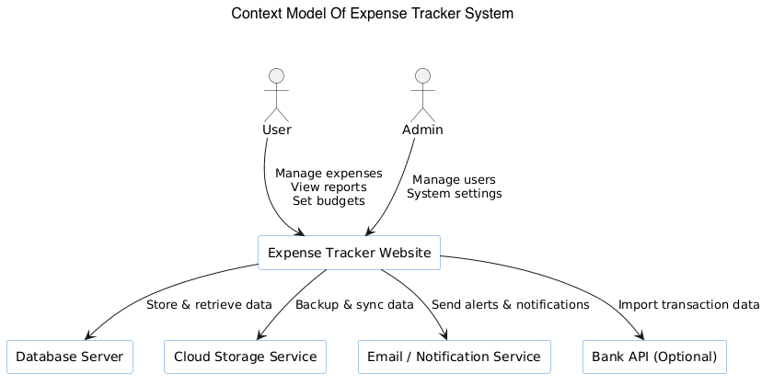
The Context Diagram shows the Expense Tracker System as a single process in the center, with external entities interacting with it. The main entities are:
- User: Sends login details, expense data, and category selections to the system. Receives expense lists, reports, and confirmation messages.
- Database: Receives data to store (new expense records, user accounts) and returns stored data when the system requests it.
- Web Browser: Acts as the interface between the user and the system. The user sees web pages and fills in forms.
The data flows include user credentials (for login/registration), expense entry data (amount, date, category, description), and summary data (totals returned to the user interface).

3.3 Use Case Diagram
)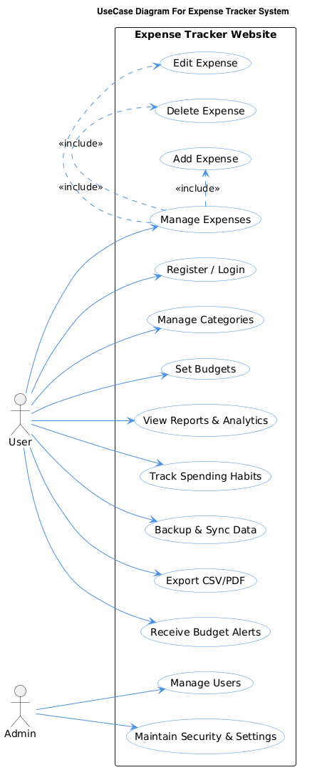
The repository contains a use case diagram saved as usecase.png. The Use Case Diagram shows the main interactions between the User actor and the system. The key use cases are:
- Register: A new user creates an account by providing their details.
- Login: An existing user authenticates to access the system.
- Logout: The user ends their session.
- Add Expense: The user fills in a form to record a new expense.
- View Expenses: The user browses the list of their recorded expenses.
- Edit Expense: The user modifies an existing expense entry.
- Delete Expense: The user removes an expense record.
- View Report/Summary: The user sees a breakdown of their spending by category or date.

3.4 Activity Diagram
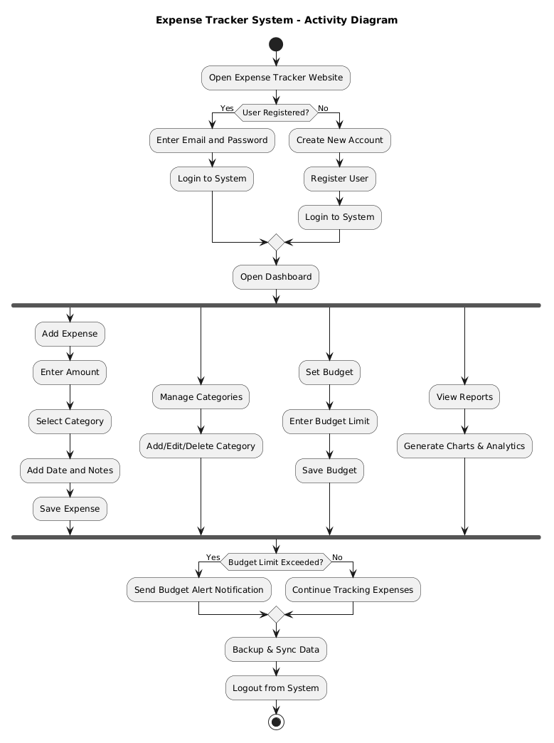
The repository includes an activity diagram saved as Activity dg.pdf. The Activity Diagram maps out the flow of actions a user takes when using the system. The key steps in the flow are:
- The user opens the application and sees the login page.
- If they are new, they click Register and fill in the form. If already registered, they log in directly.
- After successful login, the dashboard is shown with an expense overview.
- The user decides to add, edit, or delete an expense, or to view the report.
- When adding an expense, the user fills in the form and submits. The system validates the data, saves it, and refreshes the list.
- When editing, the user selects an entry, updates the fields, and saves.
- When deleting, the user confirms the deletion and the record is removed.
- At any point, the user can log out, which ends the session and returns them to the login page.

3.5 Sequence Diagram
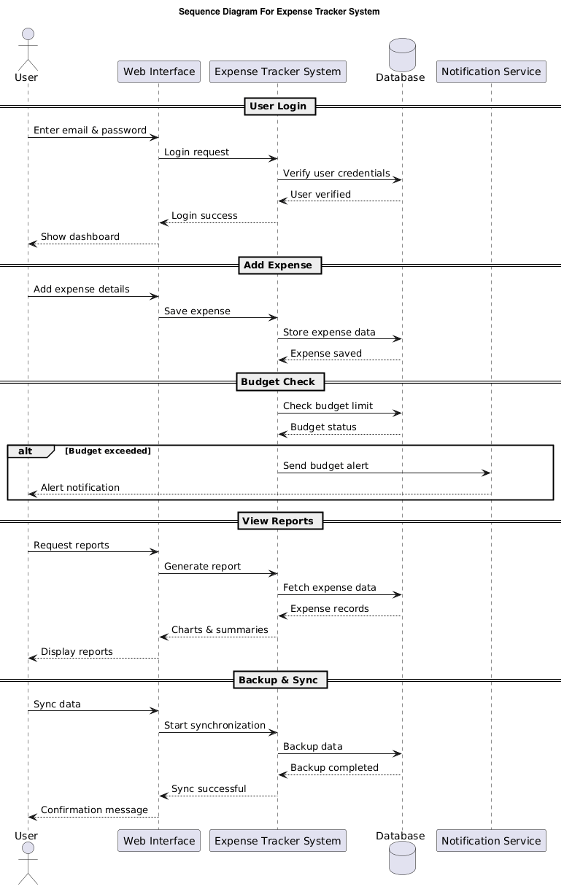The repository contains a sequence diagram saved as Sequence.png. The Sequence Diagram shows the message flow between the User, the Frontend, the Backend, and the Database for the Add Expense operation. The steps are:
- The user fills in the expense form and clicks Submit.
- The frontend sends an HTTP POST request to the backend with the expense data.
- The backend validates the input data.
- If valid, the backend sends an INSERT query to the database.
- The database confirms the record has been saved.
- The backend sends a success response back to the frontend.
- The frontend updates the expense list on screen and shows a confirmation message.

3.6 Class Diagram
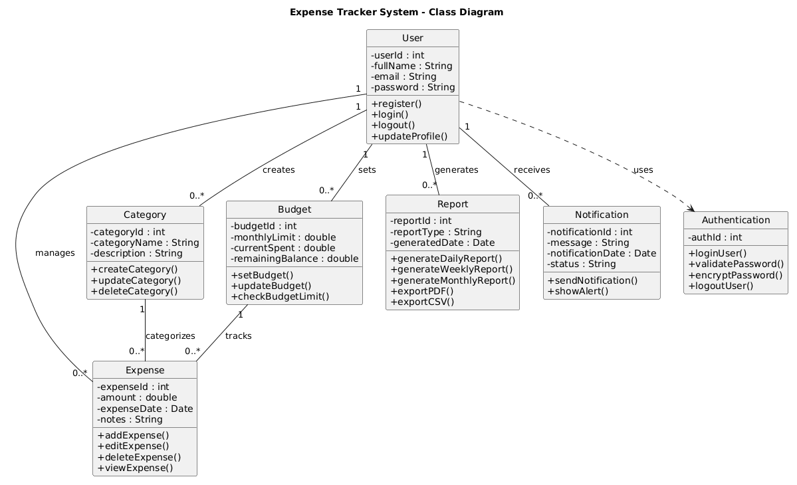Although no explicit class diagram image is named in the repository files, the system's structure implies the following main classes based on the SRS and architecture design documents:
- User: Properties include userID, name, email, and password. Methods include register(), login(), and logout().
- Expense: Properties include expenseID, userID (foreign key), amount, category, date, and description. Methods include add(), edit(), delete(), and getAll().
- Category: Properties include categoryID and categoryName. Acts as a lookup table for expense categories.
- Report: Linked to the Expense class. Generates summary data based on category or date filters.
The User class has a one-to-many relationship with the Expense class, meaning one user can have many expense records.

3.7 Database Design
Based on the ER Diagram (ER Diagram.png) the system uses a relational database with the following core tables:

Table Name | Purpose
users | Stores registered user account information including login credentials.
expenses | Stores individual expense records created by users.
categories | Stores the list of expense categories available in the system.

Table: users
Column | Data Type | Key | Description
user_id | INT | Primary Key | Unique identifier for each user (auto-incremented)
name | VARCHAR |  | Full name of the user
email | VARCHAR | Unique | Email address used for login
password | VARCHAR |  | Hashed password for the account
created_at | DATETIME |  | Timestamp when the account was created

Table: expenses
Column | Data Type | Key | Description
expense_id | INT | Primary Key | Unique identifier for each expense record
user_id | INT | Foreign Key | References user_id in the users table
category_id | INT | Foreign Key | References category_id in the categories table
amount | DECIMAL |  | The monetary value of the expense
description | VARCHAR |  | Optional notes about the expense
expense_date | DATE |  | The date the expense occurred
created_at | DATETIME |  | Timestamp when the record was added to the system

Table: categories
Column | Data Type | Key | Description
category_id | INT | Primary Key | Unique identifier for each category
category_name | VARCHAR |  | Name of the category (e.g., Food, Transport, Utilities)

Relationships: The users table is the parent table. Each expense record belongs to one user via the user_id foreign key. Each expense also links to one category via the category_id foreign key. This design ensures data integrity and makes it easy to query expenses by user or by category.

3.8 ER Diagram
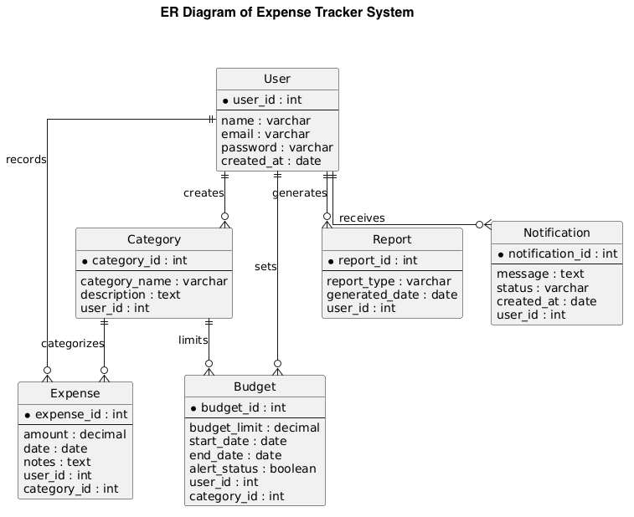The ER Diagram in the repository visualizes the three main entities: User, Expense, and Category. The key relationships are:
- A User can have MANY Expenses (one-to-many relationship).
- An Expense belongs to ONE User.
- An Expense belongs to ONE Category.
- A Category can be assigned to MANY Expenses (one-to-many relationship).
The diagram shows primary keys, foreign keys, and the cardinality between entities. This structure keeps the database normalized and avoids data duplication.

3.9 System Architecture
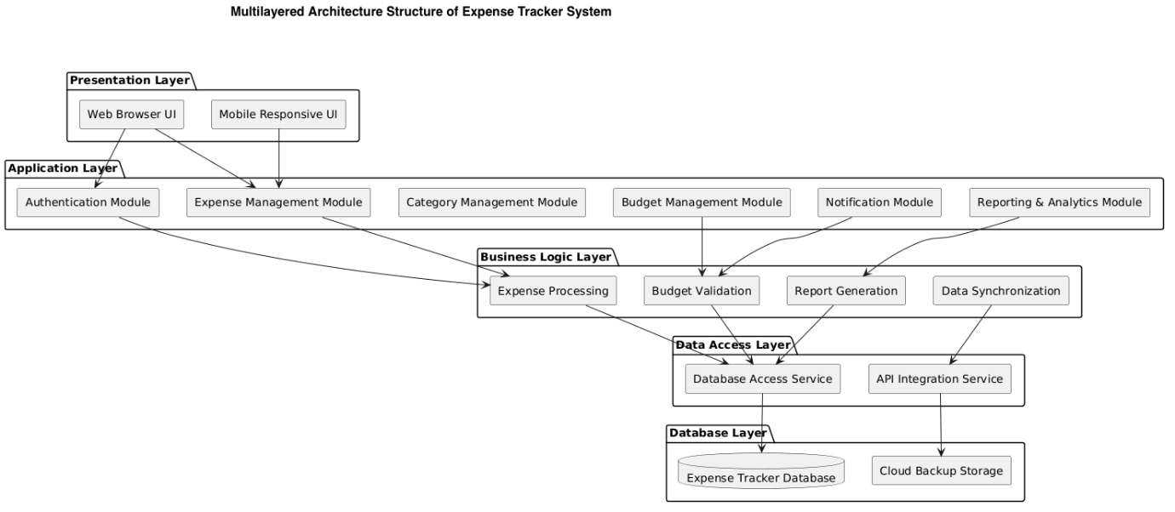
The repository includes a dedicated Architecture Design document (PDF and PPTX) that describes how the system is structured. The architecture follows a three-tier model:
- Frontend (Presentation Layer): The user interface built using HTML, CSS, and JavaScript. This is what the user sees and interacts with in their browser. It sends requests to the backend through HTTP calls and displays data returned from the backend.
- Backend (Application Layer): The server-side logic layer that processes requests from the frontend. It handles user authentication, validates inputs, and coordinates communication with the database. This layer contains the business logic, such as calculating totals and enforcing rules.
- Database (Data Layer): The relational database that stores all persistent data including user accounts, expense records, and categories. The backend communicates with the database using SQL queries.
Communication between the frontend and backend uses HTTP requests (GET for reading data, POST for creating records, PUT/PATCH for updates, DELETE for removal). The backend queries the database and returns JSON-formatted responses to the frontend.

3.10 Module Design

Module | Purpose | Description
Authentication Module | Handles user access control | Manages registration, login, logout, and session management. Ensures only logged-in users can access protected pages.
Expense Management Module | Core CRUD functionality | Allows users to create, read, update, and delete expense records. Includes form validation and database communication.
Category Module | Manages expense categories | Provides the list of available categories for expense entries. Categories are used to classify and filter expenses.
Report / Summary Module | Generates spending summaries | Calculates and displays total spending by category or date. Helps users understand their spending patterns.
Dashboard Module | Provides overview on login | Displays recent expenses and totals when the user first logs in. Acts as the home page after authentication.
Database Module | Manages data storage | Contains all database queries and connection logic. Acts as the data access layer between backend logic and the database.

Chapter 4: User Interface Design (Mockups)
This chapter presents the planned user interface for the Expense Tracker System. The implementation screenshot (implementation.png) is available in the repository and can be inserted below alongside or instead of mockups. Each section describes what the page contains and how the user interacts with it.

4.1 Login Page

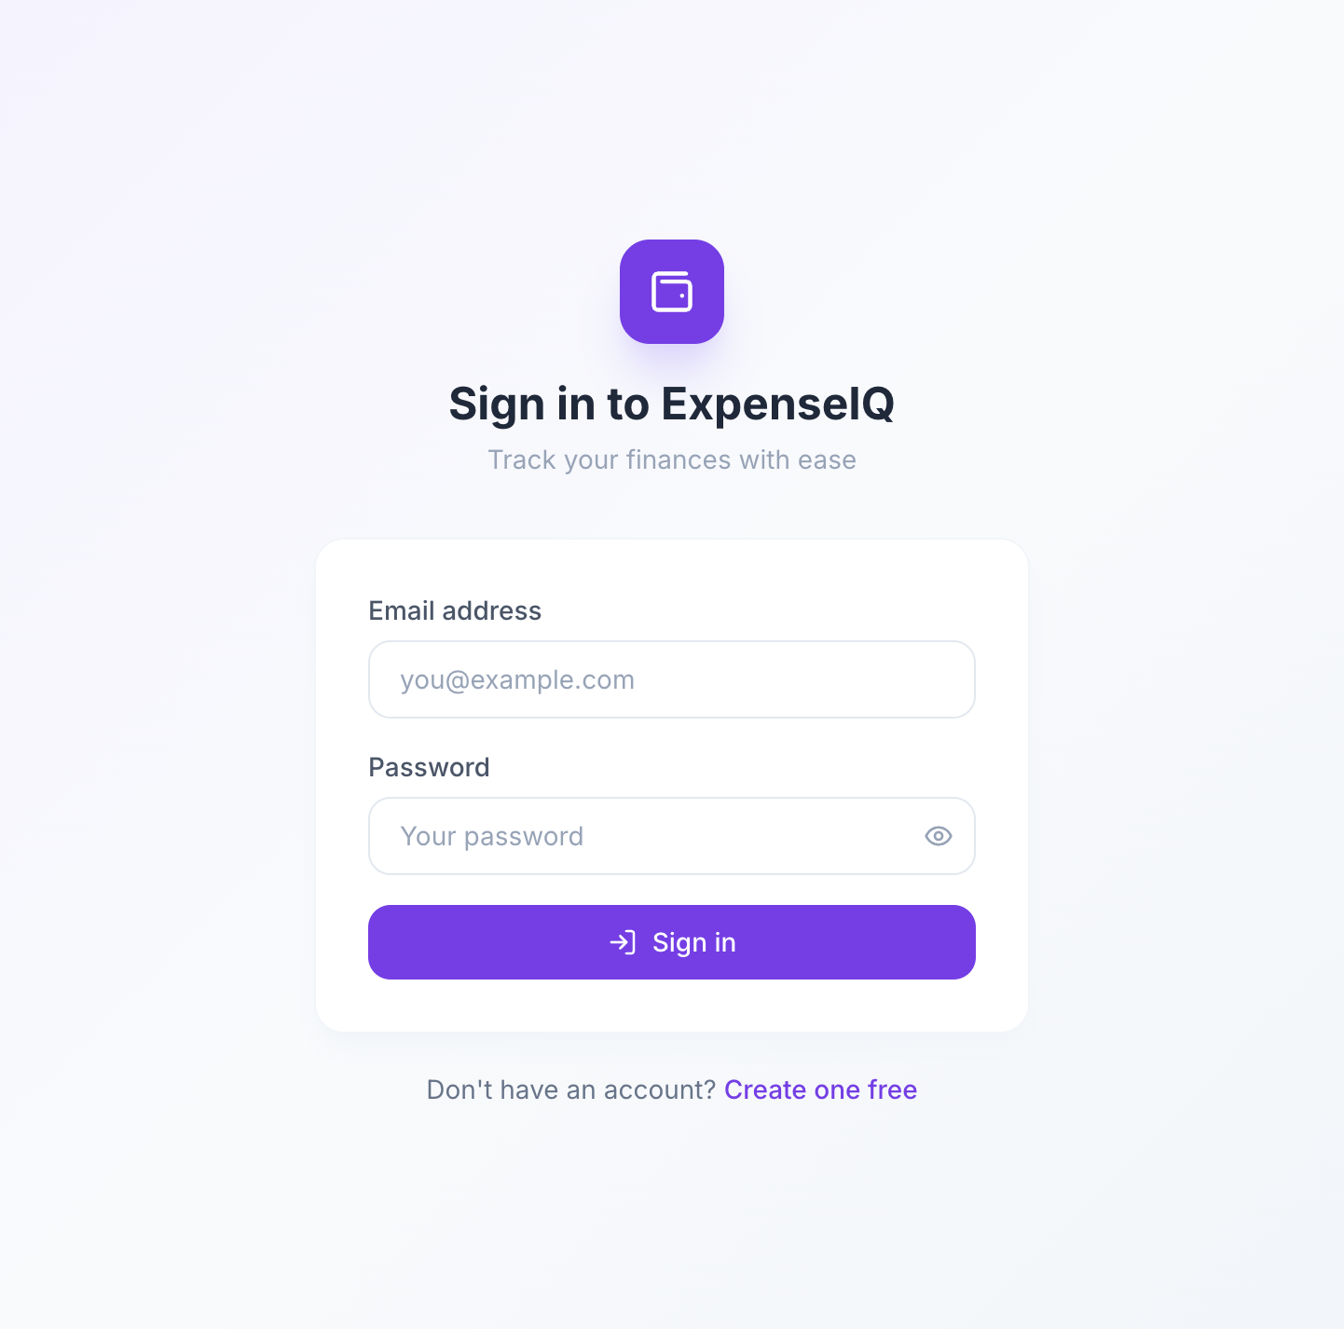
The login page is the first screen most users see when they visit the application. It contains two input fields: one for the email address and one for the password. Below the fields is a Login button. There is also a link to the registration page for new users.
When the user enters their credentials and clicks Login, the system checks whether the email and password match a registered account. If they match, the user is redirected to the dashboard. If not, an error message is shown asking them to check their details.

4.2 Registration Page
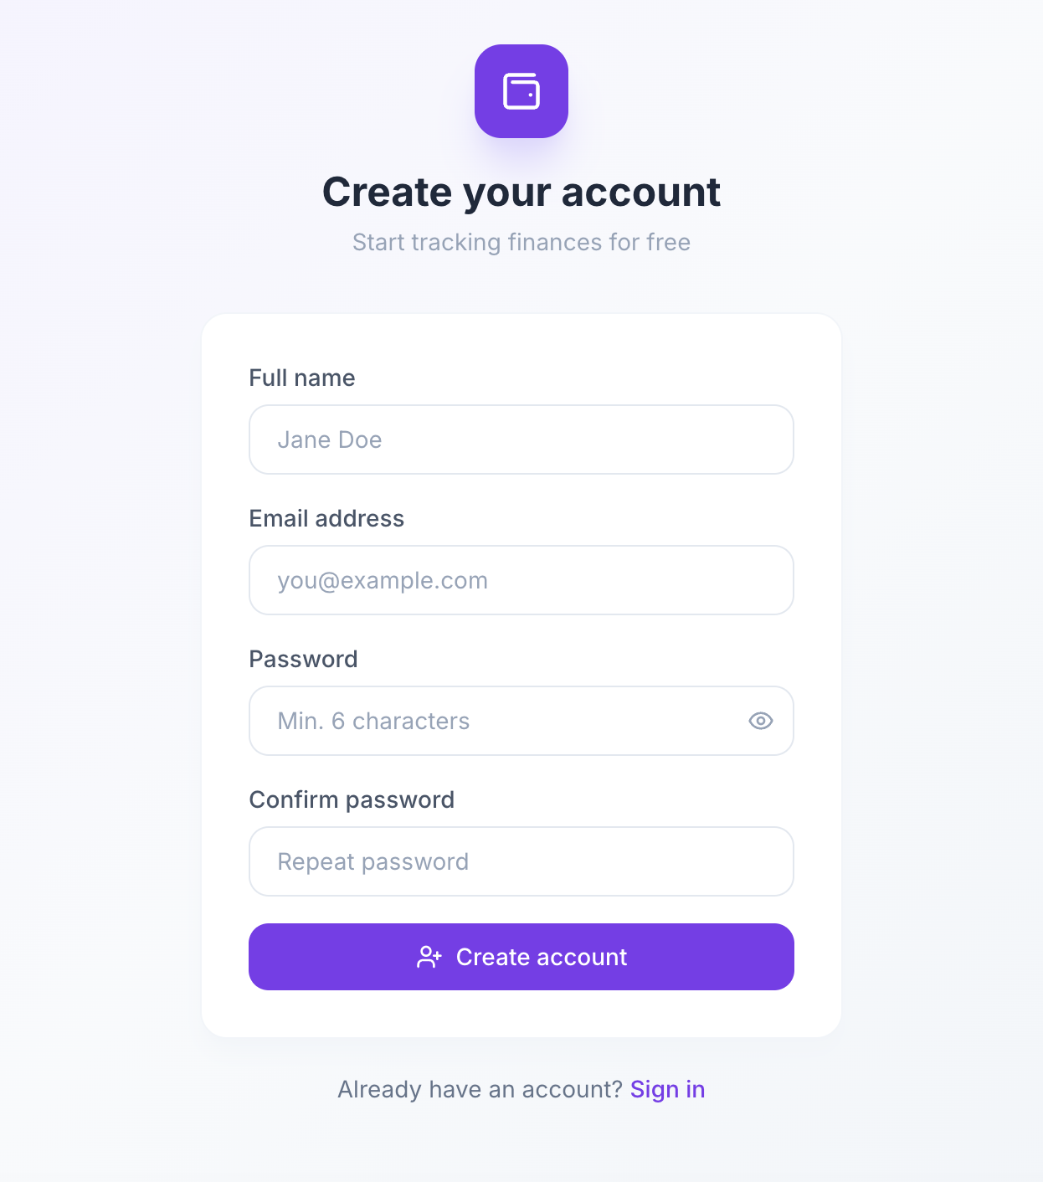The registration page allows new users to create an account. It includes fields for the user's name, email address, password, and a confirm password field. A Register button submits the form.
The system validates the input: the email must be in a valid format, the password must meet minimum length requirements, and both password fields must match. If any field is invalid, an error message is shown next to that field. On success, the user is redirected to the login page.

4.3 Dashboard

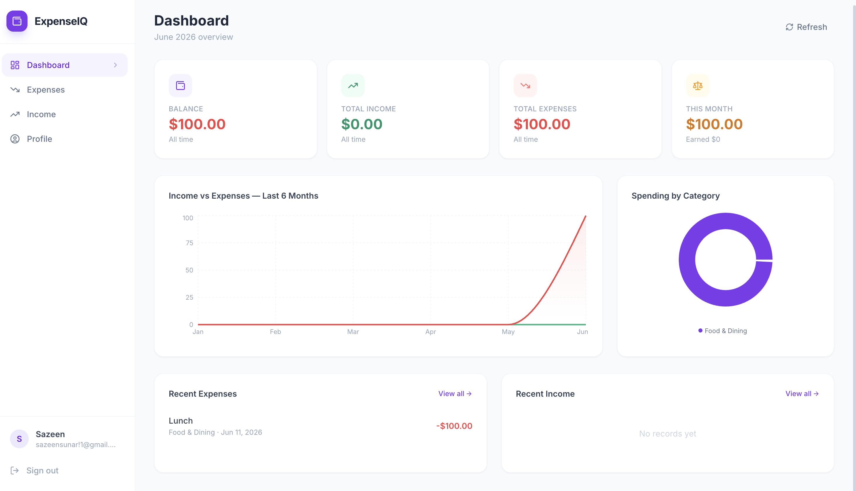
The dashboard is the main landing page after a successful login. It gives the user a quick overview of their recent expenses. The page typically shows the total amount spent, a list of the most recent entries, and possibly a brief breakdown by category.
The navigation menu is visible on the dashboard, giving the user quick access to the expense list, the add expense form, and the reports page. The dashboard is designed to be simple so the user can quickly understand their financial status at a glance.

4.4 Expense Management
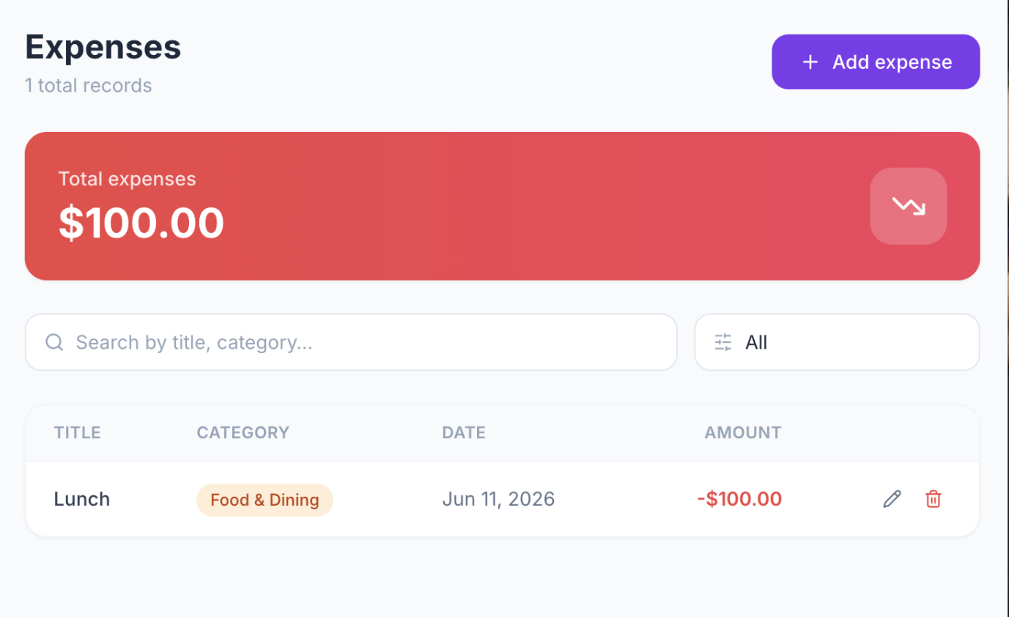The expense management page shows a full list of all expense records entered by the user. Each row in the table shows the date, category, description, and amount. At the end of each row, there are Edit and Delete buttons.
Above the table, there is an Add Expense button that opens a form. The form includes fields for amount, category (a dropdown), date (a date picker), and an optional description. After submitting the form, the new entry appears in the table.
When the user clicks Edit on a row, the same form appears pre-filled with the existing data. The user can change any field and save. When the user clicks Delete, a confirmation prompt appears before the record is removed.

4.5 Reports Page
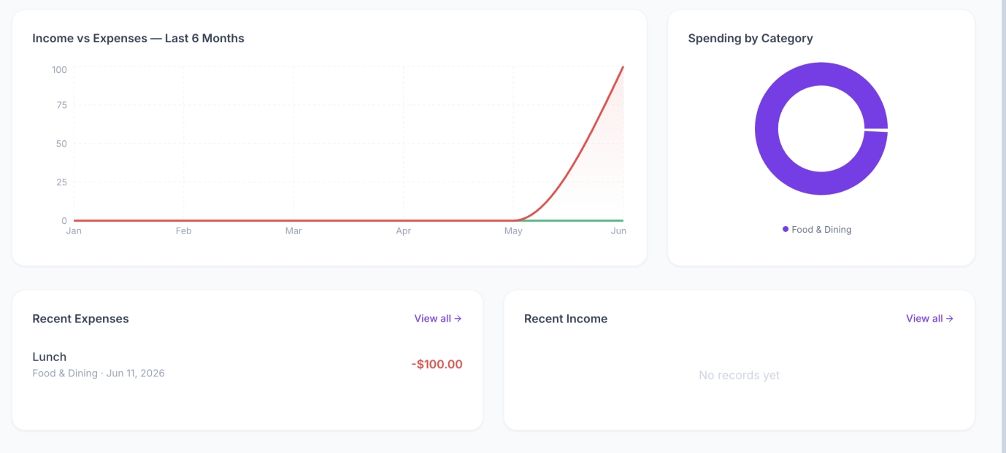The reports page provides a summary of the user's spending. It may show total amounts per category in a table or simple chart format. The user can see at a glance which categories they spend the most on.
The page could also include a date range filter so the user can see spending for a specific period, such as this month or this week. The report helps the user identify areas where they might want to reduce spending.

Chapter 5: Project Management

5.1 Development Methodology
The team followed an Agile-inspired iterative approach for this project. Because this is a university project with a fixed deadline, the team divided the work into smaller phases rather than following a rigid waterfall model. This allowed the team to review progress regularly and adjust plans if needed.
The process started with requirements gathering and documentation (SRS). Then the team moved into system design, producing the architecture document, ER diagram, use case diagram, activity diagram, and sequence diagram. After design, development began, with the team working on frontend, backend, and database components in parallel where possible. Testing was done throughout development, not just at the end.
GitHub was used as the version control and collaboration platform. The repository shows that the team committed their documents and diagrams directly, which allowed all members to access the latest versions.

5.2 Team Responsibilities

Team Member | Primary Responsibilities
Sunar Sajin | Frontend development Project coordination, backend development, database implementation, Backend logic development
Singh Shivanya | Frontend development, user interface design, mockup creation, UI testing ER diagram, use case and activity diagram creation,
Budhathoki Somiya | Project coordination Requirements gathering, SRS documentation, system architecture documentation
Tanvir MD Ashraful Islam | , API design, sequence diagram, integration testing, ER Diagram, Database Design
Kholmatov Otamurod Ruzmatovich | mockup creation, data validation, test cases
Note: The exact task breakdown above is based on typical group project roles inferred from the repository structure. The team should update this table to reflect their actual contributions.

5.3 Project Schedule
The table below describes the approximate phases and timeline of the project. The exact dates should be updated to match the actual project schedule.

Phase | Tasks | Estimated Duration
Phase 1: Planning | Understand project requirements, select technology stack, plan team responsibilities | 1 week
Phase 2: Requirements | Write the SRS document, define functional and non-functional requirements | 1-2 weeks
Phase 3: Design | Create architecture document, ER diagram, use case, activity, sequence, and class diagrams | 2 weeks
Phase 4: Development | Build frontend pages, backend logic, and database structure. Connect all layers. | 3-4 weeks
Phase 5: Testing | Test all features against requirements, write test cases, fix bugs | 1-2 weeks
Phase 6: Documentation | Finalize this project report, prepare presentation | 1 week

Chapter 6: Testing and Requirement Traceability

6.1 Testing Overview
Testing was carried out to verify that each feature of the Expense Tracker System works as expected. The team used manual functional testing, checking each feature against the requirements defined in the SRS. For each test, the input was recorded, the expected result was noted, and the actual result was compared against it.
No automated testing framework is shown in the repository, so all testing described here is based on manual verification of the implemented features against the defined requirements.

6.2 Requirement Traceability Matrix (RTM)
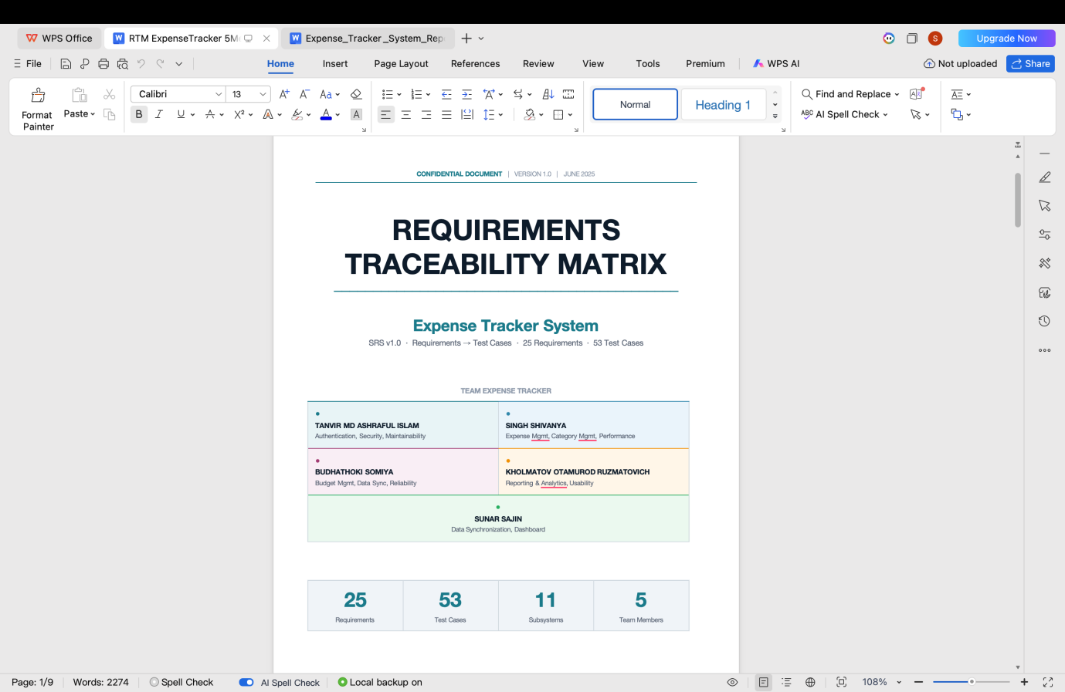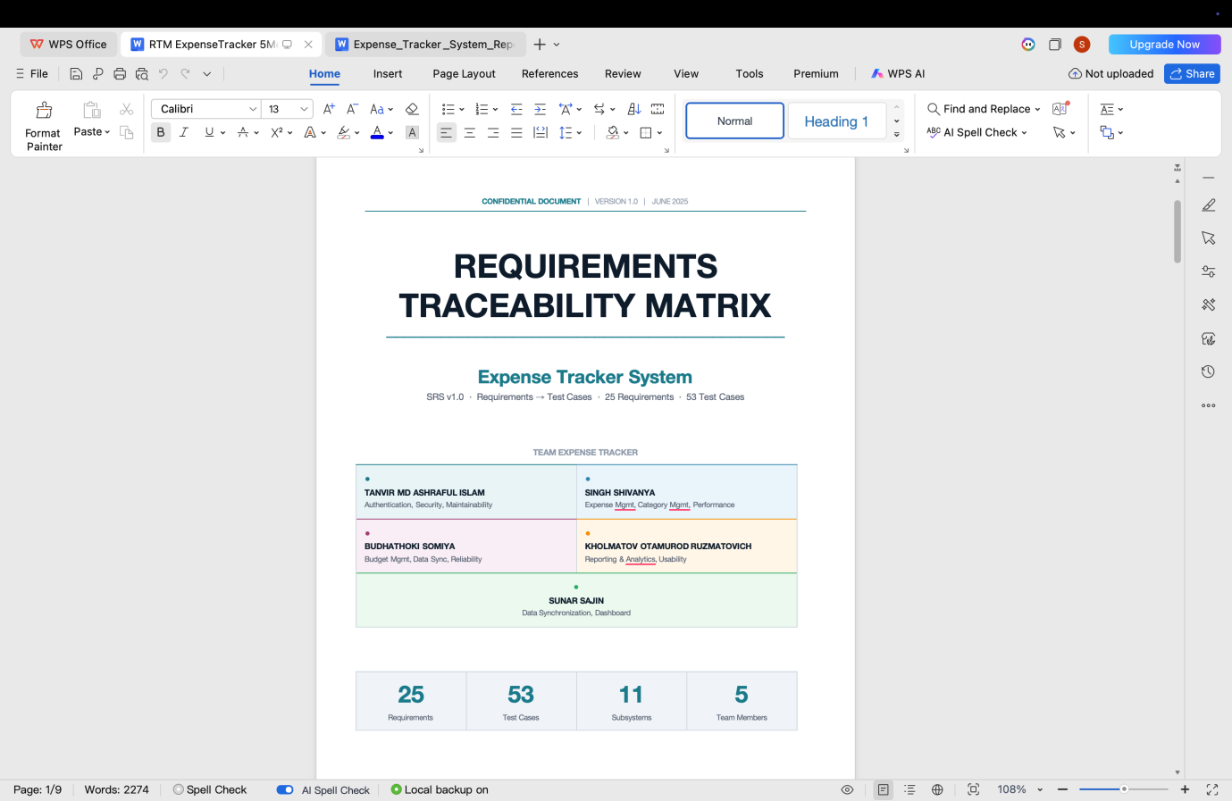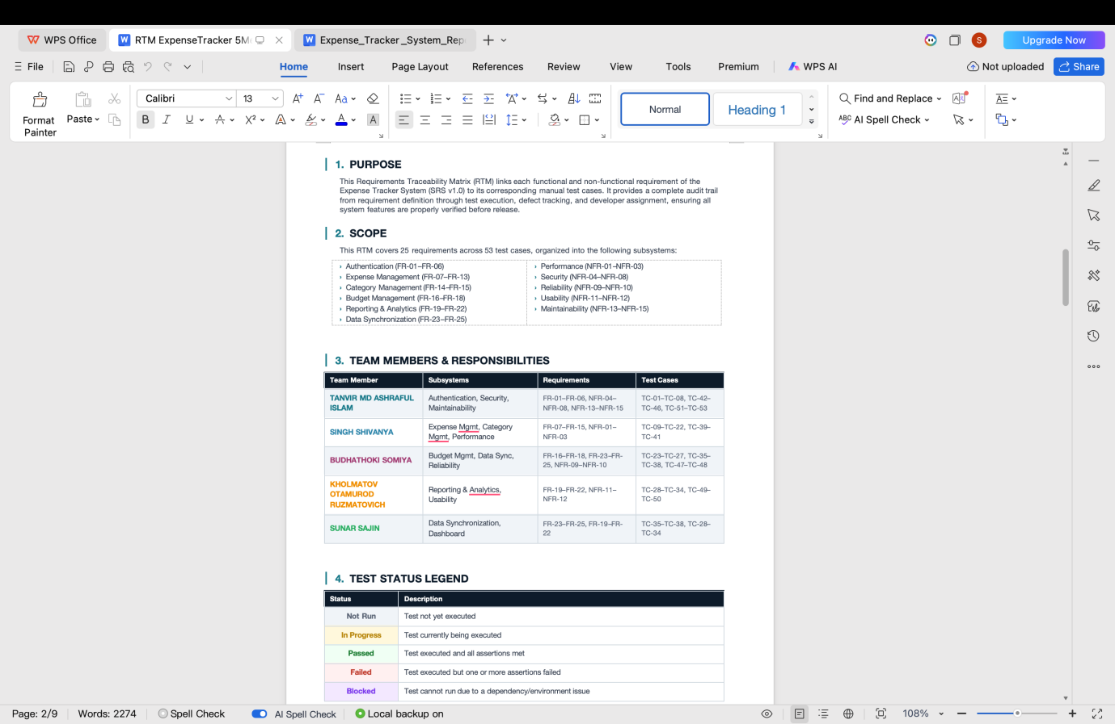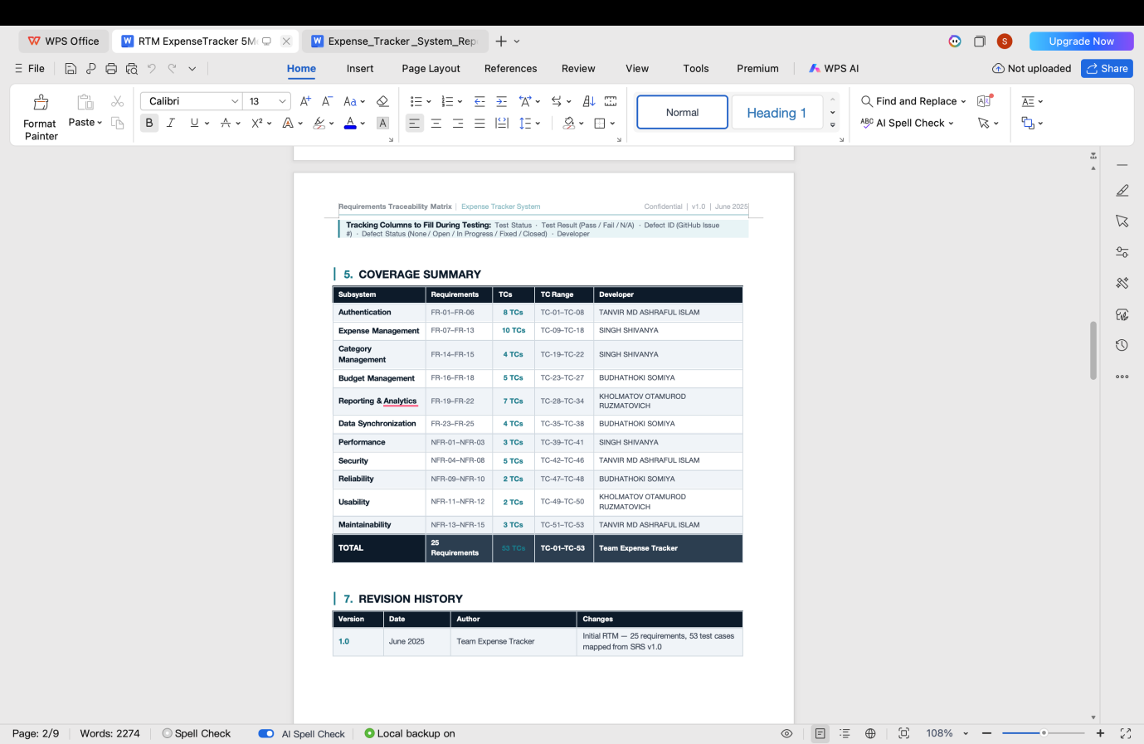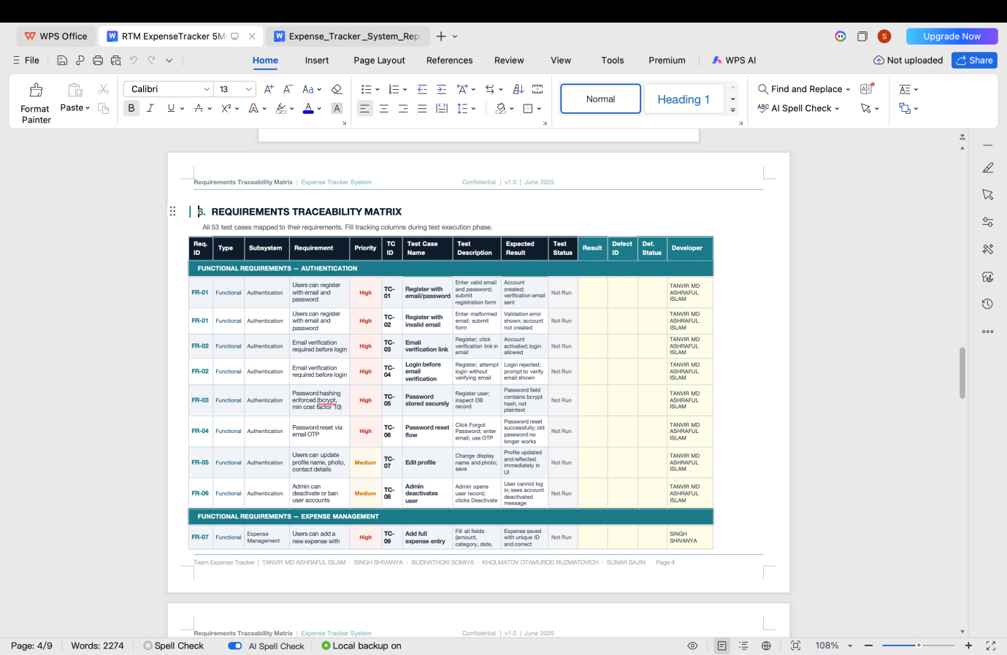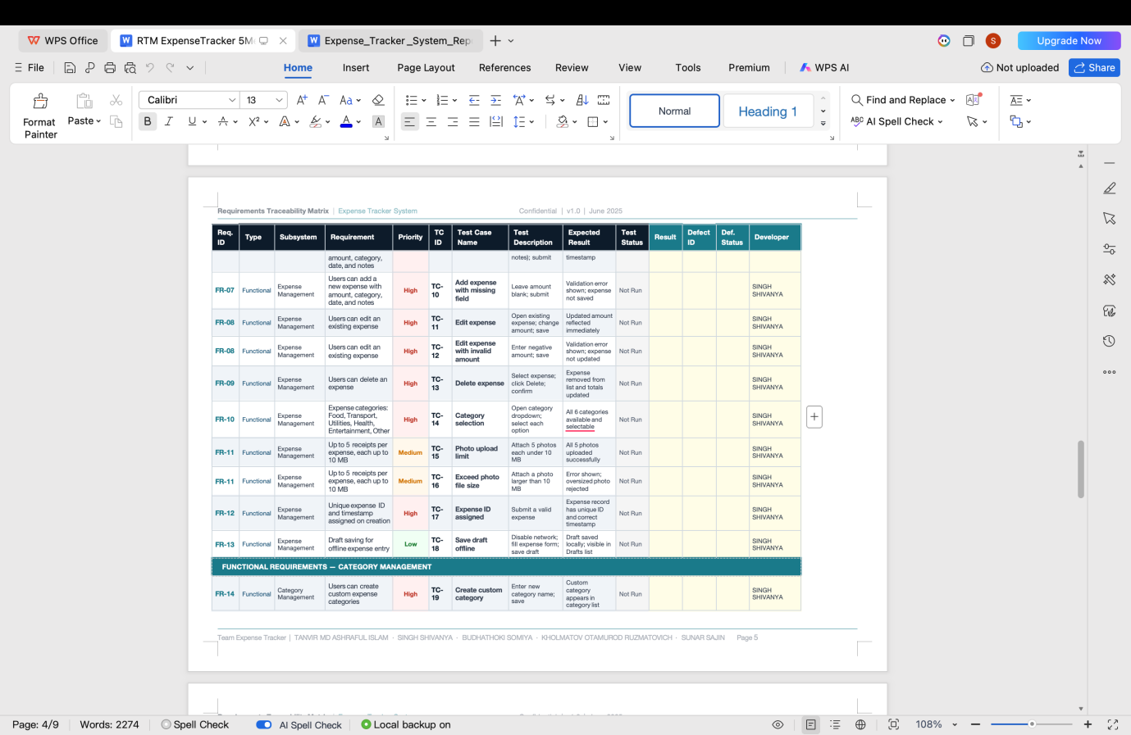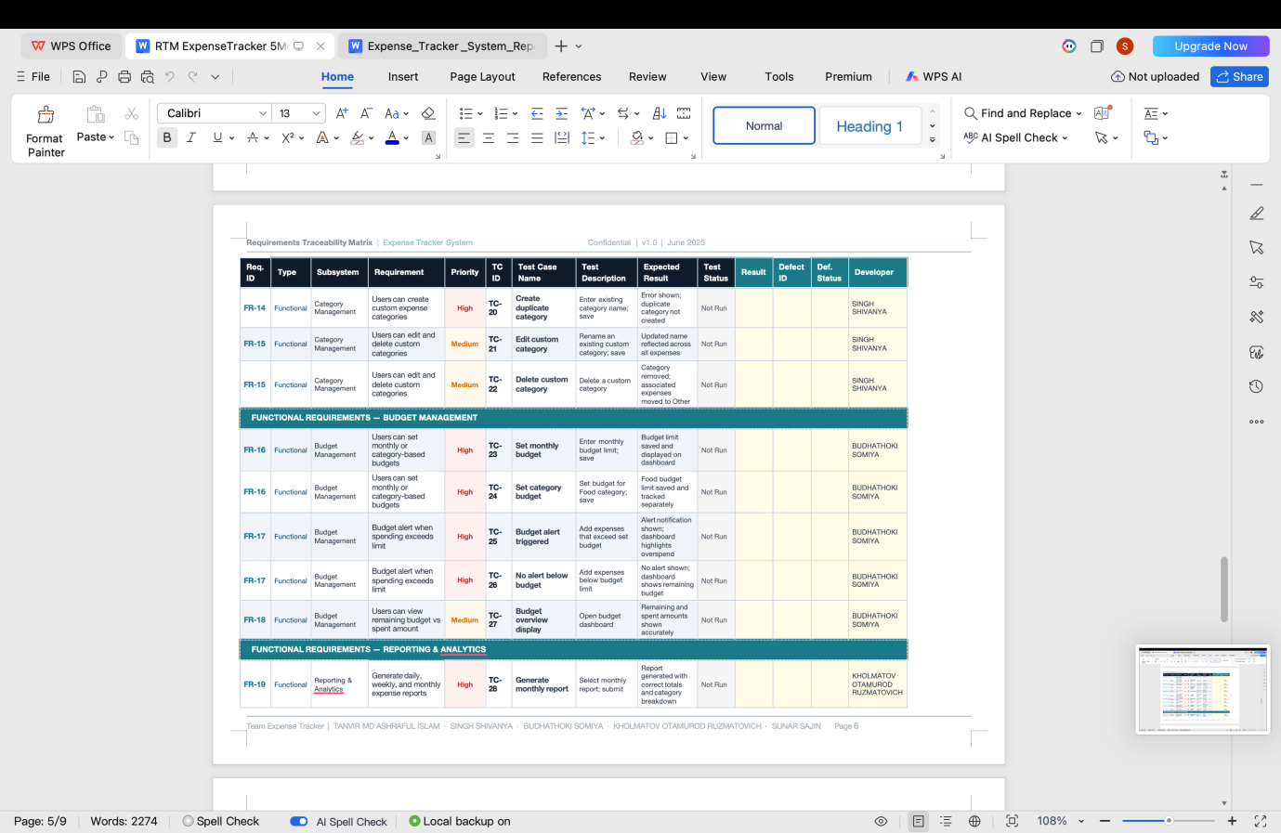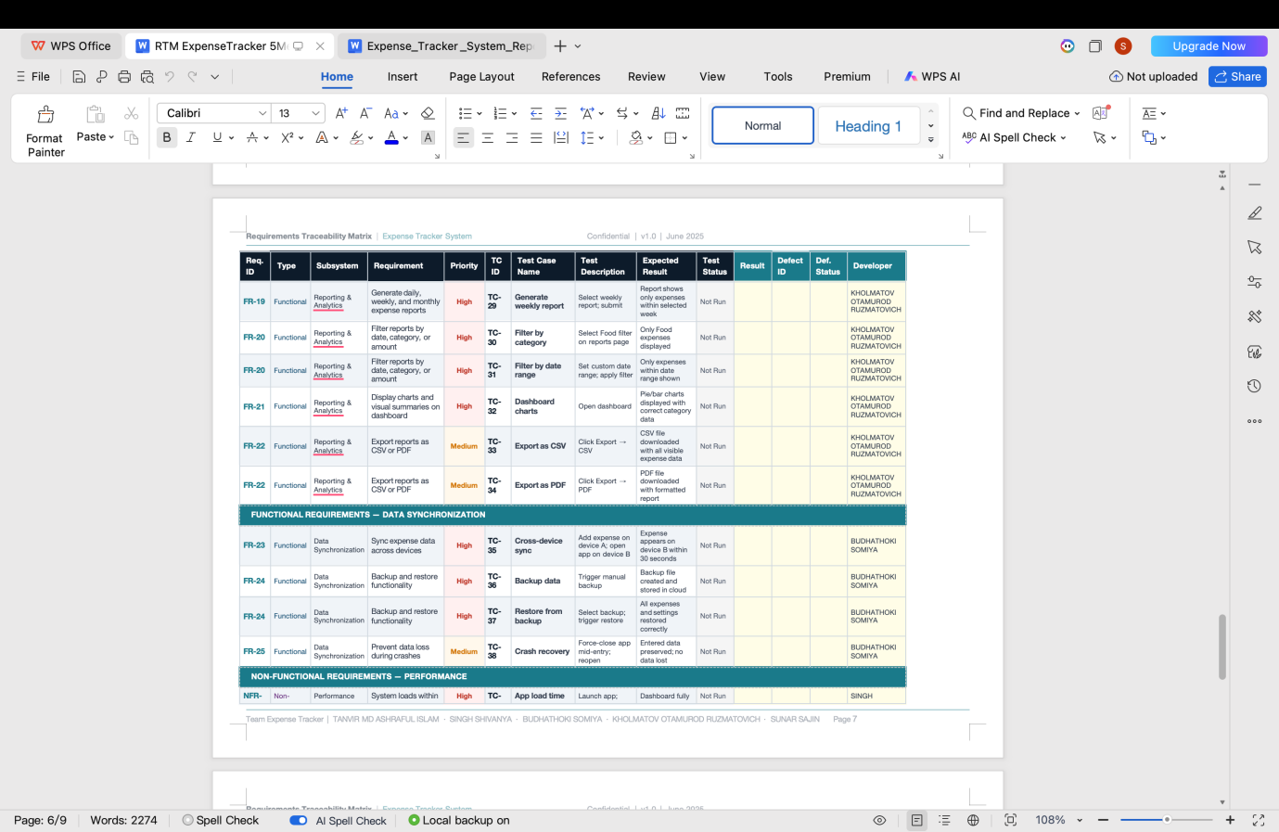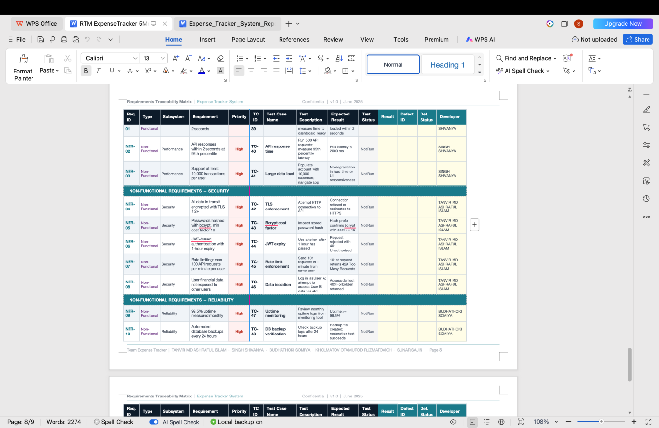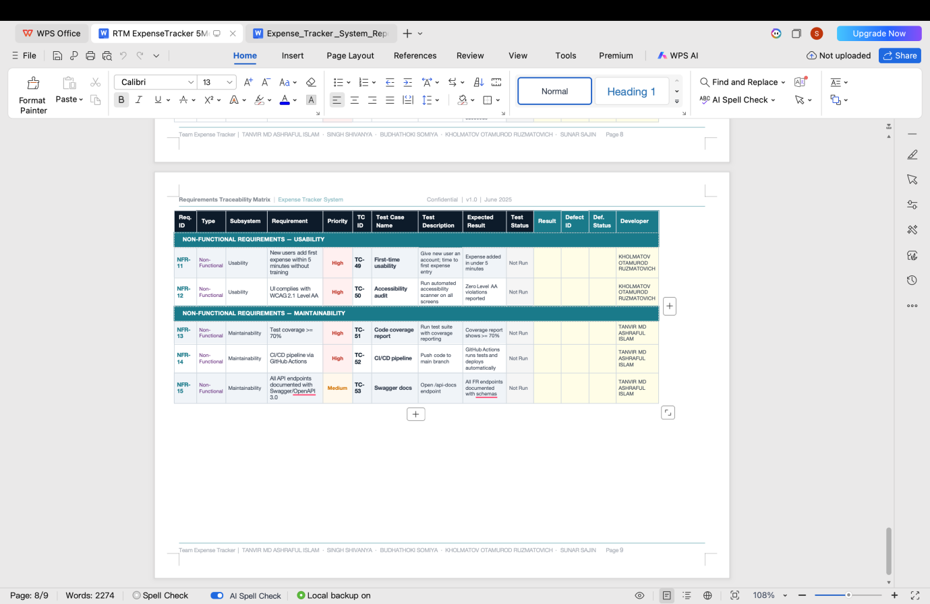The Requirement Traceability Matrix links each functional requirement to one or more test cases. This ensures that every requirement has been tested and that no feature has been missed. The table below provides a summary mapping.All 11 functional requirements are covered by at least one test case. The testing process confirmed that the core features of the system work as designed. Any failures found during testing were fixed before the final submission.

Chapter 7: References

7.1Framework and Language Documentation
- Mozilla Developer Network (MDN). (2024). HTML, CSS, and JavaScript documentation. https://developer.mozilla.org
- Node.js Foundation. (2024). Node.js documentation. https://nodejs.org/en/docs
- Python Software Foundation. (2024). Python documentation. https://docs.python.org
- MySQL. (2024). MySQL 8.0 Reference Manual. https://dev.mysql.com/doc/refman/8.0/en/

7.2Development Tools
- Visual Studio Code — Source code editor used for development. https://code.visualstudio.com
- GitHub — Version control and collaboration platform. https://github.com
- Draw.io / Lucidchart — Used for creating system diagrams (context, use case, ER, sequence, activity diagrams)
- XAMPP / WAMP — Local server environment for development and testing

7.3 Learning Resources
- W3Schools. (2024). Web development tutorials. https://www.w3schools.com
- GeeksforGeeks. (2024). Software engineering concepts and examples. https://www.geeksforgeeks.org
- YouTube. (2024). Various tutorials on web application development, database design, and UML diagrams [Online video content]

7.4 AI Tools Used
- ChatGPT (OpenAI) — Used to assist with grammar checking and explaining technical concepts during report writing
- Claude (Anthropic) — Used to assist with generating the structure and content of this project report based on repository analysis

7.5 Textbooks and Course Materials
- Sommerville, I. (2016). Software Engineering (10th ed.). Pearson Education. — Referenced for SRS structure and software development lifecycle concepts
- Course lecture slides and materials provided by the course instructor

Chapter 8: Appendix

Appendix A – Application Screenshots
[  other images from repository)

Insert screenshots of the running application here. These should include the login page, registration page, dashboard, expense list, add expense form, and reports page. The implementation.png file in the repository can be used as the primary screenshot.

Appendix B – System Diagrams from Repository





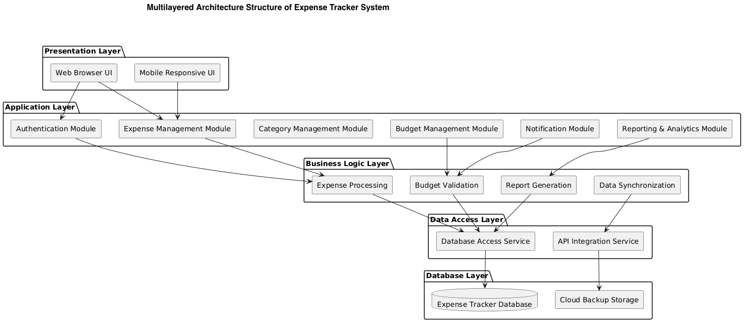Appendix C – Source Code Samples
- Backend:
const mongoose = require('mongoose');

const connectDB = async () => {
try {
const conn = await mongoose.connect(process.env.MONGO_URI, {
useNewUrlParser: true,
useUnifiedTopology: true,
});
console.log(`✅ MongoDB Connected: ${conn.connection.host}`);
} catch (error) {
console.error(`❌ MongoDB Error: ${error.message}`);
console.error('Make sure MongoDB is running: brew services start mongodb-community');
process.exit(1);
}
};

module.exports = connectDB;

const jwt = require('jsonwebtoken');
const User = require('../models/User');

const generateToken = (id) =>
jwt.sign({ id }, process.env.JWT_SECRET, { expiresIn: '30d' });

// POST /api/auth/register
const register = async (req, res) => {
try {
const { name, email, password } = req.body;

if (!name || !email || !password)
return res.status(400).json({ success: false, message: 'Please provide name, email and password.' });

if (password.length < 6)
return res.status(400).json({ success: false, message: 'Password must be at least 6 characters.' });

const exists = await User.findOne({ email: email.toLowerCase() });
if (exists)
return res.status(400).json({ success: false, message: 'An account with this email already exists.' });

const user = await User.create({ name: name.trim(), email: email.toLowerCase().trim(), password });

res.status(201).json({
success: true,
data: {
_id: user._id,
name: user.name,
email: user.email,
token: generateToken(user._id),
},
});
} catch (error) {
console.error('Register error:', error);
res.status(500).json({ success: false, message: 'Server error. Please try again.' });
}
};

// POST /api/auth/login
const login = async (req, res) => {
try {
const { email, password } = req.body;

if (!email || !password)
return res.status(400).json({ success: false, message: 'Please provide email and password.' });

const user = await User.findOne({ email: email.toLowerCase() }).select('+password');

if (!user || !(await user.matchPassword(password)))
return res.status(401).json({ success: false, message: 'Invalid email or password.' });

res.json({
success: true,
data: {
_id: user._id,
name: user.name,
email: user.email,
token: generateToken(user._id),
},
});
} catch (error) {
console.error('Login error:', error);
res.status(500).json({ success: false, message: 'Server error. Please try again.' });
}
};

// GET /api/auth/me
const getMe = async (req, res) => {
try {
const user = await User.findById(req.user._id);
res.json({ success: true, data: { _id: user._id, name: user.name, email: user.email } });
} catch (error) {
res.status(500).json({ success: false, message: 'Server error.' });
}
};

// PUT /api/auth/profile
const updateProfile = async (req, res) => {
try {
const { name, email, password } = req.body;
const user = await User.findById(req.user._id);

if (name) user.name = name.trim();
if (email) {
const exists = await User.findOne({ email: email.toLowerCase(), _id: { $ne: user._id } });
if (exists) return res.status(400).json({ success: false, message: 'Email already in use.' });
user.email = email.toLowerCase().trim();
}
if (password) {
if (password.length < 6)
return res.status(400).json({ success: false, message: 'Password must be at least 6 characters.' });
user.password = password;
}

const updated = await user.save();
res.json({
success: true,
data: { _id: updated._id, name: updated.name, email: updated.email, token: generateToken(updated._id) },
});
} catch (error) {
res.status(500).json({ success: false, message: 'Server error.' });
}
};

module.exports = { register, login, getMe, updateProfile };

const Expense = require('../models/Expense');
const Income = require('../models/Income');

// GET /api/dashboard
const getDashboard = async (req, res) => {
try {
const userId = req.user._id;
const now = new Date();
const startOfMonth = new Date(now.getFullYear(), now.getMonth(), 1);
const endOfMonth = new Date(now.getFullYear(), now.getMonth() + 1, 0, 23, 59, 59);
const sixMonthsAgo = new Date(now.getFullYear(), now.getMonth() - 5, 1);

const [
totalIncomeAgg,
totalExpenseAgg,
monthIncomeAgg,
monthExpenseAgg,
expenseByCategoryAgg,
monthlyExpensesAgg,
monthlyIncomesAgg,
recentExpenses,
recentIncomes,
] = await Promise.all([
Income.aggregate([{ $match: { user: userId } }, { $group: { _id: null, total: { $sum: '$amount' } } }]),
Expense.aggregate([{ $match: { user: userId } }, { $group: { _id: null, total: { $sum: '$amount' } } }]),
Income.aggregate([{ $match: { user: userId, date: { $gte: startOfMonth, $lte: endOfMonth } } }, { $group: { _id: null, total: { $sum: '$amount' } } }]),
Expense.aggregate([{ $match: { user: userId, date: { $gte: startOfMonth, $lte: endOfMonth } } }, { $group: { _id: null, total: { $sum: '$amount' } } }]),
Expense.aggregate([
{ $match: { user: userId, date: { $gte: startOfMonth, $lte: endOfMonth } } },
{ $group: { _id: '$category', total: { $sum: '$amount' }, count: { $sum: 1 } } },
{ $sort: { total: -1 } },
]),
Expense.aggregate([
{ $match: { user: userId, date: { $gte: sixMonthsAgo } } },
{ $group: { _id: { year: { $year: '$date' }, month: { $month: '$date' } }, total: { $sum: '$amount' } } },
{ $sort: { '_id.year': 1, '_id.month': 1 } },
]),
Income.aggregate([
{ $match: { user: userId, date: { $gte: sixMonthsAgo } } },
{ $group: { _id: { year: { $year: '$date' }, month: { $month: '$date' } }, total: { $sum: '$amount' } } },
{ $sort: { '_id.year': 1, '_id.month': 1 } },
]),
Expense.find({ user: userId }).sort({ date: -1 }).limit(5),
Income.find({ user: userId }).sort({ date: -1 }).limit(5),
]);

const totalIncome = totalIncomeAgg[0]?.total || 0;
const totalExpense = totalExpenseAgg[0]?.total || 0;
const monthIncome = monthIncomeAgg[0]?.total || 0;
const monthExpense = monthExpenseAgg[0]?.total || 0;

// Build 6-month trend array with all months represented
const months = ['Jan','Feb','Mar','Apr','May','Jun','Jul','Aug','Sep','Oct','Nov','Dec'];
const trendMap = {};
for (let i = 5; i >= 0; i--) {
const d = new Date(now.getFullYear(), now.getMonth() - i, 1);
const key = `${d.getFullYear()}-${d.getMonth() + 1}`;
trendMap[key] = { month: months[d.getMonth()], income: 0, expense: 0 };
}
monthlyExpensesAgg.forEach(({ _id, total }) => {
const key = `${_id.year}-${_id.month}`;
if (trendMap[key]) trendMap[key].expense = total;
});
monthlyIncomesAgg.forEach(({ _id, total }) => {
const key = `${_id.year}-${_id.month}`;
if (trendMap[key]) trendMap[key].income = total;
});

res.json({
success: true,
data: {
summary: {
totalIncome,
totalExpense,
balance: totalIncome - totalExpense,
monthIncome,
monthExpense,
monthBalance: monthIncome - monthExpense,
},
expenseByCategory: expenseByCategoryAgg,
monthlyTrend: Object.values(trendMap),
recentExpenses,
recentIncomes,
},
});
} catch (error) {
console.error('Dashboard error:', error);
res.status(500).json({ success: false, message: 'Failed to load dashboard data.' });
}
};

module.exports = { getDashboard };

const Expense = require('../models/Expense');

// GET /api/expenses
const getExpenses = async (req, res) => {
try {
const { category, startDate, endDate, page = 1, limit = 50 } = req.query;
const filter = { user: req.user._id };

if (category && category !== 'All') filter.category = category;
if (startDate || endDate) {
filter.date = {};
if (startDate) filter.date.$gte = new Date(startDate);
if (endDate) {
const end = new Date(endDate);
end.setHours(23, 59, 59, 999);
filter.date.$lte = end;
}
}

const skip = (Number(page) - 1) * Number(limit);
const [expenses, total] = await Promise.all([
Expense.find(filter).sort({ date: -1 }).skip(skip).limit(Number(limit)),
Expense.countDocuments(filter),
]);

res.json({ success: true, data: expenses, total, page: Number(page), pages: Math.ceil(total / limit) });
} catch (error) {
console.error('Get expenses error:', error);
res.status(500).json({ success: false, message: 'Failed to fetch expenses.' });
}
};

// POST /api/expenses
const createExpense = async (req, res) => {
try {
const { title, amount, category, description, date } = req.body;

if (!title || !amount || !category)
return res.status(400).json({ success: false, message: 'Title, amount, and category are required.' });

if (isNaN(amount) || Number(amount) <= 0)
return res.status(400).json({ success: false, message: 'Amount must be a positive number.' });

const expense = await Expense.create({
user: req.user._id,
title: title.trim(),
amount: Number(amount),
category,
description: description?.trim() || '',
date: date ? new Date(date) : new Date(),
});

res.status(201).json({ success: true, data: expense });
} catch (error) {
if (error.name === 'ValidationError') {
const msg = Object.values(error.errors).map(e => e.message).join(', ');
return res.status(400).json({ success: false, message: msg });
}
res.status(500).json({ success: false, message: 'Failed to create expense.' });
}
};

// PUT /api/expenses/:id
const updateExpense = async (req, res) => {
try {
const expense = await Expense.findById(req.params.id);
if (!expense) return res.status(404).json({ success: false, message: 'Expense not found.' });
if (expense.user.toString() !== req.user._id.toString())
return res.status(403).json({ success: false, message: 'Not authorized.' });

const { title, amount, category, description, date } = req.body;
if (title) expense.title = title.trim();
if (amount) expense.amount = Number(amount);
if (category) expense.category = category;
if (description !== undefined) expense.description = description.trim();
if (date) expense.date = new Date(date);

const updated = await expense.save();
res.json({ success: true, data: updated });
} catch (error) {
res.status(500).json({ success: false, message: 'Failed to update expense.' });
}
};

// DELETE /api/expenses/:id
const deleteExpense = async (req, res) => {
try {
const expense = await Expense.findById(req.params.id);
if (!expense) return res.status(404).json({ success: false, message: 'Expense not found.' });
if (expense.user.toString() !== req.user._id.toString())
return res.status(403).json({ success: false, message: 'Not authorized.' });

await expense.deleteOne();
res.json({ success: true, message: 'Expense deleted successfully.' });
} catch (error) {
res.status(500).json({ success: false, message: 'Failed to delete expense.' });
}
};

module.exports = { getExpenses, createExpense, updateExpense, deleteExpense };

const Income = require('../models/Income');

// GET /api/incomes
const getIncomes = async (req, res) => {
try {
const { category, startDate, endDate, page = 1, limit = 50 } = req.query;
const filter = { user: req.user._id };

if (category && category !== 'All') filter.category = category;
if (startDate || endDate) {
filter.date = {};
if (startDate) filter.date.$gte = new Date(startDate);
if (endDate) {
const end = new Date(endDate);
end.setHours(23, 59, 59, 999);
filter.date.$lte = end;
}
}

const skip = (Number(page) - 1) * Number(limit);
const [incomes, total] = await Promise.all([
Income.find(filter).sort({ date: -1 }).skip(skip).limit(Number(limit)),
Income.countDocuments(filter),
]);

res.json({ success: true, data: incomes, total, page: Number(page), pages: Math.ceil(total / limit) });
} catch (error) {
res.status(500).json({ success: false, message: 'Failed to fetch incomes.' });
}
};

// POST /api/incomes
const createIncome = async (req, res) => {
try {
const { title, amount, category, description, date } = req.body;

if (!title || !amount || !category)
return res.status(400).json({ success: false, message: 'Title, amount, and category are required.' });

if (isNaN(amount) || Number(amount) <= 0)
return res.status(400).json({ success: false, message: 'Amount must be a positive number.' });

const income = await Income.create({
user: req.user._id,
title: title.trim(),
amount: Number(amount),
category,
description: description?.trim() || '',
date: date ? new Date(date) : new Date(),
});

res.status(201).json({ success: true, data: income });
} catch (error) {
if (error.name === 'ValidationError') {
const msg = Object.values(error.errors).map(e => e.message).join(', ');
return res.status(400).json({ success: false, message: msg });
}
res.status(500).json({ success: false, message: 'Failed to create income.' });
}
};

// PUT /api/incomes/:id
const updateIncome = async (req, res) => {
try {
const income = await Income.findById(req.params.id);
if (!income) return res.status(404).json({ success: false, message: 'Income not found.' });
if (income.user.toString() !== req.user._id.toString())
return res.status(403).json({ success: false, message: 'Not authorized.' });

const { title, amount, category, description, date } = req.body;
if (title) income.title = title.trim();
if (amount) income.amount = Number(amount);
if (category) income.category = category;
if (description !== undefined) income.description = description.trim();
if (date) income.date = new Date(date);

const updated = await income.save();
res.json({ success: true, data: updated });
} catch (error) {
res.status(500).json({ success: false, message: 'Failed to update income.' });
}
};

// DELETE /api/incomes/:id
const deleteIncome = async (req, res) => {
try {
const income = await Income.findById(req.params.id);
if (!income) return res.status(404).json({ success: false, message: 'Income not found.' });
if (income.user.toString() !== req.user._id.toString())
return res.status(403).json({ success: false, message: 'Not authorized.' });

await income.deleteOne();
res.json({ success: true, message: 'Income deleted successfully.' });
} catch (error) {
res.status(500).json({ success: false, message: 'Failed to delete income.' });
}
};

module.exports = { getIncomes, createIncome, updateIncome, deleteIncome };

const jwt = require('jsonwebtoken');
const User = require('../models/User');

const protect = async (req, res, next) => {
let token;

if (req.headers.authorization && req.headers.authorization.startsWith('Bearer ')) {
token = req.headers.authorization.split(' ')[1];
}

if (!token) {
return res.status(401).json({ success: false, message: 'Not authorized. Please log in.' });
}

try {
const decoded = jwt.verify(token, process.env.JWT_SECRET);
req.user = await User.findById(decoded.id);

if (!req.user) {
return res.status(401).json({ success: false, message: 'User no longer exists.' });
}

next();
} catch (error) {
return res.status(401).json({ success: false, message: 'Invalid or expired token. Please log in again.' });
}
};

module.exports = { protect };

const mongoose = require('mongoose');

const expenseSchema = new mongoose.Schema(
{
user: {
type: mongoose.Schema.Types.ObjectId,
ref: 'User',
required: true,
},
title: {
type: String,
required: [true, 'Title is required'],
trim: true,
maxlength: [100, 'Title cannot exceed 100 characters'],
},
amount: {
type: Number,
required: [true, 'Amount is required'],
min: [0.01, 'Amount must be greater than 0'],
},
category: {
type: String,
required: [true, 'Category is required'],
enum: [
'Food & Dining',
'Transportation',
'Shopping',
'Entertainment',
'Bills & Utilities',
'Health & Fitness',
'Travel',
'Education',
'Personal Care',
'Other',
],
},
description: {
type: String,
trim: true,
maxlength: [300, 'Description cannot exceed 300 characters'],
default: '',
},
date: {
type: Date,
required: [true, 'Date is required'],
default: Date.now,
},
},
{ timestamps: true }
);

module.exports = mongoose.model('Expense', expenseSchema);

const mongoose = require('mongoose');

const incomeSchema = new mongoose.Schema(
{
user: {
type: mongoose.Schema.Types.ObjectId,
ref: 'User',
required: true,
},
title: {
type: String,
required: [true, 'Title is required'],
trim: true,
maxlength: [100, 'Title cannot exceed 100 characters'],
},
amount: {
type: Number,
required: [true, 'Amount is required'],
min: [0.01, 'Amount must be greater than 0'],
},
category: {
type: String,
required: [true, 'Category is required'],
enum: ['Salary', 'Freelance', 'Business', 'Investment', 'Rental', 'Gift', 'Other'],
},
description: {
type: String,
trim: true,
maxlength: [300, 'Description cannot exceed 300 characters'],
default: '',
},
date: {
type: Date,
required: [true, 'Date is required'],
default: Date.now,
},
},
{ timestamps: true }
);

module.exports = mongoose.model('Income', incomeSchema);

const mongoose = require('mongoose');
const bcrypt = require('bcryptjs');

const userSchema = new mongoose.Schema(
{
name: {
type: String,
required: [true, 'Name is required'],
trim: true,
maxlength: [50, 'Name cannot exceed 50 characters'],
},
email: {
type: String,
required: [true, 'Email is required'],
unique: true,
lowercase: true,
trim: true,
match: [/^\S+@\S+\.\S+$/, 'Please enter a valid email'],
},
password: {
type: String,
required: [true, 'Password is required'],
minlength: [6, 'Password must be at least 6 characters'],
select: false,
},
},
{ timestamps: true }
);

userSchema.pre('save', async function (next) {
if (!this.isModified('password')) return next();
const salt = await bcrypt.genSalt(10);
this.password = await bcrypt.hash(this.password, salt);
next();
});

userSchema.methods.matchPassword = async function (enteredPassword) {
return await bcrypt.compare(enteredPassword, this.password);
};

module.exports = mongoose.model('User', userSchema);

{
"name": "expense-tracker-backend",
"version": "1.0.0",
"lockfileVersion": 3,
"requires": true,
"packages": {
"node_modules/@mongodb-js/saslprep": {
"version": "1.4.11",
"resolved": "https://registry.npmjs.org/@mongodb-js/saslprep/-/saslprep-1.4.11.tgz",
"integrity": "sha512-o9rAHc0IpIjuPSxRutWpE1F62x7n+4mVS4rCNHkzhIUMQcc18bb6xEq5wd2NdN0WjepIyXIppRshYI2kQDOZVA==",
"license": "MIT",
"dependencies": {
"sparse-bitfield": "^3.0.3"
}
},
"node_modules/@types/webidl-conversions": {
"version": "7.0.3",
"resolved": "https://registry.npmjs.org/@types/webidl-conversions/-/webidl-conversions-7.0.3.tgz",
"integrity": "sha512-CiJJvcRtIgzadHCYXw7dqEnMNRjhGZlYK05Mj9OyktqV8uVT8fD2BFOB7S1uwBE3Kj2Z+4UyPmFw/Ixgw/LAlA==",
"license": "MIT"
},
"node_modules/@types/whatwg-url": {
"version": "11.0.5",
"resolved": "https://registry.npmjs.org/@types/whatwg-url/-/whatwg-url-11.0.5.tgz",
"integrity": "sha512-coYR071JRaHa+xoEvvYqvnIHaVqaYrLPbsufM9BF63HkwI5Lgmy2QR8Q5K/lYDYo5AK82wOvSOS0UsLTpTG7uQ==",
"license": "MIT",
"dependencies": {
"@types/webidl-conversions": "*"
}
},
"node_modules/accepts": {
"version": "1.3.8",
"resolved": "https://registry.npmjs.org/accepts/-/accepts-1.3.8.tgz",
"integrity": "sha512-PYAthTa2m2VKxuvSD3DPC/Gy+U+sOA1LAuT8mkmRuvw+NACSaeXEQ+NHcVF7rONl6qcaxV3Uuemwawk+7+SJLw==",
"license": "MIT",
"dependencies": {
"mime-types": "~2.1.34",
"negotiator": "0.6.3"
},
"engines": {
"node": ">= 0.6"
}
},
"node_modules/anymatch": {
"version": "3.1.3",
"resolved": "https://registry.npmjs.org/anymatch/-/anymatch-3.1.3.tgz",
"integrity": "sha512-KMReFUr0B4t+D+OBkjR3KYqvocp2XaSzO55UcB6mgQMd3KbcE+mWTyvVV7D/zsdEbNnV6acZUutkiHQXvTr1Rw==",
"dev": true,
"license": "ISC",
"dependencies": {
"normalize-path": "^3.0.0",
"picomatch": "^2.0.4"
},
"engines": {
"node": ">= 8"
}
},
"node_modules/array-flatten": {
"version": "1.1.1",
"resolved": "https://registry.npmjs.org/array-flatten/-/array-flatten-1.1.1.tgz",
"integrity": "sha512-PCVAQswWemu6UdxsDFFX/+gVeYqKAod3D3UVm91jHwynguOwAvYPhx8nNlM++NqRcK6CxxpUafjmhIdKiHibqg==",
"license": "MIT"
},
"node_modules/balanced-match": {
"version": "4.0.4",
"resolved": "https://registry.npmjs.org/balanced-match/-/balanced-match-4.0.4.tgz",
"integrity": "sha512-BLrgEcRTwX2o6gGxGOCNyMvGSp35YofuYzw9h1IMTRmKqttAZZVU67bdb9Pr2vUHA8+j3i2tJfjO6C6+4myGTA==",
"dev": true,
"license": "MIT",
"engines": {
"node": "18 || 20 || >=22"
}
},
"node_modules/bcryptjs": {
"version": "2.4.3",
"resolved": "https://registry.npmjs.org/bcryptjs/-/bcryptjs-2.4.3.tgz",
"integrity": "sha512-V/Hy/X9Vt7f3BbPJEi8BdVFMByHi+jNXrYkW3huaybV/kQ0KJg0Y6PkEMbn+zeT+i+SiKZ/HMqJGIIt4LZDqNQ==",
"license": "MIT"
},
"node_modules/binary-extensions": {
"version": "2.3.0",
"resolved": "https://registry.npmjs.org/binary-extensions/-/binary-extensions-2.3.0.tgz",
"integrity": "sha512-Ceh+7ox5qe7LJuLHoY0feh3pHuUDHAcRUeyL2VYghZwfpkNIy/+8Ocg0a3UuSoYzavmylwuLWQOf3hl0jjMMIw==",
"dev": true,
"license": "MIT",
"engines": {
"node": ">=8"
},
"funding": {
"url": "https://github.com/sponsors/sindresorhus"
}
},
"node_modules/body-parser": {
"version": "1.20.5",
"resolved": "https://registry.npmjs.org/body-parser/-/body-parser-1.20.5.tgz",
"integrity": "sha512-3grm+/2tUOvu2cjJkvsIxrv/wVpfXQW4PsQHYm7yk4vfpu7Ekl6nEsYBoJUL6qDwZUx8wUhQ8tR2qz+ad9c9OA==",
"license": "MIT",
"dependencies": {
"bytes": "~3.1.2",
"content-type": "~1.0.5",
"debug": "2.6.9",
"depd": "2.0.0",
"destroy": "~1.2.0",
"http-errors": "~2.0.1",
"iconv-lite": "~0.4.24",
"on-finished": "~2.4.1",
"qs": "~6.15.1",
"raw-body": "~2.5.3",
"type-is": "~1.6.18",
"unpipe": "~1.0.0"
},
"engines": {
"node": ">= 0.8",
"npm": "1.2.8000 || >= 1.4.16"
}
},
"node_modules/brace-expansion": {
"version": "5.0.6",
"resolved": "https://registry.npmjs.org/brace-expansion/-/brace-expansion-5.0.6.tgz",
"integrity": "sha512-kLpxurY4Z4r9sgMsyG0Z9uzsBlgiU/EFKhj/h91/8yHu0edo7XuixOIH3VcJ8kkxs6/jPzoI6U9Vj3WqbMQ94g==",
"dev": true,
"license": "MIT",
"dependencies": {
"balanced-match": "^4.0.2"
},
"engines": {
"node": "18 || 20 || >=22"
}
},
"node_modules/braces": {
"version": "3.0.3",
"resolved": "https://registry.npmjs.org/braces/-/braces-3.0.3.tgz",
"integrity": "sha512-yQbXgO/OSZVD2IsiLlro+7Hf6Q18EJrKSEsdoMzKePKXct3gvD8oLcOQdIzGupr5Fj+EDe8gO/lxc1BzfMpxvA==",
"dev": true,
"license": "MIT",
"dependencies": {
"fill-range": "^7.1.1"
},
"engines": {
"node": ">=8"
}
},
"node_modules/bson": {
"version": "6.10.4",
"resolved": "https://registry.npmjs.org/bson/-/bson-6.10.4.tgz",
"integrity": "sha512-WIsKqkSC0ABoBJuT1LEX+2HEvNmNKKgnTAyd0fL8qzK4SH2i9NXg+t08YtdZp/V9IZ33cxe3iV4yM0qg8lMQng==",
"license": "Apache-2.0",
"engines": {
"node": ">=16.20.1"
}
},
"node_modules/buffer-equal-constant-time": {
"version": "1.0.1",
"resolved": "https://registry.npmjs.org/buffer-equal-constant-time/-/buffer-equal-constant-time-1.0.1.tgz",
"integrity": "sha512-zRpUiDwd/xk6ADqPMATG8vc9VPrkck7T07OIx0gnjmJAnHnTVXNQG3vfvWNuiZIkwu9KrKdA1iJKfsfTVxE6NA==",
"license": "BSD-3-Clause"
},
"node_modules/bytes": {
"version": "3.1.2",
"resolved": "https://registry.npmjs.org/bytes/-/bytes-3.1.2.tgz",
"integrity": "sha512-/Nf7TyzTx6S3yRJObOAV7956r8cr2+Oj8AC5dt8wSP3BQAoeX58NoHyCU8P8zGkNXStjTSi6fzO6F0pBdcYbEg==",
"license": "MIT",
"engines": {
"node": ">= 0.8"
}
},
"node_modules/call-bind-apply-helpers": {
"version": "1.0.2",
"resolved": "https://registry.npmjs.org/call-bind-apply-helpers/-/call-bind-apply-helpers-1.0.2.tgz",
"integrity": "sha512-Sp1ablJ0ivDkSzjcaJdxEunN5/XvksFJ2sMBFfq6x0ryhQV/2b/KwFe21cMpmHtPOSij8K99/wSfoEuTObmuMQ==",
"license": "MIT",
"dependencies": {
"es-errors": "^1.3.0",
"function-bind": "^1.1.2"
},
"engines": {
"node": ">= 0.4"
}
},
"node_modules/call-bound": {
"version": "1.0.4",
"resolved": "https://registry.npmjs.org/call-bound/-/call-bound-1.0.4.tgz",
"integrity": "sha512-+ys997U96po4Kx/ABpBCqhA9EuxJaQWDQg7295H4hBphv3IZg0boBKuwYpt4YXp6MZ5AmZQnU/tyMTlRpaSejg==",
"license": "MIT",
"dependencies": {
"call-bind-apply-helpers": "^1.0.2",
"get-intrinsic": "^1.3.0"
},
"engines": {
"node": ">= 0.4"
},
"funding": {
"url": "https://github.com/sponsors/ljharb"
}
},
"node_modules/chokidar": {
"version": "3.6.0",
"resolved": "https://registry.npmjs.org/chokidar/-/chokidar-3.6.0.tgz",
"integrity": "sha512-7VT13fmjotKpGipCW9JEQAusEPE+Ei8nl6/g4FBAmIm0GOOLMua9NDDo/DWp0ZAxCr3cPq5ZpBqmPAQgDda2Pw==",
"dev": true,
"license": "MIT",
"dependencies": {
"anymatch": "~3.1.2",
"braces": "~3.0.2",
"glob-parent": "~5.1.2",
"is-binary-path": "~2.1.0",
"is-glob": "~4.0.1",
"normalize-path": "~3.0.0",
"readdirp": "~3.6.0"
},
"engines": {
"node": ">= 8.10.0"
},
"funding": {
"url": "https://paulmillr.com/funding/"
},
"optionalDependencies": {
"fsevents": "~2.3.2"
}
},
"node_modules/content-disposition": {
"version": "0.5.4",
"resolved": "https://registry.npmjs.org/content-disposition/-/content-disposition-0.5.4.tgz",
"integrity": "sha512-FveZTNuGw04cxlAiWbzi6zTAL/lhehaWbTtgluJh4/E95DqMwTmha3KZN1aAWA8cFIhHzMZUvLevkw5Rqk+tSQ==",
"license": "MIT",
"dependencies": {
"safe-buffer": "5.2.1"
},
"engines": {
"node": ">= 0.6"
}
},
"node_modules/content-type": {
"version": "1.0.5",
"resolved": "https://registry.npmjs.org/content-type/-/content-type-1.0.5.tgz",
"integrity": "sha512-nTjqfcBFEipKdXCv4YDQWCfmcLZKm81ldF0pAopTvyrFGVbcR6P/VAAd5G7N+0tTr8QqiU0tFadD6FK4NtJwOA==",
"license": "MIT",
"engines": {
"node": ">= 0.6"
}
},
"node_modules/cookie": {
"version": "0.7.2",
"resolved": "https://registry.npmjs.org/cookie/-/cookie-0.7.2.tgz",
"integrity": "sha512-yki5XnKuf750l50uGTllt6kKILY4nQ1eNIQatoXEByZ5dWgnKqbnqmTrBE5B4N7lrMJKQ2ytWMiTO2o0v6Ew/w==",
"license": "MIT",
"engines": {
"node": ">= 0.6"
}
},
"node_modules/cookie-signature": {
"version": "1.0.7",
"resolved": "https://registry.npmjs.org/cookie-signature/-/cookie-signature-1.0.7.tgz",
"integrity": "sha512-NXdYc3dLr47pBkpUCHtKSwIOQXLVn8dZEuywboCOJY/osA0wFSLlSawr3KN8qXJEyX66FcONTH8EIlVuK0yyFA==",
"license": "MIT"
},
"node_modules/cors": {
"version": "2.8.6",
"resolved": "https://registry.npmjs.org/cors/-/cors-2.8.6.tgz",
"integrity": "sha512-tJtZBBHA6vjIAaF6EnIaq6laBBP9aq/Y3ouVJjEfoHbRBcHBAHYcMh/w8LDrk2PvIMMq8gmopa5D4V8RmbrxGw==",
"license": "MIT",
"dependencies": {
"object-assign": "^4",
"vary": "^1"
},
"engines": {
"node": ">= 0.10"
},
"funding": {
"type": "opencollective",
"url": "https://opencollective.com/express"
}
},
"node_modules/debug": {
"version": "2.6.9",
"resolved": "https://registry.npmjs.org/debug/-/debug-2.6.9.tgz",
"integrity": "sha512-bC7ElrdJaJnPbAP+1EotYvqZsb3ecl5wi6Bfi6BJTUcNowp6cvspg0jXznRTKDjm/E7AdgFBVeAPVMNcKGsHMA==",
"license": "MIT",
"dependencies": {
"ms": "2.0.0"
}
},
"node_modules/depd": {
"version": "2.0.0",
"resolved": "https://registry.npmjs.org/depd/-/depd-2.0.0.tgz",
"integrity": "sha512-g7nH6P6dyDioJogAAGprGpCtVImJhpPk/roCzdb3fIh61/s/nPsfR6onyMwkCAR/OlC3yBC0lESvUoQEAssIrw==",
"license": "MIT",
"engines": {
"node": ">= 0.8"
}
},
"node_modules/destroy": {
"version": "1.2.0",
"resolved": "https://registry.npmjs.org/destroy/-/destroy-1.2.0.tgz",
"integrity": "sha512-2sJGJTaXIIaR1w4iJSNoN0hnMY7Gpc/n8D4qSCJw8QqFWXf7cuAgnEHxBpweaVcPevC2l3KpjYCx3NypQQgaJg==",
"license": "MIT",
"engines": {
"node": ">= 0.8",
"npm": "1.2.8000 || >= 1.4.16"
}
},
"node_modules/dotenv": {
"version": "16.6.1",
"resolved": "https://registry.npmjs.org/dotenv/-/dotenv-16.6.1.tgz",
"integrity": "sha512-uBq4egWHTcTt33a72vpSG0z3HnPuIl6NqYcTrKEg2azoEyl2hpW0zqlxysq2pK9HlDIHyHyakeYaYnSAwd8bow==",
"license": "BSD-2-Clause",
"engines": {
"node": ">=12"
},
"funding": {
"url": "https://dotenvx.com"
}
},
"node_modules/dunder-proto": {
"version": "1.0.1",
"resolved": "https://registry.npmjs.org/dunder-proto/-/dunder-proto-1.0.1.tgz",
"integrity": "sha512-KIN/nDJBQRcXw0MLVhZE9iQHmG68qAVIBg9CqmUYjmQIhgij9U5MFvrqkUL5FbtyyzZuOeOt0zdeRe4UY7ct+A==",
"license": "MIT",
"dependencies": {
"call-bind-apply-helpers": "^1.0.1",
"es-errors": "^1.3.0",
"gopd": "^1.2.0"
},
"engines": {
"node": ">= 0.4"
}
},
"node_modules/ecdsa-sig-formatter": {
"version": "1.0.11",
"resolved": "https://registry.npmjs.org/ecdsa-sig-formatter/-/ecdsa-sig-formatter-1.0.11.tgz",
"integrity": "sha512-nagl3RYrbNv6kQkeJIpt6NJZy8twLB/2vtz6yN9Z4vRKHN4/QZJIEbqohALSgwKdnksuY3k5Addp5lg8sVoVcQ==",
"license": "Apache-2.0",
"dependencies": {
"safe-buffer": "^5.0.1"
}
},
"node_modules/ee-first": {
"version": "1.1.1",
"resolved": "https://registry.npmjs.org/ee-first/-/ee-first-1.1.1.tgz",
"integrity": "sha512-WMwm9LhRUo+WUaRN+vRuETqG89IgZphVSNkdFgeb6sS/E4OrDIN7t48CAewSHXc6C8lefD8KKfr5vY61brQlow==",
"license": "MIT"
},
"node_modules/encodeurl": {
"version": "2.0.0",
"resolved": "https://registry.npmjs.org/encodeurl/-/encodeurl-2.0.0.tgz",
"integrity": "sha512-Q0n9HRi4m6JuGIV1eFlmvJB7ZEVxu93IrMyiMsGC0lrMJMWzRgx6WGquyfQgZVb31vhGgXnfmPNNXmxnOkRBrg==",
"license": "MIT",
"engines": {
"node": ">= 0.8"
}
},
"node_modules/es-define-property": {
"version": "1.0.1",
"resolved": "https://registry.npmjs.org/es-define-property/-/es-define-property-1.0.1.tgz",
"integrity": "sha512-e3nRfgfUZ4rNGL232gUgX06QNyyez04KdjFrF+LTRoOXmrOgFKDg4BCdsjW8EnT69eqdYGmRpJwiPVYNrCaW3g==",
"license": "MIT",
"engines": {
"node": ">= 0.4"
}
},
"node_modules/es-errors": {
"version": "1.3.0",
"resolved": "https://registry.npmjs.org/es-errors/-/es-errors-1.3.0.tgz",
"integrity": "sha512-Zf5H2Kxt2xjTvbJvP2ZWLEICxA6j+hAmMzIlypy4xcBg1vKVnx89Wy0GbS+kf5cwCVFFzdCFh2XSCFNULS6csw==",
"license": "MIT",
"engines": {
"node": ">= 0.4"
}
},
"node_modules/es-object-atoms": {
"version": "1.1.2",
"resolved": "https://registry.npmjs.org/es-object-atoms/-/es-object-atoms-1.1.2.tgz",
"integrity": "sha512-HWcBoN6NileqtSydK2FqHbS/LoDd2pqrnQHLyJzBj4kOp/ky2MWMN694xOfkK8/SnUsW2DH7EfyVlydKCsm1Zw==",
"license": "MIT",
"dependencies": {
"es-errors": "^1.3.0"
},
"engines": {
"node": ">= 0.4"
}
},
"node_modules/escape-html": {
"version": "1.0.3",
"resolved": "https://registry.npmjs.org/escape-html/-/escape-html-1.0.3.tgz",
"integrity": "sha512-NiSupZ4OeuGwr68lGIeym/ksIZMJodUGOSCZ/FSnTxcrekbvqrgdUxlJOMpijaKZVjAJrWrGs/6Jy8OMuyj9ow==",
"license": "MIT"
},
"node_modules/etag": {
"version": "1.8.1",
"resolved": "https://registry.npmjs.org/etag/-/etag-1.8.1.tgz",
"integrity": "sha512-aIL5Fx7mawVa300al2BnEE4iNvo1qETxLrPI/o05L7z6go7fCw1J6EQmbK4FmJ2AS7kgVF/KEZWufBfdClMcPg==",
"license": "MIT",
"engines": {
"node": ">= 0.6"
}
},
"node_modules/express": {
"version": "4.22.2",
"resolved": "https://registry.npmjs.org/express/-/express-4.22.2.tgz",
"integrity": "sha512-IuL+Elrou2ZvCFHs18/CIzy2Nzvo25nZ1/D2eIZlz7c+QUayAcYoiM2BthCjs+EBHVpjYjcuLDAiCWgeIX3X1Q==",
"license": "MIT",
"dependencies": {
"accepts": "~1.3.8",
"array-flatten": "1.1.1",
"body-parser": "~1.20.5",
"content-disposition": "~0.5.4",
"content-type": "~1.0.4",
"cookie": "~0.7.1",
"cookie-signature": "~1.0.6",
"debug": "2.6.9",
"depd": "2.0.0",
"encodeurl": "~2.0.0",
"escape-html": "~1.0.3",
"etag": "~1.8.1",
"finalhandler": "~1.3.1",
"fresh": "~0.5.2",
"http-errors": "~2.0.0",
"merge-descriptors": "1.0.3",
"methods": "~1.1.2",
"on-finished": "~2.4.1",
"parseurl": "~1.3.3",
"path-to-regexp": "~0.1.12",
"proxy-addr": "~2.0.7",
"qs": "~6.15.1",
"range-parser": "~1.2.1",
"safe-buffer": "5.2.1",
"send": "~0.19.0",
"serve-static": "~1.16.2",
"setprototypeof": "1.2.0",
"statuses": "~2.0.1",
"type-is": "~1.6.18",
"utils-merge": "1.0.1",
"vary": "~1.1.2"
},
"engines": {
"node": ">= 0.10.0"
},
"funding": {
"type": "opencollective",
"url": "https://opencollective.com/express"
}
},
"node_modules/fill-range": {
"version": "7.1.1",
"resolved": "https://registry.npmjs.org/fill-range/-/fill-range-7.1.1.tgz",
"integrity": "sha512-YsGpe3WHLK8ZYi4tWDg2Jy3ebRz2rXowDxnld4bkQB00cc/1Zw9AWnC0i9ztDJitivtQvaI9KaLyKrc+hBW0yg==",
"dev": true,
"license": "MIT",
"dependencies": {
"to-regex-range": "^5.0.1"
},
"engines": {
"node": ">=8"
}
},
"node_modules/finalhandler": {
"version": "1.3.2",
"resolved": "https://registry.npmjs.org/finalhandler/-/finalhandler-1.3.2.tgz",
"integrity": "sha512-aA4RyPcd3badbdABGDuTXCMTtOneUCAYH/gxoYRTZlIJdF0YPWuGqiAsIrhNnnqdXGswYk6dGujem4w80UJFhg==",
"license": "MIT",
"dependencies": {
"debug": "2.6.9",
"encodeurl": "~2.0.0",
"escape-html": "~1.0.3",
"on-finished": "~2.4.1",
"parseurl": "~1.3.3",
"statuses": "~2.0.2",
"unpipe": "~1.0.0"
},
"engines": {
"node": ">= 0.8"
}
},
"node_modules/forwarded": {
"version": "0.2.0",
"resolved": "https://registry.npmjs.org/forwarded/-/forwarded-0.2.0.tgz",
"integrity": "sha512-buRG0fpBtRHSTCOASe6hD258tEubFoRLb4ZNA6NxMVHNw2gOcwHo9wyablzMzOA5z9xA9L1KNjk/Nt6MT9aYow==",
"license": "MIT",
"engines": {
"node": ">= 0.6"
}
},
"node_modules/fresh": {
"version": "0.5.2",
"resolved": "https://registry.npmjs.org/fresh/-/fresh-0.5.2.tgz",
"integrity": "sha512-zJ2mQYM18rEFOudeV4GShTGIQ7RbzA7ozbU9I/XBpm7kqgMywgmylMwXHxZJmkVoYkna9d2pVXVXPdYTP9ej8Q==",
"license": "MIT",
"engines": {
"node": ">= 0.6"
}
},
"node_modules/function-bind": {
"version": "1.1.2",
"resolved": "https://registry.npmjs.org/function-bind/-/function-bind-1.1.2.tgz",
"integrity": "sha512-7XHNxH7qX9xG5mIwxkhumTox/MIRNcOgDrxWsMt2pAr23WHp6MrRlN7FBSFpCpr+oVO0F744iUgR82nJMfG2SA==",
"license": "MIT",
"funding": {
"url": "https://github.com/sponsors/ljharb"
}
},
"node_modules/get-intrinsic": {
"version": "1.3.0",
"resolved": "https://registry.npmjs.org/get-intrinsic/-/get-intrinsic-1.3.0.tgz",
"integrity": "sha512-9fSjSaos/fRIVIp+xSJlE6lfwhES7LNtKaCBIamHsjr2na1BiABJPo0mOjjz8GJDURarmCPGqaiVg5mfjb98CQ==",
"license": "MIT",
"dependencies": {
"call-bind-apply-helpers": "^1.0.2",
"es-define-property": "^1.0.1",
"es-errors": "^1.3.0",
"es-object-atoms": "^1.1.1",
"function-bind": "^1.1.2",
"get-proto": "^1.0.1",
"gopd": "^1.2.0",
"has-symbols": "^1.1.0",
"hasown": "^2.0.2",
"math-intrinsics": "^1.1.0"
},
"engines": {
"node": ">= 0.4"
},
"funding": {
"url": "https://github.com/sponsors/ljharb"
}
},
"node_modules/get-proto": {
"version": "1.0.1",
"resolved": "https://registry.npmjs.org/get-proto/-/get-proto-1.0.1.tgz",
"integrity": "sha512-sTSfBjoXBp89JvIKIefqw7U2CCebsc74kiY6awiGogKtoSGbgjYE/G/+l9sF3MWFPNc9IcoOC4ODfKHfxFmp0g==",
"license": "MIT",
"dependencies": {
"dunder-proto": "^1.0.1",
"es-object-atoms": "^1.0.0"
},
"engines": {
"node": ">= 0.4"
}
},
"node_modules/glob-parent": {
"version": "5.1.2",
"resolved": "https://registry.npmjs.org/glob-parent/-/glob-parent-5.1.2.tgz",
"integrity": "sha512-AOIgSQCepiJYwP3ARnGx+5VnTu2HBYdzbGP45eLw1vr3zB3vZLeyed1sC9hnbcOc9/SrMyM5RPQrkGz4aS9Zow==",
"dev": true,
"license": "ISC",
"dependencies": {
"is-glob": "^4.0.1"
},
"engines": {
"node": ">= 6"
}
},
"node_modules/gopd": {
"version": "1.2.0",
"resolved": "https://registry.npmjs.org/gopd/-/gopd-1.2.0.tgz",
"integrity": "sha512-ZUKRh6/kUFoAiTAtTYPZJ3hw9wNxx+BIBOijnlG9PnrJsCcSjs1wyyD6vJpaYtgnzDrKYRSqf3OO6Rfa93xsRg==",
"license": "MIT",
"engines": {
"node": ">= 0.4"
},
"funding": {
"url": "https://github.com/sponsors/ljharb"
}
},
"node_modules/has-flag": {
"version": "3.0.0",
"resolved": "https://registry.npmjs.org/has-flag/-/has-flag-3.0.0.tgz",
"integrity": "sha512-sKJf1+ceQBr4SMkvQnBDNDtf4TXpVhVGateu0t918bl30FnbE2m4vNLX+VWe/dpjlb+HugGYzW7uQXH98HPEYw==",
"dev": true,
"license": "MIT",
"engines": {
"node": ">=4"
}
},
"node_modules/has-symbols": {
"version": "1.1.0",
"resolved": "https://registry.npmjs.org/has-symbols/-/has-symbols-1.1.0.tgz",
"integrity": "sha512-1cDNdwJ2Jaohmb3sg4OmKaMBwuC48sYni5HUw2DvsC8LjGTLK9h+eb1X6RyuOHe4hT0ULCW68iomhjUoKUqlPQ==",
"license": "MIT",
"engines": {
"node": ">= 0.4"
},
"funding": {
"url": "https://github.com/sponsors/ljharb"
}
},
"node_modules/hasown": {
"version": "2.0.4",
"resolved": "https://registry.npmjs.org/hasown/-/hasown-2.0.4.tgz",
"integrity": "sha512-T2UbfbBEF32wiepXIsMlTW9+dDYC6wMh/t/vYA4tuOMKqWz/n3vr1NFSxQiyP+zk2mXsoMA/i/7qV6LKut1t1A==",
"license": "MIT",
"dependencies": {
"function-bind": "^1.1.2"
},
"engines": {
"node": ">= 0.4"
}
},
"node_modules/http-errors": {
"version": "2.0.1",
"resolved": "https://registry.npmjs.org/http-errors/-/http-errors-2.0.1.tgz",
"integrity": "sha512-4FbRdAX+bSdmo4AUFuS0WNiPz8NgFt+r8ThgNWmlrjQjt1Q7ZR9+zTlce2859x4KSXrwIsaeTqDoKQmtP8pLmQ==",
"license": "MIT",
"dependencies": {
"depd": "~2.0.0",
"inherits": "~2.0.4",
"setprototypeof": "~1.2.0",
"statuses": "~2.0.2",
"toidentifier": "~1.0.1"
},
"engines": {
"node": ">= 0.8"
},
"funding": {
"type": "opencollective",
"url": "https://opencollective.com/express"
}
},
"node_modules/iconv-lite": {
"version": "0.4.24",
"resolved": "https://registry.npmjs.org/iconv-lite/-/iconv-lite-0.4.24.tgz",
"integrity": "sha512-v3MXnZAcvnywkTUEZomIActle7RXXeedOR31wwl7VlyoXO4Qi9arvSenNQWne1TcRwhCL1HwLI21bEqdpj8/rA==",
"license": "MIT",
"dependencies": {
"safer-buffer": ">= 2.1.2 < 3"
},
"engines": {
"node": ">=0.10.0"
}
},
"node_modules/ignore-by-default": {
"version": "1.0.1",
"resolved": "https://registry.npmjs.org/ignore-by-default/-/ignore-by-default-1.0.1.tgz",
"integrity": "sha512-Ius2VYcGNk7T90CppJqcIkS5ooHUZyIQK+ClZfMfMNFEF9VSE73Fq+906u/CWu92x4gzZMWOwfFYckPObzdEbA==",
"dev": true,
"license": "ISC"
},
"node_modules/inherits": {
"version": "2.0.4",
"resolved": "https://registry.npmjs.org/inherits/-/inherits-2.0.4.tgz",
"integrity": "sha512-k/vGaX4/Yla3WzyMCvTQOXYeIHvqOKtnqBduzTHpzpQZzAskKMhZ2K+EnBiSM9zGSoIFeMpXKxa4dYeZIQqewQ==",
"license": "ISC"
},
"node_modules/ipaddr.js": {
"version": "1.9.1",
"resolved": "https://registry.npmjs.org/ipaddr.js/-/ipaddr.js-1.9.1.tgz",
"integrity": "sha512-0KI/607xoxSToH7GjN1FfSbLoU0+btTicjsQSWQlh/hZykN8KpmMf7uYwPW3R+akZ6R/w18ZlXSHBYXiYUPO3g==",
"license": "MIT",
"engines": {
"node": ">= 0.10"
}
},
"node_modules/is-binary-path": {
"version": "2.1.0",
"resolved": "https://registry.npmjs.org/is-binary-path/-/is-binary-path-2.1.0.tgz",
"integrity": "sha512-ZMERYes6pDydyuGidse7OsHxtbI7WVeUEozgR/g7rd0xUimYNlvZRE/K2MgZTjWy725IfelLeVcEM97mmtRGXw==",
"dev": true,
"license": "MIT",
"dependencies": {
"binary-extensions": "^2.0.0"
},
"engines": {
"node": ">=8"
}
},
"node_modules/is-extglob": {
"version": "2.1.1",
"resolved": "https://registry.npmjs.org/is-extglob/-/is-extglob-2.1.1.tgz",
"integrity": "sha512-SbKbANkN603Vi4jEZv49LeVJMn4yGwsbzZworEoyEiutsN3nJYdbO36zfhGJ6QEDpOZIFkDtnq5JRxmvl3jsoQ==",
"dev": true,
"license": "MIT",
"engines": {
"node": ">=0.10.0"
}
},
"node_modules/is-glob": {
"version": "4.0.3",
"resolved": "https://registry.npmjs.org/is-glob/-/is-glob-4.0.3.tgz",
"integrity": "sha512-xelSayHH36ZgE7ZWhli7pW34hNbNl8Ojv5KVmkJD4hBdD3th8Tfk9vYasLM+mXWOZhFkgZfxhLSnrwRr4elSSg==",
"dev": true,
"license": "MIT",
"dependencies": {
"is-extglob": "^2.1.1"
},
"engines": {
"node": ">=0.10.0"
}
},
"node_modules/is-number": {
"version": "7.0.0",
"resolved": "https://registry.npmjs.org/is-number/-/is-number-7.0.0.tgz",
"integrity": "sha512-41Cifkg6e8TylSpdtTpeLVMqvSBEVzTttHvERD741+pnZ8ANv0004MRL43QKPDlK9cGvNp6NZWZUBlbGXYxxng==",
"dev": true,
"license": "MIT",
"engines": {
"node": ">=0.12.0"
}
},
"node_modules/jsonwebtoken": {
"version": "9.0.3",
"resolved": "https://registry.npmjs.org/jsonwebtoken/-/jsonwebtoken-9.0.3.tgz",
"integrity": "sha512-MT/xP0CrubFRNLNKvxJ2BYfy53Zkm++5bX9dtuPbqAeQpTVe0MQTFhao8+Cp//EmJp244xt6Drw/GVEGCUj40g==",
"license": "MIT",
"dependencies": {
"jws": "^4.0.1",
"lodash.includes": "^4.3.0",
"lodash.isboolean": "^3.0.3",
"lodash.isinteger": "^4.0.4",
"lodash.isnumber": "^3.0.3",
"lodash.isplainobject": "^4.0.6",
"lodash.isstring": "^4.0.1",
"lodash.once": "^4.0.0",
"ms": "^2.1.1",
"semver": "^7.5.4"
},
"engines": {
"node": ">=12",
"npm": ">=6"
}
},
"node_modules/jsonwebtoken/node_modules/ms": {
"version": "2.1.3",
"resolved": "https://registry.npmjs.org/ms/-/ms-2.1.3.tgz",
"integrity": "sha512-6FlzubTLZG3J2a/NVCAleEhjzq5oxgHyaCU9yYXvcLsvoVaHJq/s5xXI6/XXP6tz7R9xAOtHnSO/tXtF3WRTlA==",
"license": "MIT"
},
"node_modules/jwa": {
"version": "2.0.1",
"resolved": "https://registry.npmjs.org/jwa/-/jwa-2.0.1.tgz",
"integrity": "sha512-hRF04fqJIP8Abbkq5NKGN0Bbr3JxlQ+qhZufXVr0DvujKy93ZCbXZMHDL4EOtodSbCWxOqR8MS1tXA5hwqCXDg==",
"license": "MIT",
"dependencies": {
"buffer-equal-constant-time": "^1.0.1",
"ecdsa-sig-formatter": "1.0.11",
"safe-buffer": "^5.0.1"
}
},
"node_modules/jws": {
"version": "4.0.1",
"resolved": "https://registry.npmjs.org/jws/-/jws-4.0.1.tgz",
"integrity": "sha512-EKI/M/yqPncGUUh44xz0PxSidXFr/+r0pA70+gIYhjv+et7yxM+s29Y+VGDkovRofQem0fs7Uvf4+YmAdyRduA==",
"license": "MIT",
"dependencies": {
"jwa": "^2.0.1",
"safe-buffer": "^5.0.1"
}
},
"node_modules/kareem": {
"version": "2.6.3",
"resolved": "https://registry.npmjs.org/kareem/-/kareem-2.6.3.tgz",
"integrity": "sha512-C3iHfuGUXK2u8/ipq9LfjFfXFxAZMQJJq7vLS45r3D9Y2xQ/m4S8zaR4zMLFWh9AsNPXmcFfUDhTEO8UIC/V6Q==",
"license": "Apache-2.0",
"engines": {
"node": ">=12.0.0"
}
},
"node_modules/lodash.includes": {
"version": "4.3.0",
"resolved": "https://registry.npmjs.org/lodash.includes/-/lodash.includes-4.3.0.tgz",
"integrity": "sha512-W3Bx6mdkRTGtlJISOvVD/lbqjTlPPUDTMnlXZFnVwi9NKJ6tiAk6LVdlhZMm17VZisqhKcgzpO5Wz91PCt5b0w==",
"license": "MIT"
},
"node_modules/lodash.isboolean": {
"version": "3.0.3",
"resolved": "https://registry.npmjs.org/lodash.isboolean/-/lodash.isboolean-3.0.3.tgz",
"integrity": "sha512-Bz5mupy2SVbPHURB98VAcw+aHh4vRV5IPNhILUCsOzRmsTmSQ17jIuqopAentWoehktxGd9e/hbIXq980/1QJg==",
"license": "MIT"
},
"node_modules/lodash.isinteger": {
"version": "4.0.4",
"resolved": "https://registry.npmjs.org/lodash.isinteger/-/lodash.isinteger-4.0.4.tgz",
"integrity": "sha512-DBwtEWN2caHQ9/imiNeEA5ys1JoRtRfY3d7V9wkqtbycnAmTvRRmbHKDV4a0EYc678/dia0jrte4tjYwVBaZUA==",
"license": "MIT"
},
"node_modules/lodash.isnumber": {
"version": "3.0.3",
"resolved": "https://registry.npmjs.org/lodash.isnumber/-/lodash.isnumber-3.0.3.tgz",
"integrity": "sha512-QYqzpfwO3/CWf3XP+Z+tkQsfaLL/EnUlXWVkIk5FUPc4sBdTehEqZONuyRt2P67PXAk+NXmTBcc97zw9t1FQrw==",
"license": "MIT"
},
"node_modules/lodash.isplainobject": {
"version": "4.0.6",
"resolved": "https://registry.npmjs.org/lodash.isplainobject/-/lodash.isplainobject-4.0.6.tgz",
"integrity": "sha512-oSXzaWypCMHkPC3NvBEaPHf0KsA5mvPrOPgQWDsbg8n7orZ290M0BmC/jgRZ4vcJ6DTAhjrsSYgdsW/F+MFOBA==",
"license": "MIT"
},
"node_modules/lodash.isstring": {
"version": "4.0.1",
"resolved": "https://registry.npmjs.org/lodash.isstring/-/lodash.isstring-4.0.1.tgz",
"integrity": "sha512-0wJxfxH1wgO3GrbuP+dTTk7op+6L41QCXbGINEmD+ny/G/eCqGzxyCsh7159S+mgDDcoarnBw6PC1PS5+wUGgw==",
"license": "MIT"
},
"node_modules/lodash.once": {
"version": "4.1.1",
"resolved": "https://registry.npmjs.org/lodash.once/-/lodash.once-4.1.1.tgz",
"integrity": "sha512-Sb487aTOCr9drQVL8pIxOzVhafOjZN9UU54hiN8PU3uAiSV7lx1yYNpbNmex2PK6dSJoNTSJUUswT651yww3Mg==",
"license": "MIT"
},
"node_modules/math-intrinsics": {
"version": "1.1.0",
"resolved": "https://registry.npmjs.org/math-intrinsics/-/math-intrinsics-1.1.0.tgz",
"integrity": "sha512-/IXtbwEk5HTPyEwyKX6hGkYXxM9nbj64B+ilVJnC/R6B0pH5G4V3b0pVbL7DBj4tkhBAppbQUlf6F6Xl9LHu1g==",
"license": "MIT",
"engines": {
"node": ">= 0.4"
}
},
"node_modules/media-typer": {
"version": "0.3.0",
"resolved": "https://registry.npmjs.org/media-typer/-/media-typer-0.3.0.tgz",
"integrity": "sha512-dq+qelQ9akHpcOl/gUVRTxVIOkAJ1wR3QAvb4RsVjS8oVoFjDGTc679wJYmUmknUF5HwMLOgb5O+a3KxfWapPQ==",
"license": "MIT",
"engines": {
"node": ">= 0.6"
}
},
"node_modules/memory-pager": {
"version": "1.5.0",
"resolved": "https://registry.npmjs.org/memory-pager/-/memory-pager-1.5.0.tgz",
"integrity": "sha512-ZS4Bp4r/Zoeq6+NLJpP+0Zzm0pR8whtGPf1XExKLJBAczGMnSi3It14OiNCStjQjM6NU1okjQGSxgEZN8eBYKg==",
"license": "MIT"
},
"node_modules/merge-descriptors": {
"version": "1.0.3",
"resolved": "https://registry.npmjs.org/merge-descriptors/-/merge-descriptors-1.0.3.tgz",
"integrity": "sha512-gaNvAS7TZ897/rVaZ0nMtAyxNyi/pdbjbAwUpFQpN70GqnVfOiXpeUUMKRBmzXaSQ8DdTX4/0ms62r2K+hE6mQ==",
"license": "MIT",
"funding": {
"url": "https://github.com/sponsors/sindresorhus"
}
},
"node_modules/methods": {
"version": "1.1.2",
"resolved": "https://registry.npmjs.org/methods/-/methods-1.1.2.tgz",
"integrity": "sha512-iclAHeNqNm68zFtnZ0e+1L2yUIdvzNoauKU4WBA3VvH/vPFieF7qfRlwUZU+DA9P9bPXIS90ulxoUoCH23sV2w==",
"license": "MIT",
"engines": {
"node": ">= 0.6"
}
},
"node_modules/mime": {
"version": "1.6.0",
"resolved": "https://registry.npmjs.org/mime/-/mime-1.6.0.tgz",
"integrity": "sha512-x0Vn8spI+wuJ1O6S7gnbaQg8Pxh4NNHb7KSINmEWKiPE4RKOplvijn+NkmYmmRgP68mc70j2EbeTFRsrswaQeg==",
"license": "MIT",
"bin": {
"mime": "cli.js"
},
"engines": {
"node": ">=4"
}
},
"node_modules/mime-db": {
"version": "1.52.0",
"resolved": "https://registry.npmjs.org/mime-db/-/mime-db-1.52.0.tgz",
"integrity": "sha512-sPU4uV7dYlvtWJxwwxHD0PuihVNiE7TyAbQ5SWxDCB9mUYvOgroQOwYQQOKPJ8CIbE+1ETVlOoK1UC2nU3gYvg==",
"license": "MIT",
"engines": {
"node": ">= 0.6"
}
},
"node_modules/mime-types": {
"version": "2.1.35",
"resolved": "https://registry.npmjs.org/mime-types/-/mime-types-2.1.35.tgz",
"integrity": "sha512-ZDY+bPm5zTTF+YpCrAU9nK0UgICYPT0QtT1NZWFv4s++TNkcgVaT0g6+4R2uI4MjQjzysHB1zxuWL50hzaeXiw==",
"license": "MIT",
"dependencies": {
"mime-db": "1.52.0"
},
"engines": {
"node": ">= 0.6"
}
},
"node_modules/minimatch": {
"version": "10.2.5",
"resolved": "https://registry.npmjs.org/minimatch/-/minimatch-10.2.5.tgz",
"integrity": "sha512-MULkVLfKGYDFYejP07QOurDLLQpcjk7Fw+7jXS2R2czRQzR56yHRveU5NDJEOviH+hETZKSkIk5c+T23GjFUMg==",
"dev": true,
"license": "BlueOak-1.0.0",
"dependencies": {
"brace-expansion": "^5.0.5"
},
"engines": {
"node": "18 || 20 || >=22"
},
"funding": {
"url": "https://github.com/sponsors/isaacs"
}
},
"node_modules/mongodb": {
"version": "6.20.0",
"resolved": "https://registry.npmjs.org/mongodb/-/mongodb-6.20.0.tgz",
"integrity": "sha512-Tl6MEIU3K4Rq3TSHd+sZQqRBoGlFsOgNrH5ltAcFBV62Re3Fd+FcaVf8uSEQFOJ51SDowDVttBTONMfoYWrWlQ==",
"license": "Apache-2.0",
"dependencies": {
"@mongodb-js/saslprep": "^1.3.0",
"bson": "^6.10.4",
"mongodb-connection-string-url": "^3.0.2"
},
"engines": {
"node": ">=16.20.1"
},
"peerDependencies": {
"@aws-sdk/credential-providers": "^3.188.0",
"@mongodb-js/zstd": "^1.1.0 || ^2.0.0",
"gcp-metadata": "^5.2.0",
"kerberos": "^2.0.1",
"mongodb-client-encryption": ">=6.0.0 <7",
"snappy": "^7.3.2",
"socks": "^2.7.1"
},
"peerDependenciesMeta": {
"@aws-sdk/credential-providers": {
"optional": true
},
"@mongodb-js/zstd": {
"optional": true
},
"gcp-metadata": {
"optional": true
},
"kerberos": {
"optional": true
},
"mongodb-client-encryption": {
"optional": true
},
"snappy": {
"optional": true
},
"socks": {
"optional": true
}
}
},
"node_modules/mongodb-connection-string-url": {
"version": "3.0.2",
"resolved": "https://registry.npmjs.org/mongodb-connection-string-url/-/mongodb-connection-string-url-3.0.2.tgz",
"integrity": "sha512-rMO7CGo/9BFwyZABcKAWL8UJwH/Kc2x0g72uhDWzG48URRax5TCIcJ7Rc3RZqffZzO/Gwff/jyKwCU9TN8gehA==",
"license": "Apache-2.0",
"dependencies": {
"@types/whatwg-url": "^11.0.2",
"whatwg-url": "^14.1.0 || ^13.0.0"
}
},
"node_modules/mongoose": {
"version": "8.24.0",
"resolved": "https://registry.npmjs.org/mongoose/-/mongoose-8.24.0.tgz",
"integrity": "sha512-EEZwOibDPZ5uZN3bFapfnRskEbdljAf6sP9ln6u+P4e5IfkOAh6Tqw2g8/Tag++KHOAJ095WXT/c0uqRq4Vckg==",
"license": "MIT",
"dependencies": {
"bson": "^6.10.4",
"kareem": "2.6.3",
"mongodb": "~6.20.0",
"mpath": "0.9.0",
"mquery": "5.0.0",
"ms": "2.1.3",
"sift": "17.1.3"
},
"engines": {
"node": ">=16.20.1"
},
"funding": {
"type": "opencollective",
"url": "https://opencollective.com/mongoose"
}
},
"node_modules/mongoose/node_modules/ms": {
"version": "2.1.3",
"resolved": "https://registry.npmjs.org/ms/-/ms-2.1.3.tgz",
"integrity": "sha512-6FlzubTLZG3J2a/NVCAleEhjzq5oxgHyaCU9yYXvcLsvoVaHJq/s5xXI6/XXP6tz7R9xAOtHnSO/tXtF3WRTlA==",
"license": "MIT"
},
"node_modules/mpath": {
"version": "0.9.0",
"resolved": "https://registry.npmjs.org/mpath/-/mpath-0.9.0.tgz",
"integrity": "sha512-ikJRQTk8hw5DEoFVxHG1Gn9T/xcjtdnOKIU1JTmGjZZlg9LST2mBLmcX3/ICIbgJydT2GOc15RnNy5mHmzfSew==",
"license": "MIT",
"engines": {
"node": ">=4.0.0"
}
},
"node_modules/mquery": {
"version": "5.0.0",
"resolved": "https://registry.npmjs.org/mquery/-/mquery-5.0.0.tgz",
"integrity": "sha512-iQMncpmEK8R8ncT8HJGsGc9Dsp8xcgYMVSbs5jgnm1lFHTZqMJTUWTDx1LBO8+mK3tPNZWFLBghQEIOULSTHZg==",
"license": "MIT",
"dependencies": {
"debug": "4.x"
},
"engines": {
"node": ">=14.0.0"
}
},
"node_modules/mquery/node_modules/debug": {
"version": "4.4.3",
"resolved": "https://registry.npmjs.org/debug/-/debug-4.4.3.tgz",
"integrity": "sha512-RGwwWnwQvkVfavKVt22FGLw+xYSdzARwm0ru6DhTVA3umU5hZc28V3kO4stgYryrTlLpuvgI9GiijltAjNbcqA==",
"license": "MIT",
"dependencies": {
"ms": "^2.1.3"
},
"engines": {
"node": ">=6.0"
},
"peerDependenciesMeta": {
"supports-color": {
"optional": true
}
}
},
"node_modules/mquery/node_modules/ms": {
"version": "2.1.3",
"resolved": "https://registry.npmjs.org/ms/-/ms-2.1.3.tgz",
"integrity": "sha512-6FlzubTLZG3J2a/NVCAleEhjzq5oxgHyaCU9yYXvcLsvoVaHJq/s5xXI6/XXP6tz7R9xAOtHnSO/tXtF3WRTlA==",
"license": "MIT"
},
"node_modules/ms": {
"version": "2.0.0",
"resolved": "https://registry.npmjs.org/ms/-/ms-2.0.0.tgz",
"integrity": "sha512-Tpp60P6IUJDTuOq/5Z8cdskzJujfwqfOTkrwIwj7IRISpnkJnT6SyJ4PCPnGMoFjC9ddhal5KVIYtAt97ix05A==",
"license": "MIT"
},
"node_modules/negotiator": {
"version": "0.6.3",
"resolved": "https://registry.npmjs.org/negotiator/-/negotiator-0.6.3.tgz",
"integrity": "sha512-+EUsqGPLsM+j/zdChZjsnX51g4XrHFOIXwfnCVPGlQk/k5giakcKsuxCObBRu6DSm9opw/O6slWbJdghQM4bBg==",
"license": "MIT",
"engines": {
"node": ">= 0.6"
}
},
"node_modules/nodemon": {
"version": "3.1.14",
"resolved": "https://registry.npmjs.org/nodemon/-/nodemon-3.1.14.tgz",
"integrity": "sha512-jakjZi93UtB3jHMWsXL68FXSAosbLfY0In5gtKq3niLSkrWznrVBzXFNOEMJUfc9+Ke7SHWoAZsiMkNP3vq6Jw==",
"dev": true,
"license": "MIT",
"dependencies": {
"chokidar": "^3.5.2",
"debug": "^4",
"ignore-by-default": "^1.0.1",
"minimatch": "^10.2.1",
"pstree.remy": "^1.1.8",
"semver": "^7.5.3",
"simple-update-notifier": "^2.0.0",
"supports-color": "^5.5.0",
"touch": "^3.1.0",
"undefsafe": "^2.0.5"
},
"bin": {
"nodemon": "bin/nodemon.js"
},
"engines": {
"node": ">=10"
},
"funding": {
"type": "opencollective",
"url": "https://opencollective.com/nodemon"
}
},
"node_modules/nodemon/node_modules/debug": {
"version": "4.4.3",
"resolved": "https://registry.npmjs.org/debug/-/debug-4.4.3.tgz",
"integrity": "sha512-RGwwWnwQvkVfavKVt22FGLw+xYSdzARwm0ru6DhTVA3umU5hZc28V3kO4stgYryrTlLpuvgI9GiijltAjNbcqA==",
"dev": true,
"license": "MIT",
"dependencies": {
"ms": "^2.1.3"
},
"engines": {
"node": ">=6.0"
},
"peerDependenciesMeta": {
"supports-color": {
"optional": true
}
}
},
"node_modules/nodemon/node_modules/ms": {
"version": "2.1.3",
"resolved": "https://registry.npmjs.org/ms/-/ms-2.1.3.tgz",
"integrity": "sha512-6FlzubTLZG3J2a/NVCAleEhjzq5oxgHyaCU9yYXvcLsvoVaHJq/s5xXI6/XXP6tz7R9xAOtHnSO/tXtF3WRTlA==",
"dev": true,
"license": "MIT"
},
"node_modules/normalize-path": {
"version": "3.0.0",
"resolved": "https://registry.npmjs.org/normalize-path/-/normalize-path-3.0.0.tgz",
"integrity": "sha512-6eZs5Ls3WtCisHWp9S2GUy8dqkpGi4BVSz3GaqiE6ezub0512ESztXUwUB6C6IKbQkY2Pnb/mD4WYojCRwcwLA==",
"dev": true,
"license": "MIT",
"engines": {
"node": ">=0.10.0"
}
},
"node_modules/object-assign": {
"version": "4.1.1",
"resolved": "https://registry.npmjs.org/object-assign/-/object-assign-4.1.1.tgz",
"integrity": "sha512-rJgTQnkUnH1sFw8yT6VSU3zD3sWmu6sZhIseY8VX+GRu3P6F7Fu+JNDoXfklElbLJSnc3FUQHVe4cU5hj+BcUg==",
"license": "MIT",
"engines": {
"node": ">=0.10.0"
}
},
"node_modules/object-inspect": {
"version": "1.13.4",
"resolved": "https://registry.npmjs.org/object-inspect/-/object-inspect-1.13.4.tgz",
"integrity": "sha512-W67iLl4J2EXEGTbfeHCffrjDfitvLANg0UlX3wFUUSTx92KXRFegMHUVgSqE+wvhAbi4WqjGg9czysTV2Epbew==",
"license": "MIT",
"engines": {
"node": ">= 0.4"
},
"funding": {
"url": "https://github.com/sponsors/ljharb"
}
},
"node_modules/on-finished": {
"version": "2.4.1",
"resolved": "https://registry.npmjs.org/on-finished/-/on-finished-2.4.1.tgz",
"integrity": "sha512-oVlzkg3ENAhCk2zdv7IJwd/QUD4z2RxRwpkcGY8psCVcCYZNq4wYnVWALHM+brtuJjePWiYF/ClmuDr8Ch5+kg==",
"license": "MIT",
"dependencies": {
"ee-first": "1.1.1"
},
"engines": {
"node": ">= 0.8"
}
},
"node_modules/parseurl": {
"version": "1.3.3",
"resolved": "https://registry.npmjs.org/parseurl/-/parseurl-1.3.3.tgz",
"integrity": "sha512-CiyeOxFT/JZyN5m0z9PfXw4SCBJ6Sygz1Dpl0wqjlhDEGGBP1GnsUVEL0p63hoG1fcj3fHynXi9NYO4nWOL+qQ==",
"license": "MIT",
"engines": {
"node": ">= 0.8"
}
},
"node_modules/path-to-regexp": {
"version": "0.1.13",
"resolved": "https://registry.npmjs.org/path-to-regexp/-/path-to-regexp-0.1.13.tgz",
"integrity": "sha512-A/AGNMFN3c8bOlvV9RreMdrv7jsmF9XIfDeCd87+I8RNg6s78BhJxMu69NEMHBSJFxKidViTEdruRwEk/WIKqA==",
"license": "MIT"
},
"node_modules/picomatch": {
"version": "2.3.2",
"resolved": "https://registry.npmjs.org/picomatch/-/picomatch-2.3.2.tgz",
"integrity": "sha512-V7+vQEJ06Z+c5tSye8S+nHUfI51xoXIXjHQ99cQtKUkQqqO1kO/KCJUfZXuB47h/YBlDhah2H3hdUGXn8ie0oA==",
"dev": true,
"license": "MIT",
"engines": {
"node": ">=8.6"
},
"funding": {
"url": "https://github.com/sponsors/jonschlinkert"
}
},
"node_modules/proxy-addr": {
"version": "2.0.7",
"resolved": "https://registry.npmjs.org/proxy-addr/-/proxy-addr-2.0.7.tgz",
"integrity": "sha512-llQsMLSUDUPT44jdrU/O37qlnifitDP+ZwrmmZcoSKyLKvtZxpyV0n2/bD/N4tBAAZ/gJEdZU7KMraoK1+XYAg==",
"license": "MIT",
"dependencies": {
"forwarded": "0.2.0",
"ipaddr.js": "1.9.1"
},
"engines": {
"node": ">= 0.10"
}
},
"node_modules/pstree.remy": {
"version": "1.1.8",
"resolved": "https://registry.npmjs.org/pstree.remy/-/pstree.remy-1.1.8.tgz",
"integrity": "sha512-77DZwxQmxKnu3aR542U+X8FypNzbfJ+C5XQDk3uWjWxn6151aIMGthWYRXTqT1E5oJvg+ljaa2OJi+VfvCOQ8w==",
"dev": true,
"license": "MIT"
},
"node_modules/punycode": {
"version": "2.3.1",
"resolved": "https://registry.npmjs.org/punycode/-/punycode-2.3.1.tgz",
"integrity": "sha512-vYt7UD1U9Wg6138shLtLOvdAu+8DsC/ilFtEVHcH+wydcSpNE20AfSOduf6MkRFahL5FY7X1oU7nKVZFtfq8Fg==",
"license": "MIT",
"engines": {
"node": ">=6"
}
},
"node_modules/qs": {
"version": "6.15.2",
"resolved": "https://registry.npmjs.org/qs/-/qs-6.15.2.tgz",
"integrity": "sha512-Rzq0KEyX/w/tEybncDgdkZrJgVUsUMk3xjh3t5bv3S1HTAtg+uOYt72+ZfwiQwKdysThkTBdL/rTi6HDmX9Ddw==",
"license": "BSD-3-Clause",
"dependencies": {
"side-channel": "^1.1.0"
},
"engines": {
"node": ">=0.6"
},
"funding": {
"url": "https://github.com/sponsors/ljharb"
}
},
"node_modules/range-parser": {
"version": "1.2.1",
"resolved": "https://registry.npmjs.org/range-parser/-/range-parser-1.2.1.tgz",
"integrity": "sha512-Hrgsx+orqoygnmhFbKaHE6c296J+HTAQXoxEF6gNupROmmGJRoyzfG3ccAveqCBrwr/2yxQ5BVd/GTl5agOwSg==",
"license": "MIT",
"engines": {
"node": ">= 0.6"
}
},
"node_modules/raw-body": {
"version": "2.5.3",
"resolved": "https://registry.npmjs.org/raw-body/-/raw-body-2.5.3.tgz",
"integrity": "sha512-s4VSOf6yN0rvbRZGxs8Om5CWj6seneMwK3oDb4lWDH0UPhWcxwOWw5+qk24bxq87szX1ydrwylIOp2uG1ojUpA==",
"license": "MIT",
"dependencies": {
"bytes": "~3.1.2",
"http-errors": "~2.0.1",
"iconv-lite": "~0.4.24",
"unpipe": "~1.0.0"
},
"engines": {
"node": ">= 0.8"
}
},
"node_modules/readdirp": {
"version": "3.6.0",
"resolved": "https://registry.npmjs.org/readdirp/-/readdirp-3.6.0.tgz",
"integrity": "sha512-hOS089on8RduqdbhvQ5Z37A0ESjsqz6qnRcffsMU3495FuTdqSm+7bhJ29JvIOsBDEEnan5DPu9t3To9VRlMzA==",
"dev": true,
"license": "MIT",
"dependencies": {
"picomatch": "^2.2.1"
},
"engines": {
"node": ">=8.10.0"
}
},
"node_modules/safe-buffer": {
"version": "5.2.1",
"resolved": "https://registry.npmjs.org/safe-buffer/-/safe-buffer-5.2.1.tgz",
"integrity": "sha512-rp3So07KcdmmKbGvgaNxQSJr7bGVSVk5S9Eq1F+ppbRo70+YeaDxkw5Dd8NPN+GD6bjnYm2VuPuCXmpuYvmCXQ==",
"funding": [
{
"type": "github",
"url": "https://github.com/sponsors/feross"
},
{
"type": "patreon",
"url": "https://www.patreon.com/feross"
},
{
"type": "consulting",
"url": "https://feross.org/support"
}
],
"license": "MIT"
},
"node_modules/safer-buffer": {
"version": "2.1.2",
"resolved": "https://registry.npmjs.org/safer-buffer/-/safer-buffer-2.1.2.tgz",
"integrity": "sha512-YZo3K82SD7Riyi0E1EQPojLz7kpepnSQI9IyPbHHg1XXXevb5dJI7tpyN2ADxGcQbHG7vcyRHk0cbwqcQriUtg==",
"license": "MIT"
},
"node_modules/semver": {
"version": "7.8.4",
"resolved": "https://registry.npmjs.org/semver/-/semver-7.8.4.tgz",
"integrity": "sha512-rUCObTnP32Q08R2uuIrt7r9PlEonuTmtuXYcW6s5kjdlj3xbnwe+21yXptAUYcMAABLkYYTtnmzb3w3EDZfueA==",
"license": "ISC",
"bin": {
"semver": "bin/semver.js"
},
"engines": {
"node": ">=10"
}
},
"node_modules/send": {
"version": "0.19.2",
"resolved": "https://registry.npmjs.org/send/-/send-0.19.2.tgz",
"integrity": "sha512-VMbMxbDeehAxpOtWJXlcUS5E8iXh6QmN+BkRX1GARS3wRaXEEgzCcB10gTQazO42tpNIya8xIyNx8fll1OFPrg==",
"license": "MIT",
"dependencies": {
"debug": "2.6.9",
"depd": "2.0.0",
"destroy": "1.2.0",
"encodeurl": "~2.0.0",
"escape-html": "~1.0.3",
"etag": "~1.8.1",
"fresh": "~0.5.2",
"http-errors": "~2.0.1",
"mime": "1.6.0",
"ms": "2.1.3",
"on-finished": "~2.4.1",
"range-parser": "~1.2.1",
"statuses": "~2.0.2"
},
"engines": {
"node": ">= 0.8.0"
}
},
"node_modules/send/node_modules/ms": {
"version": "2.1.3",
"resolved": "https://registry.npmjs.org/ms/-/ms-2.1.3.tgz",
"integrity": "sha512-6FlzubTLZG3J2a/NVCAleEhjzq5oxgHyaCU9yYXvcLsvoVaHJq/s5xXI6/XXP6tz7R9xAOtHnSO/tXtF3WRTlA==",
"license": "MIT"
},
"node_modules/serve-static": {
"version": "1.16.3",
"resolved": "https://registry.npmjs.org/serve-static/-/serve-static-1.16.3.tgz",
"integrity": "sha512-x0RTqQel6g5SY7Lg6ZreMmsOzncHFU7nhnRWkKgWuMTu5NN0DR5oruckMqRvacAN9d5w6ARnRBXl9xhDCgfMeA==",
"license": "MIT",
"dependencies": {
"encodeurl": "~2.0.0",
"escape-html": "~1.0.3",
"parseurl": "~1.3.3",
"send": "~0.19.1"
},
"engines": {
"node": ">= 0.8.0"
}
},
"node_modules/setprototypeof": {
"version": "1.2.0",
"resolved": "https://registry.npmjs.org/setprototypeof/-/setprototypeof-1.2.0.tgz",
"integrity": "sha512-E5LDX7Wrp85Kil5bhZv46j8jOeboKq5JMmYM3gVGdGH8xFpPWXUMsNrlODCrkoxMEeNi/XZIwuRvY4XNwYMJpw==",
"license": "ISC"
},
"node_modules/side-channel": {
"version": "1.1.1",
"resolved": "https://registry.npmjs.org/side-channel/-/side-channel-1.1.1.tgz",
"integrity": "sha512-6x6dK6zJdpTzF4sQeNYxwtvBzf6Eg4GtlesS94HOvTudUeyK2WXAaIfmDgsyslYrRBeFIlsi54AYsFGUuhmvrQ==",
"license": "MIT",
"dependencies": {
"es-errors": "^1.3.0",
"object-inspect": "^1.13.4",
"side-channel-list": "^1.0.1",
"side-channel-map": "^1.0.1",
"side-channel-weakmap": "^1.0.2"
},
"engines": {
"node": ">= 0.4"
},
"funding": {
"url": "https://github.com/sponsors/ljharb"
}
},
"node_modules/side-channel-list": {
"version": "1.0.1",
"resolved": "https://registry.npmjs.org/side-channel-list/-/side-channel-list-1.0.1.tgz",
"integrity": "sha512-mjn/0bi/oUURjc5Xl7IaWi/OJJJumuoJFQJfDDyO46+hBWsfaVM65TBHq2eoZBhzl9EchxOijpkbRC8SVBQU0w==",
"license": "MIT",
"dependencies": {
"es-errors": "^1.3.0",
"object-inspect": "^1.13.4"
},
"engines": {
"node": ">= 0.4"
},
"funding": {
"url": "https://github.com/sponsors/ljharb"
}
},
"node_modules/side-channel-map": {
"version": "1.0.1",
"resolved": "https://registry.npmjs.org/side-channel-map/-/side-channel-map-1.0.1.tgz",
"integrity": "sha512-VCjCNfgMsby3tTdo02nbjtM/ewra6jPHmpThenkTYh8pG9ucZ/1P8So4u4FGBek/BjpOVsDCMoLA/iuBKIFXRA==",
"license": "MIT",
"dependencies": {
"call-bound": "^1.0.2",
"es-errors": "^1.3.0",
"get-intrinsic": "^1.2.5",
"object-inspect": "^1.13.3"
},
"engines": {
"node": ">= 0.4"
},
"funding": {
"url": "https://github.com/sponsors/ljharb"
}
},
"node_modules/side-channel-weakmap": {
"version": "1.0.2",
"resolved": "https://registry.npmjs.org/side-channel-weakmap/-/side-channel-weakmap-1.0.2.tgz",
"integrity": "sha512-WPS/HvHQTYnHisLo9McqBHOJk2FkHO/tlpvldyrnem4aeQp4hai3gythswg6p01oSoTl58rcpiFAjF2br2Ak2A==",
"license": "MIT",
"dependencies": {
"call-bound": "^1.0.2",
"es-errors": "^1.3.0",
"get-intrinsic": "^1.2.5",
"object-inspect": "^1.13.3",
"side-channel-map": "^1.0.1"
},
"engines": {
"node": ">= 0.4"
},
"funding": {
"url": "https://github.com/sponsors/ljharb"
}
},
"node_modules/sift": {
"version": "17.1.3",
"resolved": "https://registry.npmjs.org/sift/-/sift-17.1.3.tgz",
"integrity": "sha512-Rtlj66/b0ICeFzYTuNvX/EF1igRbbnGSvEyT79McoZa/DeGhMyC5pWKOEsZKnpkqtSeovd5FL/bjHWC3CIIvCQ==",
"license": "MIT"
},
"node_modules/simple-update-notifier": {
"version": "2.0.0",
"resolved": "https://registry.npmjs.org/simple-update-notifier/-/simple-update-notifier-2.0.0.tgz",
"integrity": "sha512-a2B9Y0KlNXl9u/vsW6sTIu9vGEpfKu2wRV6l1H3XEas/0gUIzGzBoP/IouTcUQbm9JWZLH3COxyn03TYlFax6w==",
"dev": true,
"license": "MIT",
"dependencies": {
"semver": "^7.5.3"
},
"engines": {
"node": ">=10"
}
},
"node_modules/sparse-bitfield": {
"version": "3.0.3",
"resolved": "https://registry.npmjs.org/sparse-bitfield/-/sparse-bitfield-3.0.3.tgz",
"integrity": "sha512-kvzhi7vqKTfkh0PZU+2D2PIllw2ymqJKujUcyPMd9Y75Nv4nPbGJZXNhxsgdQab2BmlDct1YnfQCguEvHr7VsQ==",
"license": "MIT",
"dependencies": {
"memory-pager": "^1.0.2"
}
},
"node_modules/statuses": {
"version": "2.0.2",
"resolved": "https://registry.npmjs.org/statuses/-/statuses-2.0.2.tgz",
"integrity": "sha512-DvEy55V3DB7uknRo+4iOGT5fP1slR8wQohVdknigZPMpMstaKJQWhwiYBACJE3Ul2pTnATihhBYnRhZQHGBiRw==",
"license": "MIT",
"engines": {
"node": ">= 0.8"
}
},
"node_modules/supports-color": {
"version": "5.5.0",
"resolved": "https://registry.npmjs.org/supports-color/-/supports-color-5.5.0.tgz",
"integrity": "sha512-QjVjwdXIt408MIiAqCX4oUKsgU2EqAGzs2Ppkm4aQYbjm+ZEWEcW4SfFNTr4uMNZma0ey4f5lgLrkB0aX0QMow==",
"dev": true,
"license": "MIT",
"dependencies": {
"has-flag": "^3.0.0"
},
"engines": {
"node": ">=4"
}
},
"node_modules/to-regex-range": {
"version": "5.0.1",
"resolved": "https://registry.npmjs.org/to-regex-range/-/to-regex-range-5.0.1.tgz",
"integrity": "sha512-65P7iz6X5yEr1cwcgvQxbbIw7Uk3gOy5dIdtZ4rDveLqhrdJP+Li/Hx6tyK0NEb+2GCyneCMJiGqrADCSNk8sQ==",
"dev": true,
"license": "MIT",
"dependencies": {
"is-number": "^7.0.0"
},
"engines": {
"node": ">=8.0"
}
},
"node_modules/toidentifier": {
"version": "1.0.1",
"resolved": "https://registry.npmjs.org/toidentifier/-/toidentifier-1.0.1.tgz",
"integrity": "sha512-o5sSPKEkg/DIQNmH43V0/uerLrpzVedkUh8tGNvaeXpfpuwjKenlSox/2O/BTlZUtEe+JG7s5YhEz608PlAHRA==",
"license": "MIT",
"engines": {
"node": ">=0.6"
}
},
"node_modules/touch": {
"version": "3.1.1",
"resolved": "https://registry.npmjs.org/touch/-/touch-3.1.1.tgz",
"integrity": "sha512-r0eojU4bI8MnHr8c5bNo7lJDdI2qXlWWJk6a9EAFG7vbhTjElYhBVS3/miuE0uOuoLdb8Mc/rVfsmm6eo5o9GA==",
"dev": true,
"license": "ISC",
"bin": {
"nodetouch": "bin/nodetouch.js"
}
},
"node_modules/tr46": {
"version": "5.1.1",
"resolved": "https://registry.npmjs.org/tr46/-/tr46-5.1.1.tgz",
"integrity": "sha512-hdF5ZgjTqgAntKkklYw0R03MG2x/bSzTtkxmIRw/sTNV8YXsCJ1tfLAX23lhxhHJlEf3CRCOCGGWw3vI3GaSPw==",
"license": "MIT",
"dependencies": {
"punycode": "^2.3.1"
},
"engines": {
"node": ">=18"
}
},
"node_modules/type-is": {
"version": "1.6.18",
"resolved": "https://registry.npmjs.org/type-is/-/type-is-1.6.18.tgz",
"integrity": "sha512-TkRKr9sUTxEH8MdfuCSP7VizJyzRNMjj2J2do2Jr3Kym598JVdEksuzPQCnlFPW4ky9Q+iA+ma9BGm06XQBy8g==",
"license": "MIT",
"dependencies": {
"media-typer": "0.3.0",
"mime-types": "~2.1.24"
},
"engines": {
"node": ">= 0.6"
}
},
"node_modules/undefsafe": {
"version": "2.0.5",
"resolved": "https://registry.npmjs.org/undefsafe/-/undefsafe-2.0.5.tgz",
"integrity": "sha512-WxONCrssBM8TSPRqN5EmsjVrsv4A8X12J4ArBiiayv3DyyG3ZlIg6yysuuSYdZsVz3TKcTg2fd//Ujd4CHV1iA==",
"dev": true,
"license": "MIT"
},
"node_modules/unpipe": {
"version": "1.0.0",
"resolved": "https://registry.npmjs.org/unpipe/-/unpipe-1.0.0.tgz",
"integrity": "sha512-pjy2bYhSsufwWlKwPc+l3cN7+wuJlK6uz0YdJEOlQDbl6jo/YlPi4mb8agUkVC8BF7V8NuzeyPNqRksA3hztKQ==",
"license": "MIT",
"engines": {
"node": ">= 0.8"
}
},
"node_modules/utils-merge": {
"version": "1.0.1",
"resolved": "https://registry.npmjs.org/utils-merge/-/utils-merge-1.0.1.tgz",
"integrity": "sha512-pMZTvIkT1d+TFGvDOqodOclx0QWkkgi6Tdoa8gC8ffGAAqz9pzPTZWAybbsHHoED/ztMtkv/VoYTYyShUn81hA==",
"license": "MIT",
"engines": {
"node": ">= 0.4.0"
}
},
"node_modules/vary": {
"version": "1.1.2",
"resolved": "https://registry.npmjs.org/vary/-/vary-1.1.2.tgz",
"integrity": "sha512-BNGbWLfd0eUPabhkXUVm0j8uuvREyTh5ovRa/dyow/BqAbZJyC+5fU+IzQOzmAKzYqYRAISoRhdQr3eIZ/PXqg==",
"license": "MIT",
"engines": {
"node": ">= 0.8"
}
},
"node_modules/webidl-conversions": {
"version": "7.0.0",
"resolved": "https://registry.npmjs.org/webidl-conversions/-/webidl-conversions-7.0.0.tgz",
"integrity": "sha512-VwddBukDzu71offAQR975unBIGqfKZpM+8ZX6ySk8nYhVoo5CYaZyzt3YBvYtRtO+aoGlqxPg/B87NGVZ/fu6g==",
"license": "BSD-2-Clause",
"engines": {
"node": ">=12"
}
},
"node_modules/whatwg-url": {
"version": "14.2.0",
"resolved": "https://registry.npmjs.org/whatwg-url/-/whatwg-url-14.2.0.tgz",
"integrity": "sha512-De72GdQZzNTUBBChsXueQUnPKDkg/5A5zp7pFDuQAj5UFoENpiACU0wlCvzpAGnTkj++ihpKwKyYewn/XNUbKw==",
"license": "MIT",
"dependencies": {
"tr46": "^5.1.0",
"webidl-conversions": "^7.0.0"
},
"engines": {
"node": ">=18"
}
}
}
}

const express = require('express');
const router = express.Router();
const { register, login, getMe, updateProfile } = require('../controllers/authController');
const { protect } = require('../middleware/authMiddleware');

router.post('/register', register);
router.post('/login', login);
router.get('/me', protect, getMe);
router.put('/profile', protect, updateProfile);

module.exports = router;

const express = require('express');
const router = express.Router();
const { getDashboard } = require('../controllers/dashboardController');
const { protect } = require('../middleware/authMiddleware');

router.get('/', protect, getDashboard);

module.exports = router;

const express = require('express');
const router = express.Router();
const { getExpenses, createExpense, updateExpense, deleteExpense } = require('../controllers/expenseController');
const { protect } = require('../middleware/authMiddleware');

router.route('/').get(protect, getExpenses).post(protect, createExpense);
router.route('/:id').put(protect, updateExpense).delete(protect, deleteExpense);

module.exports = router;

const express = require('express');
const router = express.Router();
const { getIncomes, createIncome, updateIncome, deleteIncome } = require('../controllers/incomeController');
const { protect } = require('../middleware/authMiddleware');

router.route('/').get(protect, getIncomes).post(protect, createIncome);
router.route('/:id').put(protect, updateIncome).delete(protect, deleteIncome);

module.exports = router;

PORT=5000
MONGO_URI=mongodb://127.0.0.1:27017/expense-tracker
JWT_SECRET=expensetracker_super_secret_jwt_key_2024
NODE_ENV=development

{
"name": "expense-tracker-backend",
"version": "1.0.0",
"lockfileVersion": 3,
"requires": true,
"packages": {
"": {
"name": "expense-tracker-backend",
"version": "1.0.0",
"dependencies": {
"bcryptjs": "^2.4.3",
"cors": "^2.8.5",
"dotenv": "^16.3.1",
"express": "^4.18.2",
"jsonwebtoken": "^9.0.2",
"mongoose": "^8.0.3"
},
"devDependencies": {
"nodemon": "^3.0.2"
}
},
"node_modules/@mongodb-js/saslprep": {
"version": "1.4.11",
"resolved": "https://registry.npmjs.org/@mongodb-js/saslprep/-/saslprep-1.4.11.tgz",
"integrity": "sha512-o9rAHc0IpIjuPSxRutWpE1F62x7n+4mVS4rCNHkzhIUMQcc18bb6xEq5wd2NdN0WjepIyXIppRshYI2kQDOZVA==",
"license": "MIT",
"dependencies": {
"sparse-bitfield": "^3.0.3"
}
},
"node_modules/@types/webidl-conversions": {
"version": "7.0.3",
"resolved": "https://registry.npmjs.org/@types/webidl-conversions/-/webidl-conversions-7.0.3.tgz",
"integrity": "sha512-CiJJvcRtIgzadHCYXw7dqEnMNRjhGZlYK05Mj9OyktqV8uVT8fD2BFOB7S1uwBE3Kj2Z+4UyPmFw/Ixgw/LAlA==",
"license": "MIT"
},
"node_modules/@types/whatwg-url": {
"version": "11.0.5",
"resolved": "https://registry.npmjs.org/@types/whatwg-url/-/whatwg-url-11.0.5.tgz",
"integrity": "sha512-coYR071JRaHa+xoEvvYqvnIHaVqaYrLPbsufM9BF63HkwI5Lgmy2QR8Q5K/lYDYo5AK82wOvSOS0UsLTpTG7uQ==",
"license": "MIT",
"dependencies": {
"@types/webidl-conversions": "*"
}
},
"node_modules/accepts": {
"version": "1.3.8",
"resolved": "https://registry.npmjs.org/accepts/-/accepts-1.3.8.tgz",
"integrity": "sha512-PYAthTa2m2VKxuvSD3DPC/Gy+U+sOA1LAuT8mkmRuvw+NACSaeXEQ+NHcVF7rONl6qcaxV3Uuemwawk+7+SJLw==",
"license": "MIT",
"dependencies": {
"mime-types": "~2.1.34",
"negotiator": "0.6.3"
},
"engines": {
"node": ">= 0.6"
}
},
"node_modules/anymatch": {
"version": "3.1.3",
"resolved": "https://registry.npmjs.org/anymatch/-/anymatch-3.1.3.tgz",
"integrity": "sha512-KMReFUr0B4t+D+OBkjR3KYqvocp2XaSzO55UcB6mgQMd3KbcE+mWTyvVV7D/zsdEbNnV6acZUutkiHQXvTr1Rw==",
"dev": true,
"license": "ISC",
"dependencies": {
"normalize-path": "^3.0.0",
"picomatch": "^2.0.4"
},
"engines": {
"node": ">= 8"
}
},
"node_modules/array-flatten": {
"version": "1.1.1",
"resolved": "https://registry.npmjs.org/array-flatten/-/array-flatten-1.1.1.tgz",
"integrity": "sha512-PCVAQswWemu6UdxsDFFX/+gVeYqKAod3D3UVm91jHwynguOwAvYPhx8nNlM++NqRcK6CxxpUafjmhIdKiHibqg==",
"license": "MIT"
},
"node_modules/balanced-match": {
"version": "4.0.4",
"resolved": "https://registry.npmjs.org/balanced-match/-/balanced-match-4.0.4.tgz",
"integrity": "sha512-BLrgEcRTwX2o6gGxGOCNyMvGSp35YofuYzw9h1IMTRmKqttAZZVU67bdb9Pr2vUHA8+j3i2tJfjO6C6+4myGTA==",
"dev": true,
"license": "MIT",
"engines": {
"node": "18 || 20 || >=22"
}
},
"node_modules/bcryptjs": {
"version": "2.4.3",
"resolved": "https://registry.npmjs.org/bcryptjs/-/bcryptjs-2.4.3.tgz",
"integrity": "sha512-V/Hy/X9Vt7f3BbPJEi8BdVFMByHi+jNXrYkW3huaybV/kQ0KJg0Y6PkEMbn+zeT+i+SiKZ/HMqJGIIt4LZDqNQ==",
"license": "MIT"
},
"node_modules/binary-extensions": {
"version": "2.3.0",
"resolved": "https://registry.npmjs.org/binary-extensions/-/binary-extensions-2.3.0.tgz",
"integrity": "sha512-Ceh+7ox5qe7LJuLHoY0feh3pHuUDHAcRUeyL2VYghZwfpkNIy/+8Ocg0a3UuSoYzavmylwuLWQOf3hl0jjMMIw==",
"dev": true,
"license": "MIT",
"engines": {
"node": ">=8"
},
"funding": {
"url": "https://github.com/sponsors/sindresorhus"
}
},
"node_modules/body-parser": {
"version": "1.20.5",
"resolved": "https://registry.npmjs.org/body-parser/-/body-parser-1.20.5.tgz",
"integrity": "sha512-3grm+/2tUOvu2cjJkvsIxrv/wVpfXQW4PsQHYm7yk4vfpu7Ekl6nEsYBoJUL6qDwZUx8wUhQ8tR2qz+ad9c9OA==",
"license": "MIT",
"dependencies": {
"bytes": "~3.1.2",
"content-type": "~1.0.5",
"debug": "2.6.9",
"depd": "2.0.0",
"destroy": "~1.2.0",
"http-errors": "~2.0.1",
"iconv-lite": "~0.4.24",
"on-finished": "~2.4.1",
"qs": "~6.15.1",
"raw-body": "~2.5.3",
"type-is": "~1.6.18",
"unpipe": "~1.0.0"
},
"engines": {
"node": ">= 0.8",
"npm": "1.2.8000 || >= 1.4.16"
}
},
"node_modules/brace-expansion": {
"version": "5.0.6",
"resolved": "https://registry.npmjs.org/brace-expansion/-/brace-expansion-5.0.6.tgz",
"integrity": "sha512-kLpxurY4Z4r9sgMsyG0Z9uzsBlgiU/EFKhj/h91/8yHu0edo7XuixOIH3VcJ8kkxs6/jPzoI6U9Vj3WqbMQ94g==",
"dev": true,
"license": "MIT",
"dependencies": {
"balanced-match": "^4.0.2"
},
"engines": {
"node": "18 || 20 || >=22"
}
},
"node_modules/braces": {
"version": "3.0.3",
"resolved": "https://registry.npmjs.org/braces/-/braces-3.0.3.tgz",
"integrity": "sha512-yQbXgO/OSZVD2IsiLlro+7Hf6Q18EJrKSEsdoMzKePKXct3gvD8oLcOQdIzGupr5Fj+EDe8gO/lxc1BzfMpxvA==",
"dev": true,
"license": "MIT",
"dependencies": {
"fill-range": "^7.1.1"
},
"engines": {
"node": ">=8"
}
},
"node_modules/bson": {
"version": "6.10.4",
"resolved": "https://registry.npmjs.org/bson/-/bson-6.10.4.tgz",
"integrity": "sha512-WIsKqkSC0ABoBJuT1LEX+2HEvNmNKKgnTAyd0fL8qzK4SH2i9NXg+t08YtdZp/V9IZ33cxe3iV4yM0qg8lMQng==",
"license": "Apache-2.0",
"engines": {
"node": ">=16.20.1"
}
},
"node_modules/buffer-equal-constant-time": {
"version": "1.0.1",
"resolved": "https://registry.npmjs.org/buffer-equal-constant-time/-/buffer-equal-constant-time-1.0.1.tgz",
"integrity": "sha512-zRpUiDwd/xk6ADqPMATG8vc9VPrkck7T07OIx0gnjmJAnHnTVXNQG3vfvWNuiZIkwu9KrKdA1iJKfsfTVxE6NA==",
"license": "BSD-3-Clause"
},
"node_modules/bytes": {
"version": "3.1.2",
"resolved": "https://registry.npmjs.org/bytes/-/bytes-3.1.2.tgz",
"integrity": "sha512-/Nf7TyzTx6S3yRJObOAV7956r8cr2+Oj8AC5dt8wSP3BQAoeX58NoHyCU8P8zGkNXStjTSi6fzO6F0pBdcYbEg==",
"license": "MIT",
"engines": {
"node": ">= 0.8"
}
},
"node_modules/call-bind-apply-helpers": {
"version": "1.0.2",
"resolved": "https://registry.npmjs.org/call-bind-apply-helpers/-/call-bind-apply-helpers-1.0.2.tgz",
"integrity": "sha512-Sp1ablJ0ivDkSzjcaJdxEunN5/XvksFJ2sMBFfq6x0ryhQV/2b/KwFe21cMpmHtPOSij8K99/wSfoEuTObmuMQ==",
"license": "MIT",
"dependencies": {
"es-errors": "^1.3.0",
"function-bind": "^1.1.2"
},
"engines": {
"node": ">= 0.4"
}
},
"node_modules/call-bound": {
"version": "1.0.4",
"resolved": "https://registry.npmjs.org/call-bound/-/call-bound-1.0.4.tgz",
"integrity": "sha512-+ys997U96po4Kx/ABpBCqhA9EuxJaQWDQg7295H4hBphv3IZg0boBKuwYpt4YXp6MZ5AmZQnU/tyMTlRpaSejg==",
"license": "MIT",
"dependencies": {
"call-bind-apply-helpers": "^1.0.2",
"get-intrinsic": "^1.3.0"
},
"engines": {
"node": ">= 0.4"
},
"funding": {
"url": "https://github.com/sponsors/ljharb"
}
},
"node_modules/chokidar": {
"version": "3.6.0",
"resolved": "https://registry.npmjs.org/chokidar/-/chokidar-3.6.0.tgz",
"integrity": "sha512-7VT13fmjotKpGipCW9JEQAusEPE+Ei8nl6/g4FBAmIm0GOOLMua9NDDo/DWp0ZAxCr3cPq5ZpBqmPAQgDda2Pw==",
"dev": true,
"license": "MIT",
"dependencies": {
"anymatch": "~3.1.2",
"braces": "~3.0.2",
"glob-parent": "~5.1.2",
"is-binary-path": "~2.1.0",
"is-glob": "~4.0.1",
"normalize-path": "~3.0.0",
"readdirp": "~3.6.0"
},
"engines": {
"node": ">= 8.10.0"
},
"funding": {
"url": "https://paulmillr.com/funding/"
},
"optionalDependencies": {
"fsevents": "~2.3.2"
}
},
"node_modules/content-disposition": {
"version": "0.5.4",
"resolved": "https://registry.npmjs.org/content-disposition/-/content-disposition-0.5.4.tgz",
"integrity": "sha512-FveZTNuGw04cxlAiWbzi6zTAL/lhehaWbTtgluJh4/E95DqMwTmha3KZN1aAWA8cFIhHzMZUvLevkw5Rqk+tSQ==",
"license": "MIT",
"dependencies": {
"safe-buffer": "5.2.1"
},
"engines": {
"node": ">= 0.6"
}
},
"node_modules/content-type": {
"version": "1.0.5",
"resolved": "https://registry.npmjs.org/content-type/-/content-type-1.0.5.tgz",
"integrity": "sha512-nTjqfcBFEipKdXCv4YDQWCfmcLZKm81ldF0pAopTvyrFGVbcR6P/VAAd5G7N+0tTr8QqiU0tFadD6FK4NtJwOA==",
"license": "MIT",
"engines": {
"node": ">= 0.6"
}
},
"node_modules/cookie": {
"version": "0.7.2",
"resolved": "https://registry.npmjs.org/cookie/-/cookie-0.7.2.tgz",
"integrity": "sha512-yki5XnKuf750l50uGTllt6kKILY4nQ1eNIQatoXEByZ5dWgnKqbnqmTrBE5B4N7lrMJKQ2ytWMiTO2o0v6Ew/w==",
"license": "MIT",
"engines": {
"node": ">= 0.6"
}
},
"node_modules/cookie-signature": {
"version": "1.0.7",
"resolved": "https://registry.npmjs.org/cookie-signature/-/cookie-signature-1.0.7.tgz",
"integrity": "sha512-NXdYc3dLr47pBkpUCHtKSwIOQXLVn8dZEuywboCOJY/osA0wFSLlSawr3KN8qXJEyX66FcONTH8EIlVuK0yyFA==",
"license": "MIT"
},
"node_modules/cors": {
"version": "2.8.6",
"resolved": "https://registry.npmjs.org/cors/-/cors-2.8.6.tgz",
"integrity": "sha512-tJtZBBHA6vjIAaF6EnIaq6laBBP9aq/Y3ouVJjEfoHbRBcHBAHYcMh/w8LDrk2PvIMMq8gmopa5D4V8RmbrxGw==",
"license": "MIT",
"dependencies": {
"object-assign": "^4",
"vary": "^1"
},
"engines": {
"node": ">= 0.10"
},
"funding": {
"type": "opencollective",
"url": "https://opencollective.com/express"
}
},
"node_modules/debug": {
"version": "2.6.9",
"resolved": "https://registry.npmjs.org/debug/-/debug-2.6.9.tgz",
"integrity": "sha512-bC7ElrdJaJnPbAP+1EotYvqZsb3ecl5wi6Bfi6BJTUcNowp6cvspg0jXznRTKDjm/E7AdgFBVeAPVMNcKGsHMA==",
"license": "MIT",
"dependencies": {
"ms": "2.0.0"
}
},
"node_modules/depd": {
"version": "2.0.0",
"resolved": "https://registry.npmjs.org/depd/-/depd-2.0.0.tgz",
"integrity": "sha512-g7nH6P6dyDioJogAAGprGpCtVImJhpPk/roCzdb3fIh61/s/nPsfR6onyMwkCAR/OlC3yBC0lESvUoQEAssIrw==",
"license": "MIT",
"engines": {
"node": ">= 0.8"
}
},
"node_modules/destroy": {
"version": "1.2.0",
"resolved": "https://registry.npmjs.org/destroy/-/destroy-1.2.0.tgz",
"integrity": "sha512-2sJGJTaXIIaR1w4iJSNoN0hnMY7Gpc/n8D4qSCJw8QqFWXf7cuAgnEHxBpweaVcPevC2l3KpjYCx3NypQQgaJg==",
"license": "MIT",
"engines": {
"node": ">= 0.8",
"npm": "1.2.8000 || >= 1.4.16"
}
},
"node_modules/dotenv": {
"version": "16.6.1",
"resolved": "https://registry.npmjs.org/dotenv/-/dotenv-16.6.1.tgz",
"integrity": "sha512-uBq4egWHTcTt33a72vpSG0z3HnPuIl6NqYcTrKEg2azoEyl2hpW0zqlxysq2pK9HlDIHyHyakeYaYnSAwd8bow==",
"license": "BSD-2-Clause",
"engines": {
"node": ">=12"
},
"funding": {
"url": "https://dotenvx.com"
}
},
"node_modules/dunder-proto": {
"version": "1.0.1",
"resolved": "https://registry.npmjs.org/dunder-proto/-/dunder-proto-1.0.1.tgz",
"integrity": "sha512-KIN/nDJBQRcXw0MLVhZE9iQHmG68qAVIBg9CqmUYjmQIhgij9U5MFvrqkUL5FbtyyzZuOeOt0zdeRe4UY7ct+A==",
"license": "MIT",
"dependencies": {
"call-bind-apply-helpers": "^1.0.1",
"es-errors": "^1.3.0",
"gopd": "^1.2.0"
},
"engines": {
"node": ">= 0.4"
}
},
"node_modules/ecdsa-sig-formatter": {
"version": "1.0.11",
"resolved": "https://registry.npmjs.org/ecdsa-sig-formatter/-/ecdsa-sig-formatter-1.0.11.tgz",
"integrity": "sha512-nagl3RYrbNv6kQkeJIpt6NJZy8twLB/2vtz6yN9Z4vRKHN4/QZJIEbqohALSgwKdnksuY3k5Addp5lg8sVoVcQ==",
"license": "Apache-2.0",
"dependencies": {
"safe-buffer": "^5.0.1"
}
},
"node_modules/ee-first": {
"version": "1.1.1",
"resolved": "https://registry.npmjs.org/ee-first/-/ee-first-1.1.1.tgz",
"integrity": "sha512-WMwm9LhRUo+WUaRN+vRuETqG89IgZphVSNkdFgeb6sS/E4OrDIN7t48CAewSHXc6C8lefD8KKfr5vY61brQlow==",
"license": "MIT"
},
"node_modules/encodeurl": {
"version": "2.0.0",
"resolved": "https://registry.npmjs.org/encodeurl/-/encodeurl-2.0.0.tgz",
"integrity": "sha512-Q0n9HRi4m6JuGIV1eFlmvJB7ZEVxu93IrMyiMsGC0lrMJMWzRgx6WGquyfQgZVb31vhGgXnfmPNNXmxnOkRBrg==",
"license": "MIT",
"engines": {
"node": ">= 0.8"
}
},
"node_modules/es-define-property": {
"version": "1.0.1",
"resolved": "https://registry.npmjs.org/es-define-property/-/es-define-property-1.0.1.tgz",
"integrity": "sha512-e3nRfgfUZ4rNGL232gUgX06QNyyez04KdjFrF+LTRoOXmrOgFKDg4BCdsjW8EnT69eqdYGmRpJwiPVYNrCaW3g==",
"license": "MIT",
"engines": {
"node": ">= 0.4"
}
},
"node_modules/es-errors": {
"version": "1.3.0",
"resolved": "https://registry.npmjs.org/es-errors/-/es-errors-1.3.0.tgz",
"integrity": "sha512-Zf5H2Kxt2xjTvbJvP2ZWLEICxA6j+hAmMzIlypy4xcBg1vKVnx89Wy0GbS+kf5cwCVFFzdCFh2XSCFNULS6csw==",
"license": "MIT",
"engines": {
"node": ">= 0.4"
}
},
"node_modules/es-object-atoms": {
"version": "1.1.2",
"resolved": "https://registry.npmjs.org/es-object-atoms/-/es-object-atoms-1.1.2.tgz",
"integrity": "sha512-HWcBoN6NileqtSydK2FqHbS/LoDd2pqrnQHLyJzBj4kOp/ky2MWMN694xOfkK8/SnUsW2DH7EfyVlydKCsm1Zw==",
"license": "MIT",
"dependencies": {
"es-errors": "^1.3.0"
},
"engines": {
"node": ">= 0.4"
}
},
"node_modules/escape-html": {
"version": "1.0.3",
"resolved": "https://registry.npmjs.org/escape-html/-/escape-html-1.0.3.tgz",
"integrity": "sha512-NiSupZ4OeuGwr68lGIeym/ksIZMJodUGOSCZ/FSnTxcrekbvqrgdUxlJOMpijaKZVjAJrWrGs/6Jy8OMuyj9ow==",
"license": "MIT"
},
"node_modules/etag": {
"version": "1.8.1",
"resolved": "https://registry.npmjs.org/etag/-/etag-1.8.1.tgz",
"integrity": "sha512-aIL5Fx7mawVa300al2BnEE4iNvo1qETxLrPI/o05L7z6go7fCw1J6EQmbK4FmJ2AS7kgVF/KEZWufBfdClMcPg==",
"license": "MIT",
"engines": {
"node": ">= 0.6"
}
},
"node_modules/express": {
"version": "4.22.2",
"resolved": "https://registry.npmjs.org/express/-/express-4.22.2.tgz",
"integrity": "sha512-IuL+Elrou2ZvCFHs18/CIzy2Nzvo25nZ1/D2eIZlz7c+QUayAcYoiM2BthCjs+EBHVpjYjcuLDAiCWgeIX3X1Q==",
"license": "MIT",
"dependencies": {
"accepts": "~1.3.8",
"array-flatten": "1.1.1",
"body-parser": "~1.20.5",
"content-disposition": "~0.5.4",
"content-type": "~1.0.4",
"cookie": "~0.7.1",
"cookie-signature": "~1.0.6",
"debug": "2.6.9",
"depd": "2.0.0",
"encodeurl": "~2.0.0",
"escape-html": "~1.0.3",
"etag": "~1.8.1",
"finalhandler": "~1.3.1",
"fresh": "~0.5.2",
"http-errors": "~2.0.0",
"merge-descriptors": "1.0.3",
"methods": "~1.1.2",
"on-finished": "~2.4.1",
"parseurl": "~1.3.3",
"path-to-regexp": "~0.1.12",
"proxy-addr": "~2.0.7",
"qs": "~6.15.1",
"range-parser": "~1.2.1",
"safe-buffer": "5.2.1",
"send": "~0.19.0",
"serve-static": "~1.16.2",
"setprototypeof": "1.2.0",
"statuses": "~2.0.1",
"type-is": "~1.6.18",
"utils-merge": "1.0.1",
"vary": "~1.1.2"
},
"engines": {
"node": ">= 0.10.0"
},
"funding": {
"type": "opencollective",
"url": "https://opencollective.com/express"
}
},
"node_modules/fill-range": {
"version": "7.1.1",
"resolved": "https://registry.npmjs.org/fill-range/-/fill-range-7.1.1.tgz",
"integrity": "sha512-YsGpe3WHLK8ZYi4tWDg2Jy3ebRz2rXowDxnld4bkQB00cc/1Zw9AWnC0i9ztDJitivtQvaI9KaLyKrc+hBW0yg==",
"dev": true,
"license": "MIT",
"dependencies": {
"to-regex-range": "^5.0.1"
},
"engines": {
"node": ">=8"
}
},
"node_modules/finalhandler": {
"version": "1.3.2",
"resolved": "https://registry.npmjs.org/finalhandler/-/finalhandler-1.3.2.tgz",
"integrity": "sha512-aA4RyPcd3badbdABGDuTXCMTtOneUCAYH/gxoYRTZlIJdF0YPWuGqiAsIrhNnnqdXGswYk6dGujem4w80UJFhg==",
"license": "MIT",
"dependencies": {
"debug": "2.6.9",
"encodeurl": "~2.0.0",
"escape-html": "~1.0.3",
"on-finished": "~2.4.1",
"parseurl": "~1.3.3",
"statuses": "~2.0.2",
"unpipe": "~1.0.0"
},
"engines": {
"node": ">= 0.8"
}
},
"node_modules/forwarded": {
"version": "0.2.0",
"resolved": "https://registry.npmjs.org/forwarded/-/forwarded-0.2.0.tgz",
"integrity": "sha512-buRG0fpBtRHSTCOASe6hD258tEubFoRLb4ZNA6NxMVHNw2gOcwHo9wyablzMzOA5z9xA9L1KNjk/Nt6MT9aYow==",
"license": "MIT",
"engines": {
"node": ">= 0.6"
}
},
"node_modules/fresh": {
"version": "0.5.2",
"resolved": "https://registry.npmjs.org/fresh/-/fresh-0.5.2.tgz",
"integrity": "sha512-zJ2mQYM18rEFOudeV4GShTGIQ7RbzA7ozbU9I/XBpm7kqgMywgmylMwXHxZJmkVoYkna9d2pVXVXPdYTP9ej8Q==",
"license": "MIT",
"engines": {
"node": ">= 0.6"
}
},
"node_modules/fsevents": {
"version": "2.3.3",
"resolved": "https://registry.npmjs.org/fsevents/-/fsevents-2.3.3.tgz",
"integrity": "sha512-5xoDfX+fL7faATnagmWPpbFtwh/R77WmMMqqHGS65C3vvB0YHrgF+B1YmZ3441tMj5n63k0212XNoJwzlhffQw==",
"dev": true,
"hasInstallScript": true,
"license": "MIT",
"optional": true,
"os": [
"darwin"
],
"engines": {
"node": "^8.16.0 || ^10.6.0 || >=11.0.0"
}
},
"node_modules/function-bind": {
"version": "1.1.2",
"resolved": "https://registry.npmjs.org/function-bind/-/function-bind-1.1.2.tgz",
"integrity": "sha512-7XHNxH7qX9xG5mIwxkhumTox/MIRNcOgDrxWsMt2pAr23WHp6MrRlN7FBSFpCpr+oVO0F744iUgR82nJMfG2SA==",
"license": "MIT",
"funding": {
"url": "https://github.com/sponsors/ljharb"
}
},
"node_modules/get-intrinsic": {
"version": "1.3.0",
"resolved": "https://registry.npmjs.org/get-intrinsic/-/get-intrinsic-1.3.0.tgz",
"integrity": "sha512-9fSjSaos/fRIVIp+xSJlE6lfwhES7LNtKaCBIamHsjr2na1BiABJPo0mOjjz8GJDURarmCPGqaiVg5mfjb98CQ==",
"license": "MIT",
"dependencies": {
"call-bind-apply-helpers": "^1.0.2",
"es-define-property": "^1.0.1",
"es-errors": "^1.3.0",
"es-object-atoms": "^1.1.1",
"function-bind": "^1.1.2",
"get-proto": "^1.0.1",
"gopd": "^1.2.0",
"has-symbols": "^1.1.0",
"hasown": "^2.0.2",
"math-intrinsics": "^1.1.0"
},
"engines": {
"node": ">= 0.4"
},
"funding": {
"url": "https://github.com/sponsors/ljharb"
}
},
"node_modules/get-proto": {
"version": "1.0.1",
"resolved": "https://registry.npmjs.org/get-proto/-/get-proto-1.0.1.tgz",
"integrity": "sha512-sTSfBjoXBp89JvIKIefqw7U2CCebsc74kiY6awiGogKtoSGbgjYE/G/+l9sF3MWFPNc9IcoOC4ODfKHfxFmp0g==",
"license": "MIT",
"dependencies": {
"dunder-proto": "^1.0.1",
"es-object-atoms": "^1.0.0"
},
"engines": {
"node": ">= 0.4"
}
},
"node_modules/glob-parent": {
"version": "5.1.2",
"resolved": "https://registry.npmjs.org/glob-parent/-/glob-parent-5.1.2.tgz",
"integrity": "sha512-AOIgSQCepiJYwP3ARnGx+5VnTu2HBYdzbGP45eLw1vr3zB3vZLeyed1sC9hnbcOc9/SrMyM5RPQrkGz4aS9Zow==",
"dev": true,
"license": "ISC",
"dependencies": {
"is-glob": "^4.0.1"
},
"engines": {
"node": ">= 6"
}
},
"node_modules/gopd": {
"version": "1.2.0",
"resolved": "https://registry.npmjs.org/gopd/-/gopd-1.2.0.tgz",
"integrity": "sha512-ZUKRh6/kUFoAiTAtTYPZJ3hw9wNxx+BIBOijnlG9PnrJsCcSjs1wyyD6vJpaYtgnzDrKYRSqf3OO6Rfa93xsRg==",
"license": "MIT",
"engines": {
"node": ">= 0.4"
},
"funding": {
"url": "https://github.com/sponsors/ljharb"
}
},
"node_modules/has-flag": {
"version": "3.0.0",
"resolved": "https://registry.npmjs.org/has-flag/-/has-flag-3.0.0.tgz",
"integrity": "sha512-sKJf1+ceQBr4SMkvQnBDNDtf4TXpVhVGateu0t918bl30FnbE2m4vNLX+VWe/dpjlb+HugGYzW7uQXH98HPEYw==",
"dev": true,
"license": "MIT",
"engines": {
"node": ">=4"
}
},
"node_modules/has-symbols": {
"version": "1.1.0",
"resolved": "https://registry.npmjs.org/has-symbols/-/has-symbols-1.1.0.tgz",
"integrity": "sha512-1cDNdwJ2Jaohmb3sg4OmKaMBwuC48sYni5HUw2DvsC8LjGTLK9h+eb1X6RyuOHe4hT0ULCW68iomhjUoKUqlPQ==",
"license": "MIT",
"engines": {
"node": ">= 0.4"
},
"funding": {
"url": "https://github.com/sponsors/ljharb"
}
},
"node_modules/hasown": {
"version": "2.0.4",
"resolved": "https://registry.npmjs.org/hasown/-/hasown-2.0.4.tgz",
"integrity": "sha512-T2UbfbBEF32wiepXIsMlTW9+dDYC6wMh/t/vYA4tuOMKqWz/n3vr1NFSxQiyP+zk2mXsoMA/i/7qV6LKut1t1A==",
"license": "MIT",
"dependencies": {
"function-bind": "^1.1.2"
},
"engines": {
"node": ">= 0.4"
}
},
"node_modules/http-errors": {
"version": "2.0.1",
"resolved": "https://registry.npmjs.org/http-errors/-/http-errors-2.0.1.tgz",
"integrity": "sha512-4FbRdAX+bSdmo4AUFuS0WNiPz8NgFt+r8ThgNWmlrjQjt1Q7ZR9+zTlce2859x4KSXrwIsaeTqDoKQmtP8pLmQ==",
"license": "MIT",
"dependencies": {
"depd": "~2.0.0",
"inherits": "~2.0.4",
"setprototypeof": "~1.2.0",
"statuses": "~2.0.2",
"toidentifier": "~1.0.1"
},
"engines": {
"node": ">= 0.8"
},
"funding": {
"type": "opencollective",
"url": "https://opencollective.com/express"
}
},
"node_modules/iconv-lite": {
"version": "0.4.24",
"resolved": "https://registry.npmjs.org/iconv-lite/-/iconv-lite-0.4.24.tgz",
"integrity": "sha512-v3MXnZAcvnywkTUEZomIActle7RXXeedOR31wwl7VlyoXO4Qi9arvSenNQWne1TcRwhCL1HwLI21bEqdpj8/rA==",
"license": "MIT",
"dependencies": {
"safer-buffer": ">= 2.1.2 < 3"
},
"engines": {
"node": ">=0.10.0"
}
},
"node_modules/ignore-by-default": {
"version": "1.0.1",
"resolved": "https://registry.npmjs.org/ignore-by-default/-/ignore-by-default-1.0.1.tgz",
"integrity": "sha512-Ius2VYcGNk7T90CppJqcIkS5ooHUZyIQK+ClZfMfMNFEF9VSE73Fq+906u/CWu92x4gzZMWOwfFYckPObzdEbA==",
"dev": true,
"license": "ISC"
},
"node_modules/inherits": {
"version": "2.0.4",
"resolved": "https://registry.npmjs.org/inherits/-/inherits-2.0.4.tgz",
"integrity": "sha512-k/vGaX4/Yla3WzyMCvTQOXYeIHvqOKtnqBduzTHpzpQZzAskKMhZ2K+EnBiSM9zGSoIFeMpXKxa4dYeZIQqewQ==",
"license": "ISC"
},
"node_modules/ipaddr.js": {
"version": "1.9.1",
"resolved": "https://registry.npmjs.org/ipaddr.js/-/ipaddr.js-1.9.1.tgz",
"integrity": "sha512-0KI/607xoxSToH7GjN1FfSbLoU0+btTicjsQSWQlh/hZykN8KpmMf7uYwPW3R+akZ6R/w18ZlXSHBYXiYUPO3g==",
"license": "MIT",
"engines": {
"node": ">= 0.10"
}
},
"node_modules/is-binary-path": {
"version": "2.1.0",
"resolved": "https://registry.npmjs.org/is-binary-path/-/is-binary-path-2.1.0.tgz",
"integrity": "sha512-ZMERYes6pDydyuGidse7OsHxtbI7WVeUEozgR/g7rd0xUimYNlvZRE/K2MgZTjWy725IfelLeVcEM97mmtRGXw==",
"dev": true,
"license": "MIT",
"dependencies": {
"binary-extensions": "^2.0.0"
},
"engines": {
"node": ">=8"
}
},
"node_modules/is-extglob": {
"version": "2.1.1",
"resolved": "https://registry.npmjs.org/is-extglob/-/is-extglob-2.1.1.tgz",
"integrity": "sha512-SbKbANkN603Vi4jEZv49LeVJMn4yGwsbzZworEoyEiutsN3nJYdbO36zfhGJ6QEDpOZIFkDtnq5JRxmvl3jsoQ==",
"dev": true,
"license": "MIT",
"engines": {
"node": ">=0.10.0"
}
},
"node_modules/is-glob": {
"version": "4.0.3",
"resolved": "https://registry.npmjs.org/is-glob/-/is-glob-4.0.3.tgz",
"integrity": "sha512-xelSayHH36ZgE7ZWhli7pW34hNbNl8Ojv5KVmkJD4hBdD3th8Tfk9vYasLM+mXWOZhFkgZfxhLSnrwRr4elSSg==",
"dev": true,
"license": "MIT",
"dependencies": {
"is-extglob": "^2.1.1"
},
"engines": {
"node": ">=0.10.0"
}
},
"node_modules/is-number": {
"version": "7.0.0",
"resolved": "https://registry.npmjs.org/is-number/-/is-number-7.0.0.tgz",
"integrity": "sha512-41Cifkg6e8TylSpdtTpeLVMqvSBEVzTttHvERD741+pnZ8ANv0004MRL43QKPDlK9cGvNp6NZWZUBlbGXYxxng==",
"dev": true,
"license": "MIT",
"engines": {
"node": ">=0.12.0"
}
},
"node_modules/jsonwebtoken": {
"version": "9.0.3",
"resolved": "https://registry.npmjs.org/jsonwebtoken/-/jsonwebtoken-9.0.3.tgz",
"integrity": "sha512-MT/xP0CrubFRNLNKvxJ2BYfy53Zkm++5bX9dtuPbqAeQpTVe0MQTFhao8+Cp//EmJp244xt6Drw/GVEGCUj40g==",
"license": "MIT",
"dependencies": {
"jws": "^4.0.1",
"lodash.includes": "^4.3.0",
"lodash.isboolean": "^3.0.3",
"lodash.isinteger": "^4.0.4",
"lodash.isnumber": "^3.0.3",
"lodash.isplainobject": "^4.0.6",
"lodash.isstring": "^4.0.1",
"lodash.once": "^4.0.0",
"ms": "^2.1.1",
"semver": "^7.5.4"
},
"engines": {
"node": ">=12",
"npm": ">=6"
}
},
"node_modules/jsonwebtoken/node_modules/ms": {
"version": "2.1.3",
"resolved": "https://registry.npmjs.org/ms/-/ms-2.1.3.tgz",
"integrity": "sha512-6FlzubTLZG3J2a/NVCAleEhjzq5oxgHyaCU9yYXvcLsvoVaHJq/s5xXI6/XXP6tz7R9xAOtHnSO/tXtF3WRTlA==",
"license": "MIT"
},
"node_modules/jwa": {
"version": "2.0.1",
"resolved": "https://registry.npmjs.org/jwa/-/jwa-2.0.1.tgz",
"integrity": "sha512-hRF04fqJIP8Abbkq5NKGN0Bbr3JxlQ+qhZufXVr0DvujKy93ZCbXZMHDL4EOtodSbCWxOqR8MS1tXA5hwqCXDg==",
"license": "MIT",
"dependencies": {
"buffer-equal-constant-time": "^1.0.1",
"ecdsa-sig-formatter": "1.0.11",
"safe-buffer": "^5.0.1"
}
},
"node_modules/jws": {
"version": "4.0.1",
"resolved": "https://registry.npmjs.org/jws/-/jws-4.0.1.tgz",
"integrity": "sha512-EKI/M/yqPncGUUh44xz0PxSidXFr/+r0pA70+gIYhjv+et7yxM+s29Y+VGDkovRofQem0fs7Uvf4+YmAdyRduA==",
"license": "MIT",
"dependencies": {
"jwa": "^2.0.1",
"safe-buffer": "^5.0.1"
}
},
"node_modules/kareem": {
"version": "2.6.3",
"resolved": "https://registry.npmjs.org/kareem/-/kareem-2.6.3.tgz",
"integrity": "sha512-C3iHfuGUXK2u8/ipq9LfjFfXFxAZMQJJq7vLS45r3D9Y2xQ/m4S8zaR4zMLFWh9AsNPXmcFfUDhTEO8UIC/V6Q==",
"license": "Apache-2.0",
"engines": {
"node": ">=12.0.0"
}
},
"node_modules/lodash.includes": {
"version": "4.3.0",
"resolved": "https://registry.npmjs.org/lodash.includes/-/lodash.includes-4.3.0.tgz",
"integrity": "sha512-W3Bx6mdkRTGtlJISOvVD/lbqjTlPPUDTMnlXZFnVwi9NKJ6tiAk6LVdlhZMm17VZisqhKcgzpO5Wz91PCt5b0w==",
"license": "MIT"
},
"node_modules/lodash.isboolean": {
"version": "3.0.3",
"resolved": "https://registry.npmjs.org/lodash.isboolean/-/lodash.isboolean-3.0.3.tgz",
"integrity": "sha512-Bz5mupy2SVbPHURB98VAcw+aHh4vRV5IPNhILUCsOzRmsTmSQ17jIuqopAentWoehktxGd9e/hbIXq980/1QJg==",
"license": "MIT"
},
"node_modules/lodash.isinteger": {
"version": "4.0.4",
"resolved": "https://registry.npmjs.org/lodash.isinteger/-/lodash.isinteger-4.0.4.tgz",
"integrity": "sha512-DBwtEWN2caHQ9/imiNeEA5ys1JoRtRfY3d7V9wkqtbycnAmTvRRmbHKDV4a0EYc678/dia0jrte4tjYwVBaZUA==",
"license": "MIT"
},
"node_modules/lodash.isnumber": {
"version": "3.0.3",
"resolved": "https://registry.npmjs.org/lodash.isnumber/-/lodash.isnumber-3.0.3.tgz",
"integrity": "sha512-QYqzpfwO3/CWf3XP+Z+tkQsfaLL/EnUlXWVkIk5FUPc4sBdTehEqZONuyRt2P67PXAk+NXmTBcc97zw9t1FQrw==",
"license": "MIT"
},
"node_modules/lodash.isplainobject": {
"version": "4.0.6",
"resolved": "https://registry.npmjs.org/lodash.isplainobject/-/lodash.isplainobject-4.0.6.tgz",
"integrity": "sha512-oSXzaWypCMHkPC3NvBEaPHf0KsA5mvPrOPgQWDsbg8n7orZ290M0BmC/jgRZ4vcJ6DTAhjrsSYgdsW/F+MFOBA==",
"license": "MIT"
},
"node_modules/lodash.isstring": {
"version": "4.0.1",
"resolved": "https://registry.npmjs.org/lodash.isstring/-/lodash.isstring-4.0.1.tgz",
"integrity": "sha512-0wJxfxH1wgO3GrbuP+dTTk7op+6L41QCXbGINEmD+ny/G/eCqGzxyCsh7159S+mgDDcoarnBw6PC1PS5+wUGgw==",
"license": "MIT"
},
"node_modules/lodash.once": {
"version": "4.1.1",
"resolved": "https://registry.npmjs.org/lodash.once/-/lodash.once-4.1.1.tgz",
"integrity": "sha512-Sb487aTOCr9drQVL8pIxOzVhafOjZN9UU54hiN8PU3uAiSV7lx1yYNpbNmex2PK6dSJoNTSJUUswT651yww3Mg==",
"license": "MIT"
},
"node_modules/math-intrinsics": {
"version": "1.1.0",
"resolved": "https://registry.npmjs.org/math-intrinsics/-/math-intrinsics-1.1.0.tgz",
"integrity": "sha512-/IXtbwEk5HTPyEwyKX6hGkYXxM9nbj64B+ilVJnC/R6B0pH5G4V3b0pVbL7DBj4tkhBAppbQUlf6F6Xl9LHu1g==",
"license": "MIT",
"engines": {
"node": ">= 0.4"
}
},
"node_modules/media-typer": {
"version": "0.3.0",
"resolved": "https://registry.npmjs.org/media-typer/-/media-typer-0.3.0.tgz",
"integrity": "sha512-dq+qelQ9akHpcOl/gUVRTxVIOkAJ1wR3QAvb4RsVjS8oVoFjDGTc679wJYmUmknUF5HwMLOgb5O+a3KxfWapPQ==",
"license": "MIT",
"engines": {
"node": ">= 0.6"
}
},
"node_modules/memory-pager": {
"version": "1.5.0",
"resolved": "https://registry.npmjs.org/memory-pager/-/memory-pager-1.5.0.tgz",
"integrity": "sha512-ZS4Bp4r/Zoeq6+NLJpP+0Zzm0pR8whtGPf1XExKLJBAczGMnSi3It14OiNCStjQjM6NU1okjQGSxgEZN8eBYKg==",
"license": "MIT"
},
"node_modules/merge-descriptors": {
"version": "1.0.3",
"resolved": "https://registry.npmjs.org/merge-descriptors/-/merge-descriptors-1.0.3.tgz",
"integrity": "sha512-gaNvAS7TZ897/rVaZ0nMtAyxNyi/pdbjbAwUpFQpN70GqnVfOiXpeUUMKRBmzXaSQ8DdTX4/0ms62r2K+hE6mQ==",
"license": "MIT",
"funding": {
"url": "https://github.com/sponsors/sindresorhus"
}
},
"node_modules/methods": {
"version": "1.1.2",
"resolved": "https://registry.npmjs.org/methods/-/methods-1.1.2.tgz",
"integrity": "sha512-iclAHeNqNm68zFtnZ0e+1L2yUIdvzNoauKU4WBA3VvH/vPFieF7qfRlwUZU+DA9P9bPXIS90ulxoUoCH23sV2w==",
"license": "MIT",
"engines": {
"node": ">= 0.6"
}
},
"node_modules/mime": {
"version": "1.6.0",
"resolved": "https://registry.npmjs.org/mime/-/mime-1.6.0.tgz",
"integrity": "sha512-x0Vn8spI+wuJ1O6S7gnbaQg8Pxh4NNHb7KSINmEWKiPE4RKOplvijn+NkmYmmRgP68mc70j2EbeTFRsrswaQeg==",
"license": "MIT",
"bin": {
"mime": "cli.js"
},
"engines": {
"node": ">=4"
}
},
"node_modules/mime-db": {
"version": "1.52.0",
"resolved": "https://registry.npmjs.org/mime-db/-/mime-db-1.52.0.tgz",
"integrity": "sha512-sPU4uV7dYlvtWJxwwxHD0PuihVNiE7TyAbQ5SWxDCB9mUYvOgroQOwYQQOKPJ8CIbE+1ETVlOoK1UC2nU3gYvg==",
"license": "MIT",
"engines": {
"node": ">= 0.6"
}
},
"node_modules/mime-types": {
"version": "2.1.35",
"resolved": "https://registry.npmjs.org/mime-types/-/mime-types-2.1.35.tgz",
"integrity": "sha512-ZDY+bPm5zTTF+YpCrAU9nK0UgICYPT0QtT1NZWFv4s++TNkcgVaT0g6+4R2uI4MjQjzysHB1zxuWL50hzaeXiw==",
"license": "MIT",
"dependencies": {
"mime-db": "1.52.0"
},
"engines": {
"node": ">= 0.6"
}
},
"node_modules/minimatch": {
"version": "10.2.5",
"resolved": "https://registry.npmjs.org/minimatch/-/minimatch-10.2.5.tgz",
"integrity": "sha512-MULkVLfKGYDFYejP07QOurDLLQpcjk7Fw+7jXS2R2czRQzR56yHRveU5NDJEOviH+hETZKSkIk5c+T23GjFUMg==",
"dev": true,
"license": "BlueOak-1.0.0",
"dependencies": {
"brace-expansion": "^5.0.5"
},
"engines": {
"node": "18 || 20 || >=22"
},
"funding": {
"url": "https://github.com/sponsors/isaacs"
}
},
"node_modules/mongodb": {
"version": "6.20.0",
"resolved": "https://registry.npmjs.org/mongodb/-/mongodb-6.20.0.tgz",
"integrity": "sha512-Tl6MEIU3K4Rq3TSHd+sZQqRBoGlFsOgNrH5ltAcFBV62Re3Fd+FcaVf8uSEQFOJ51SDowDVttBTONMfoYWrWlQ==",
"license": "Apache-2.0",
"dependencies": {
"@mongodb-js/saslprep": "^1.3.0",
"bson": "^6.10.4",
"mongodb-connection-string-url": "^3.0.2"
},
"engines": {
"node": ">=16.20.1"
},
"peerDependencies": {
"@aws-sdk/credential-providers": "^3.188.0",
"@mongodb-js/zstd": "^1.1.0 || ^2.0.0",
"gcp-metadata": "^5.2.0",
"kerberos": "^2.0.1",
"mongodb-client-encryption": ">=6.0.0 <7",
"snappy": "^7.3.2",
"socks": "^2.7.1"
},
"peerDependenciesMeta": {
"@aws-sdk/credential-providers": {
"optional": true
},
"@mongodb-js/zstd": {
"optional": true
},
"gcp-metadata": {
"optional": true
},
"kerberos": {
"optional": true
},
"mongodb-client-encryption": {
"optional": true
},
"snappy": {
"optional": true
},
"socks": {
"optional": true
}
}
},
"node_modules/mongodb-connection-string-url": {
"version": "3.0.2",
"resolved": "https://registry.npmjs.org/mongodb-connection-string-url/-/mongodb-connection-string-url-3.0.2.tgz",
"integrity": "sha512-rMO7CGo/9BFwyZABcKAWL8UJwH/Kc2x0g72uhDWzG48URRax5TCIcJ7Rc3RZqffZzO/Gwff/jyKwCU9TN8gehA==",
"license": "Apache-2.0",
"dependencies": {
"@types/whatwg-url": "^11.0.2",
"whatwg-url": "^14.1.0 || ^13.0.0"
}
},
"node_modules/mongoose": {
"version": "8.24.0",
"resolved": "https://registry.npmjs.org/mongoose/-/mongoose-8.24.0.tgz",
"integrity": "sha512-EEZwOibDPZ5uZN3bFapfnRskEbdljAf6sP9ln6u+P4e5IfkOAh6Tqw2g8/Tag++KHOAJ095WXT/c0uqRq4Vckg==",
"license": "MIT",
"dependencies": {
"bson": "^6.10.4",
"kareem": "2.6.3",
"mongodb": "~6.20.0",
"mpath": "0.9.0",
"mquery": "5.0.0",
"ms": "2.1.3",
"sift": "17.1.3"
},
"engines": {
"node": ">=16.20.1"
},
"funding": {
"type": "opencollective",
"url": "https://opencollective.com/mongoose"
}
},
"node_modules/mongoose/node_modules/ms": {
"version": "2.1.3",
"resolved": "https://registry.npmjs.org/ms/-/ms-2.1.3.tgz",
"integrity": "sha512-6FlzubTLZG3J2a/NVCAleEhjzq5oxgHyaCU9yYXvcLsvoVaHJq/s5xXI6/XXP6tz7R9xAOtHnSO/tXtF3WRTlA==",
"license": "MIT"
},
"node_modules/mpath": {
"version": "0.9.0",
"resolved": "https://registry.npmjs.org/mpath/-/mpath-0.9.0.tgz",
"integrity": "sha512-ikJRQTk8hw5DEoFVxHG1Gn9T/xcjtdnOKIU1JTmGjZZlg9LST2mBLmcX3/ICIbgJydT2GOc15RnNy5mHmzfSew==",
"license": "MIT",
"engines": {
"node": ">=4.0.0"
}
},
"node_modules/mquery": {
"version": "5.0.0",
"resolved": "https://registry.npmjs.org/mquery/-/mquery-5.0.0.tgz",
"integrity": "sha512-iQMncpmEK8R8ncT8HJGsGc9Dsp8xcgYMVSbs5jgnm1lFHTZqMJTUWTDx1LBO8+mK3tPNZWFLBghQEIOULSTHZg==",
"license": "MIT",
"dependencies": {
"debug": "4.x"
},
"engines": {
"node": ">=14.0.0"
}
},
"node_modules/mquery/node_modules/debug": {
"version": "4.4.3",
"resolved": "https://registry.npmjs.org/debug/-/debug-4.4.3.tgz",
"integrity": "sha512-RGwwWnwQvkVfavKVt22FGLw+xYSdzARwm0ru6DhTVA3umU5hZc28V3kO4stgYryrTlLpuvgI9GiijltAjNbcqA==",
"license": "MIT",
"dependencies": {
"ms": "^2.1.3"
},
"engines": {
"node": ">=6.0"
},
"peerDependenciesMeta": {
"supports-color": {
"optional": true
}
}
},
"node_modules/mquery/node_modules/ms": {
"version": "2.1.3",
"resolved": "https://registry.npmjs.org/ms/-/ms-2.1.3.tgz",
"integrity": "sha512-6FlzubTLZG3J2a/NVCAleEhjzq5oxgHyaCU9yYXvcLsvoVaHJq/s5xXI6/XXP6tz7R9xAOtHnSO/tXtF3WRTlA==",
"license": "MIT"
},
"node_modules/ms": {
"version": "2.0.0",
"resolved": "https://registry.npmjs.org/ms/-/ms-2.0.0.tgz",
"integrity": "sha512-Tpp60P6IUJDTuOq/5Z8cdskzJujfwqfOTkrwIwj7IRISpnkJnT6SyJ4PCPnGMoFjC9ddhal5KVIYtAt97ix05A==",
"license": "MIT"
},
"node_modules/negotiator": {
"version": "0.6.3",
"resolved": "https://registry.npmjs.org/negotiator/-/negotiator-0.6.3.tgz",
"integrity": "sha512-+EUsqGPLsM+j/zdChZjsnX51g4XrHFOIXwfnCVPGlQk/k5giakcKsuxCObBRu6DSm9opw/O6slWbJdghQM4bBg==",
"license": "MIT",
"engines": {
"node": ">= 0.6"
}
},
"node_modules/nodemon": {
"version": "3.1.14",
"resolved": "https://registry.npmjs.org/nodemon/-/nodemon-3.1.14.tgz",
"integrity": "sha512-jakjZi93UtB3jHMWsXL68FXSAosbLfY0In5gtKq3niLSkrWznrVBzXFNOEMJUfc9+Ke7SHWoAZsiMkNP3vq6Jw==",
"dev": true,
"license": "MIT",
"dependencies": {
"chokidar": "^3.5.2",
"debug": "^4",
"ignore-by-default": "^1.0.1",
"minimatch": "^10.2.1",
"pstree.remy": "^1.1.8",
"semver": "^7.5.3",
"simple-update-notifier": "^2.0.0",
"supports-color": "^5.5.0",
"touch": "^3.1.0",
"undefsafe": "^2.0.5"
},
"bin": {
"nodemon": "bin/nodemon.js"
},
"engines": {
"node": ">=10"
},
"funding": {
"type": "opencollective",
"url": "https://opencollective.com/nodemon"
}
},
"node_modules/nodemon/node_modules/debug": {
"version": "4.4.3",
"resolved": "https://registry.npmjs.org/debug/-/debug-4.4.3.tgz",
"integrity": "sha512-RGwwWnwQvkVfavKVt22FGLw+xYSdzARwm0ru6DhTVA3umU5hZc28V3kO4stgYryrTlLpuvgI9GiijltAjNbcqA==",
"dev": true,
"license": "MIT",
"dependencies": {
"ms": "^2.1.3"
},
"engines": {
"node": ">=6.0"
},
"peerDependenciesMeta": {
"supports-color": {
"optional": true
}
}
},
"node_modules/nodemon/node_modules/ms": {
"version": "2.1.3",
"resolved": "https://registry.npmjs.org/ms/-/ms-2.1.3.tgz",
"integrity": "sha512-6FlzubTLZG3J2a/NVCAleEhjzq5oxgHyaCU9yYXvcLsvoVaHJq/s5xXI6/XXP6tz7R9xAOtHnSO/tXtF3WRTlA==",
"dev": true,
"license": "MIT"
},
"node_modules/normalize-path": {
"version": "3.0.0",
"resolved": "https://registry.npmjs.org/normalize-path/-/normalize-path-3.0.0.tgz",
"integrity": "sha512-6eZs5Ls3WtCisHWp9S2GUy8dqkpGi4BVSz3GaqiE6ezub0512ESztXUwUB6C6IKbQkY2Pnb/mD4WYojCRwcwLA==",
"dev": true,
"license": "MIT",
"engines": {
"node": ">=0.10.0"
}
},
"node_modules/object-assign": {
"version": "4.1.1",
"resolved": "https://registry.npmjs.org/object-assign/-/object-assign-4.1.1.tgz",
"integrity": "sha512-rJgTQnkUnH1sFw8yT6VSU3zD3sWmu6sZhIseY8VX+GRu3P6F7Fu+JNDoXfklElbLJSnc3FUQHVe4cU5hj+BcUg==",
"license": "MIT",
"engines": {
"node": ">=0.10.0"
}
},
"node_modules/object-inspect": {
"version": "1.13.4",
"resolved": "https://registry.npmjs.org/object-inspect/-/object-inspect-1.13.4.tgz",
"integrity": "sha512-W67iLl4J2EXEGTbfeHCffrjDfitvLANg0UlX3wFUUSTx92KXRFegMHUVgSqE+wvhAbi4WqjGg9czysTV2Epbew==",
"license": "MIT",
"engines": {
"node": ">= 0.4"
},
"funding": {
"url": "https://github.com/sponsors/ljharb"
}
},
"node_modules/on-finished": {
"version": "2.4.1",
"resolved": "https://registry.npmjs.org/on-finished/-/on-finished-2.4.1.tgz",
"integrity": "sha512-oVlzkg3ENAhCk2zdv7IJwd/QUD4z2RxRwpkcGY8psCVcCYZNq4wYnVWALHM+brtuJjePWiYF/ClmuDr8Ch5+kg==",
"license": "MIT",
"dependencies": {
"ee-first": "1.1.1"
},
"engines": {
"node": ">= 0.8"
}
},
"node_modules/parseurl": {
"version": "1.3.3",
"resolved": "https://registry.npmjs.org/parseurl/-/parseurl-1.3.3.tgz",
"integrity": "sha512-CiyeOxFT/JZyN5m0z9PfXw4SCBJ6Sygz1Dpl0wqjlhDEGGBP1GnsUVEL0p63hoG1fcj3fHynXi9NYO4nWOL+qQ==",
"license": "MIT",
"engines": {
"node": ">= 0.8"
}
},
"node_modules/path-to-regexp": {
"version": "0.1.13",
"resolved": "https://registry.npmjs.org/path-to-regexp/-/path-to-regexp-0.1.13.tgz",
"integrity": "sha512-A/AGNMFN3c8bOlvV9RreMdrv7jsmF9XIfDeCd87+I8RNg6s78BhJxMu69NEMHBSJFxKidViTEdruRwEk/WIKqA==",
"license": "MIT"
},
"node_modules/picomatch": {
"version": "2.3.2",
"resolved": "https://registry.npmjs.org/picomatch/-/picomatch-2.3.2.tgz",
"integrity": "sha512-V7+vQEJ06Z+c5tSye8S+nHUfI51xoXIXjHQ99cQtKUkQqqO1kO/KCJUfZXuB47h/YBlDhah2H3hdUGXn8ie0oA==",
"dev": true,
"license": "MIT",
"engines": {
"node": ">=8.6"
},
"funding": {
"url": "https://github.com/sponsors/jonschlinkert"
}
},
"node_modules/proxy-addr": {
"version": "2.0.7",
"resolved": "https://registry.npmjs.org/proxy-addr/-/proxy-addr-2.0.7.tgz",
"integrity": "sha512-llQsMLSUDUPT44jdrU/O37qlnifitDP+ZwrmmZcoSKyLKvtZxpyV0n2/bD/N4tBAAZ/gJEdZU7KMraoK1+XYAg==",
"license": "MIT",
"dependencies": {
"forwarded": "0.2.0",
"ipaddr.js": "1.9.1"
},
"engines": {
"node": ">= 0.10"
}
},
"node_modules/pstree.remy": {
"version": "1.1.8",
"resolved": "https://registry.npmjs.org/pstree.remy/-/pstree.remy-1.1.8.tgz",
"integrity": "sha512-77DZwxQmxKnu3aR542U+X8FypNzbfJ+C5XQDk3uWjWxn6151aIMGthWYRXTqT1E5oJvg+ljaa2OJi+VfvCOQ8w==",
"dev": true,
"license": "MIT"
},
"node_modules/punycode": {
"version": "2.3.1",
"resolved": "https://registry.npmjs.org/punycode/-/punycode-2.3.1.tgz",
"integrity": "sha512-vYt7UD1U9Wg6138shLtLOvdAu+8DsC/ilFtEVHcH+wydcSpNE20AfSOduf6MkRFahL5FY7X1oU7nKVZFtfq8Fg==",
"license": "MIT",
"engines": {
"node": ">=6"
}
},
"node_modules/qs": {
"version": "6.15.2",
"resolved": "https://registry.npmjs.org/qs/-/qs-6.15.2.tgz",
"integrity": "sha512-Rzq0KEyX/w/tEybncDgdkZrJgVUsUMk3xjh3t5bv3S1HTAtg+uOYt72+ZfwiQwKdysThkTBdL/rTi6HDmX9Ddw==",
"license": "BSD-3-Clause",
"dependencies": {
"side-channel": "^1.1.0"
},
"engines": {
"node": ">=0.6"
},
"funding": {
"url": "https://github.com/sponsors/ljharb"
}
},
"node_modules/range-parser": {
"version": "1.2.1",
"resolved": "https://registry.npmjs.org/range-parser/-/range-parser-1.2.1.tgz",
"integrity": "sha512-Hrgsx+orqoygnmhFbKaHE6c296J+HTAQXoxEF6gNupROmmGJRoyzfG3ccAveqCBrwr/2yxQ5BVd/GTl5agOwSg==",
"license": "MIT",
"engines": {
"node": ">= 0.6"
}
},
"node_modules/raw-body": {
"version": "2.5.3",
"resolved": "https://registry.npmjs.org/raw-body/-/raw-body-2.5.3.tgz",
"integrity": "sha512-s4VSOf6yN0rvbRZGxs8Om5CWj6seneMwK3oDb4lWDH0UPhWcxwOWw5+qk24bxq87szX1ydrwylIOp2uG1ojUpA==",
"license": "MIT",
"dependencies": {
"bytes": "~3.1.2",
"http-errors": "~2.0.1",
"iconv-lite": "~0.4.24",
"unpipe": "~1.0.0"
},
"engines": {
"node": ">= 0.8"
}
},
"node_modules/readdirp": {
"version": "3.6.0",
"resolved": "https://registry.npmjs.org/readdirp/-/readdirp-3.6.0.tgz",
"integrity": "sha512-hOS089on8RduqdbhvQ5Z37A0ESjsqz6qnRcffsMU3495FuTdqSm+7bhJ29JvIOsBDEEnan5DPu9t3To9VRlMzA==",
"dev": true,
"license": "MIT",
"dependencies": {
"picomatch": "^2.2.1"
},
"engines": {
"node": ">=8.10.0"
}
},
"node_modules/safe-buffer": {
"version": "5.2.1",
"resolved": "https://registry.npmjs.org/safe-buffer/-/safe-buffer-5.2.1.tgz",
"integrity": "sha512-rp3So07KcdmmKbGvgaNxQSJr7bGVSVk5S9Eq1F+ppbRo70+YeaDxkw5Dd8NPN+GD6bjnYm2VuPuCXmpuYvmCXQ==",
"funding": [
{
"type": "github",
"url": "https://github.com/sponsors/feross"
},
{
"type": "patreon",
"url": "https://www.patreon.com/feross"
},
{
"type": "consulting",
"url": "https://feross.org/support"
}
],
"license": "MIT"
},
"node_modules/safer-buffer": {
"version": "2.1.2",
"resolved": "https://registry.npmjs.org/safer-buffer/-/safer-buffer-2.1.2.tgz",
"integrity": "sha512-YZo3K82SD7Riyi0E1EQPojLz7kpepnSQI9IyPbHHg1XXXevb5dJI7tpyN2ADxGcQbHG7vcyRHk0cbwqcQriUtg==",
"license": "MIT"
},
"node_modules/semver": {
"version": "7.8.4",
"resolved": "https://registry.npmjs.org/semver/-/semver-7.8.4.tgz",
"integrity": "sha512-rUCObTnP32Q08R2uuIrt7r9PlEonuTmtuXYcW6s5kjdlj3xbnwe+21yXptAUYcMAABLkYYTtnmzb3w3EDZfueA==",
"license": "ISC",
"bin": {
"semver": "bin/semver.js"
},
"engines": {
"node": ">=10"
}
},
"node_modules/send": {
"version": "0.19.2",
"resolved": "https://registry.npmjs.org/send/-/send-0.19.2.tgz",
"integrity": "sha512-VMbMxbDeehAxpOtWJXlcUS5E8iXh6QmN+BkRX1GARS3wRaXEEgzCcB10gTQazO42tpNIya8xIyNx8fll1OFPrg==",
"license": "MIT",
"dependencies": {
"debug": "2.6.9",
"depd": "2.0.0",
"destroy": "1.2.0",
"encodeurl": "~2.0.0",
"escape-html": "~1.0.3",
"etag": "~1.8.1",
"fresh": "~0.5.2",
"http-errors": "~2.0.1",
"mime": "1.6.0",
"ms": "2.1.3",
"on-finished": "~2.4.1",
"range-parser": "~1.2.1",
"statuses": "~2.0.2"
},
"engines": {
"node": ">= 0.8.0"
}
},
"node_modules/send/node_modules/ms": {
"version": "2.1.3",
"resolved": "https://registry.npmjs.org/ms/-/ms-2.1.3.tgz",
"integrity": "sha512-6FlzubTLZG3J2a/NVCAleEhjzq5oxgHyaCU9yYXvcLsvoVaHJq/s5xXI6/XXP6tz7R9xAOtHnSO/tXtF3WRTlA==",
"license": "MIT"
},
"node_modules/serve-static": {
"version": "1.16.3",
"resolved": "https://registry.npmjs.org/serve-static/-/serve-static-1.16.3.tgz",
"integrity": "sha512-x0RTqQel6g5SY7Lg6ZreMmsOzncHFU7nhnRWkKgWuMTu5NN0DR5oruckMqRvacAN9d5w6ARnRBXl9xhDCgfMeA==",
"license": "MIT",
"dependencies": {
"encodeurl": "~2.0.0",
"escape-html": "~1.0.3",
"parseurl": "~1.3.3",
"send": "~0.19.1"
},
"engines": {
"node": ">= 0.8.0"
}
},
"node_modules/setprototypeof": {
"version": "1.2.0",
"resolved": "https://registry.npmjs.org/setprototypeof/-/setprototypeof-1.2.0.tgz",
"integrity": "sha512-E5LDX7Wrp85Kil5bhZv46j8jOeboKq5JMmYM3gVGdGH8xFpPWXUMsNrlODCrkoxMEeNi/XZIwuRvY4XNwYMJpw==",
"license": "ISC"
},
"node_modules/side-channel": {
"version": "1.1.1",
"resolved": "https://registry.npmjs.org/side-channel/-/side-channel-1.1.1.tgz",
"integrity": "sha512-6x6dK6zJdpTzF4sQeNYxwtvBzf6Eg4GtlesS94HOvTudUeyK2WXAaIfmDgsyslYrRBeFIlsi54AYsFGUuhmvrQ==",
"license": "MIT",
"dependencies": {
"es-errors": "^1.3.0",
"object-inspect": "^1.13.4",
"side-channel-list": "^1.0.1",
"side-channel-map": "^1.0.1",
"side-channel-weakmap": "^1.0.2"
},
"engines": {
"node": ">= 0.4"
},
"funding": {
"url": "https://github.com/sponsors/ljharb"
}
},
"node_modules/side-channel-list": {
"version": "1.0.1",
"resolved": "https://registry.npmjs.org/side-channel-list/-/side-channel-list-1.0.1.tgz",
"integrity": "sha512-mjn/0bi/oUURjc5Xl7IaWi/OJJJumuoJFQJfDDyO46+hBWsfaVM65TBHq2eoZBhzl9EchxOijpkbRC8SVBQU0w==",
"license": "MIT",
"dependencies": {
"es-errors": "^1.3.0",
"object-inspect": "^1.13.4"
},
"engines": {
"node": ">= 0.4"
},
"funding": {
"url": "https://github.com/sponsors/ljharb"
}
},
"node_modules/side-channel-map": {
"version": "1.0.1",
"resolved": "https://registry.npmjs.org/side-channel-map/-/side-channel-map-1.0.1.tgz",
"integrity": "sha512-VCjCNfgMsby3tTdo02nbjtM/ewra6jPHmpThenkTYh8pG9ucZ/1P8So4u4FGBek/BjpOVsDCMoLA/iuBKIFXRA==",
"license": "MIT",
"dependencies": {
"call-bound": "^1.0.2",
"es-errors": "^1.3.0",
"get-intrinsic": "^1.2.5",
"object-inspect": "^1.13.3"
},
"engines": {
"node": ">= 0.4"
},
"funding": {
"url": "https://github.com/sponsors/ljharb"
}
},
"node_modules/side-channel-weakmap": {
"version": "1.0.2",
"resolved": "https://registry.npmjs.org/side-channel-weakmap/-/side-channel-weakmap-1.0.2.tgz",
"integrity": "sha512-WPS/HvHQTYnHisLo9McqBHOJk2FkHO/tlpvldyrnem4aeQp4hai3gythswg6p01oSoTl58rcpiFAjF2br2Ak2A==",
"license": "MIT",
"dependencies": {
"call-bound": "^1.0.2",
"es-errors": "^1.3.0",
"get-intrinsic": "^1.2.5",
"object-inspect": "^1.13.3",
"side-channel-map": "^1.0.1"
},
"engines": {
"node": ">= 0.4"
},
"funding": {
"url": "https://github.com/sponsors/ljharb"
}
},
"node_modules/sift": {
"version": "17.1.3",
"resolved": "https://registry.npmjs.org/sift/-/sift-17.1.3.tgz",
"integrity": "sha512-Rtlj66/b0ICeFzYTuNvX/EF1igRbbnGSvEyT79McoZa/DeGhMyC5pWKOEsZKnpkqtSeovd5FL/bjHWC3CIIvCQ==",
"license": "MIT"
},
"node_modules/simple-update-notifier": {
"version": "2.0.0",
"resolved": "https://registry.npmjs.org/simple-update-notifier/-/simple-update-notifier-2.0.0.tgz",
"integrity": "sha512-a2B9Y0KlNXl9u/vsW6sTIu9vGEpfKu2wRV6l1H3XEas/0gUIzGzBoP/IouTcUQbm9JWZLH3COxyn03TYlFax6w==",
"dev": true,
"license": "MIT",
"dependencies": {
"semver": "^7.5.3"
},
"engines": {
"node": ">=10"
}
},
"node_modules/sparse-bitfield": {
"version": "3.0.3",
"resolved": "https://registry.npmjs.org/sparse-bitfield/-/sparse-bitfield-3.0.3.tgz",
"integrity": "sha512-kvzhi7vqKTfkh0PZU+2D2PIllw2ymqJKujUcyPMd9Y75Nv4nPbGJZXNhxsgdQab2BmlDct1YnfQCguEvHr7VsQ==",
"license": "MIT",
"dependencies": {
"memory-pager": "^1.0.2"
}
},
"node_modules/statuses": {
"version": "2.0.2",
"resolved": "https://registry.npmjs.org/statuses/-/statuses-2.0.2.tgz",
"integrity": "sha512-DvEy55V3DB7uknRo+4iOGT5fP1slR8wQohVdknigZPMpMstaKJQWhwiYBACJE3Ul2pTnATihhBYnRhZQHGBiRw==",
"license": "MIT",
"engines": {
"node": ">= 0.8"
}
},
"node_modules/supports-color": {
"version": "5.5.0",
"resolved": "https://registry.npmjs.org/supports-color/-/supports-color-5.5.0.tgz",
"integrity": "sha512-QjVjwdXIt408MIiAqCX4oUKsgU2EqAGzs2Ppkm4aQYbjm+ZEWEcW4SfFNTr4uMNZma0ey4f5lgLrkB0aX0QMow==",
"dev": true,
"license": "MIT",
"dependencies": {
"has-flag": "^3.0.0"
},
"engines": {
"node": ">=4"
}
},
"node_modules/to-regex-range": {
"version": "5.0.1",
"resolved": "https://registry.npmjs.org/to-regex-range/-/to-regex-range-5.0.1.tgz",
"integrity": "sha512-65P7iz6X5yEr1cwcgvQxbbIw7Uk3gOy5dIdtZ4rDveLqhrdJP+Li/Hx6tyK0NEb+2GCyneCMJiGqrADCSNk8sQ==",
"dev": true,
"license": "MIT",
"dependencies": {
"is-number": "^7.0.0"
},
"engines": {
"node": ">=8.0"
}
},
"node_modules/toidentifier": {
"version": "1.0.1",
"resolved": "https://registry.npmjs.org/toidentifier/-/toidentifier-1.0.1.tgz",
"integrity": "sha512-o5sSPKEkg/DIQNmH43V0/uerLrpzVedkUh8tGNvaeXpfpuwjKenlSox/2O/BTlZUtEe+JG7s5YhEz608PlAHRA==",
"license": "MIT",
"engines": {
"node": ">=0.6"
}
},
"node_modules/touch": {
"version": "3.1.1",
"resolved": "https://registry.npmjs.org/touch/-/touch-3.1.1.tgz",
"integrity": "sha512-r0eojU4bI8MnHr8c5bNo7lJDdI2qXlWWJk6a9EAFG7vbhTjElYhBVS3/miuE0uOuoLdb8Mc/rVfsmm6eo5o9GA==",
"dev": true,
"license": "ISC",
"bin": {
"nodetouch": "bin/nodetouch.js"
}
},
"node_modules/tr46": {
"version": "5.1.1",
"resolved": "https://registry.npmjs.org/tr46/-/tr46-5.1.1.tgz",
"integrity": "sha512-hdF5ZgjTqgAntKkklYw0R03MG2x/bSzTtkxmIRw/sTNV8YXsCJ1tfLAX23lhxhHJlEf3CRCOCGGWw3vI3GaSPw==",
"license": "MIT",
"dependencies": {
"punycode": "^2.3.1"
},
"engines": {
"node": ">=18"
}
},
"node_modules/type-is": {
"version": "1.6.18",
"resolved": "https://registry.npmjs.org/type-is/-/type-is-1.6.18.tgz",
"integrity": "sha512-TkRKr9sUTxEH8MdfuCSP7VizJyzRNMjj2J2do2Jr3Kym598JVdEksuzPQCnlFPW4ky9Q+iA+ma9BGm06XQBy8g==",
"license": "MIT",
"dependencies": {
"media-typer": "0.3.0",
"mime-types": "~2.1.24"
},
"engines": {
"node": ">= 0.6"
}
},
"node_modules/undefsafe": {
"version": "2.0.5",
"resolved": "https://registry.npmjs.org/undefsafe/-/undefsafe-2.0.5.tgz",
"integrity": "sha512-WxONCrssBM8TSPRqN5EmsjVrsv4A8X12J4ArBiiayv3DyyG3ZlIg6yysuuSYdZsVz3TKcTg2fd//Ujd4CHV1iA==",
"dev": true,
"license": "MIT"
},
"node_modules/unpipe": {
"version": "1.0.0",
"resolved": "https://registry.npmjs.org/unpipe/-/unpipe-1.0.0.tgz",
"integrity": "sha512-pjy2bYhSsufwWlKwPc+l3cN7+wuJlK6uz0YdJEOlQDbl6jo/YlPi4mb8agUkVC8BF7V8NuzeyPNqRksA3hztKQ==",
"license": "MIT",
"engines": {
"node": ">= 0.8"
}
},
"node_modules/utils-merge": {
"version": "1.0.1",
"resolved": "https://registry.npmjs.org/utils-merge/-/utils-merge-1.0.1.tgz",
"integrity": "sha512-pMZTvIkT1d+TFGvDOqodOclx0QWkkgi6Tdoa8gC8ffGAAqz9pzPTZWAybbsHHoED/ztMtkv/VoYTYyShUn81hA==",
"license": "MIT",
"engines": {
"node": ">= 0.4.0"
}
},
"node_modules/vary": {
"version": "1.1.2",
"resolved": "https://registry.npmjs.org/vary/-/vary-1.1.2.tgz",
"integrity": "sha512-BNGbWLfd0eUPabhkXUVm0j8uuvREyTh5ovRa/dyow/BqAbZJyC+5fU+IzQOzmAKzYqYRAISoRhdQr3eIZ/PXqg==",
"license": "MIT",
"engines": {
"node": ">= 0.8"
}
},
"node_modules/webidl-conversions": {
"version": "7.0.0",
"resolved": "https://registry.npmjs.org/webidl-conversions/-/webidl-conversions-7.0.0.tgz",
"integrity": "sha512-VwddBukDzu71offAQR975unBIGqfKZpM+8ZX6ySk8nYhVoo5CYaZyzt3YBvYtRtO+aoGlqxPg/B87NGVZ/fu6g==",
"license": "BSD-2-Clause",
"engines": {
"node": ">=12"
}
},
"node_modules/whatwg-url": {
"version": "14.2.0",
"resolved": "https://registry.npmjs.org/whatwg-url/-/whatwg-url-14.2.0.tgz",
"integrity": "sha512-De72GdQZzNTUBBChsXueQUnPKDkg/5A5zp7pFDuQAj5UFoENpiACU0wlCvzpAGnTkj++ihpKwKyYewn/XNUbKw==",
"license": "MIT",
"dependencies": {
"tr46": "^5.1.0",
"webidl-conversions": "^7.0.0"
},
"engines": {
"node": ">=18"
}
}
}
}

{
"name": "expense-tracker-backend",
"version": "1.0.0",
"main": "server.js",
"scripts": {
"start": "node server.js",
"dev": "nodemon server.js"
},
"dependencies": {
"bcryptjs": "^2.4.3",
"cors": "^2.8.5",
"dotenv": "^16.3.1",
"express": "^4.18.2",
"jsonwebtoken": "^9.0.2",
"mongoose": "^8.0.3"
},
"devDependencies": {
"nodemon": "^3.0.2"
}
}

const express = require('express');
const cors = require('cors');
const dotenv = require('dotenv');
const path = require('path');
const connectDB = require('./config/db');

dotenv.config();

// Connect to MongoDB
connectDB();

const app = express();

// Middleware
app.use(cors({
origin: ['http://localhost:5173', 'http://localhost:3000', 'http://127.0.0.1:5173'],
credentials: true,
}));
app.use(express.json({ limit: '10mb' }));
app.use(express.urlencoded({ extended: false }));

// Request logger (development)
if (process.env.NODE_ENV === 'development') {
app.use((req, res, next) => {
console.log(`${req.method} ${req.path}`);
next();
});
}

// API Routes
app.use('/api/auth', require('./routes/authRoutes'));
app.use('/api/expenses', require('./routes/expenseRoutes'));
app.use('/api/incomes', require('./routes/incomeRoutes'));
app.use('/api/dashboard', require('./routes/dashboardRoutes'));

// Health check
app.get('/api/health', (req, res) => {
res.json({ success: true, message: 'Expense Tracker API is running ✅', timestamp: new Date() });
});

// 404 handler
app.use('/api/*', (req, res) => {
res.status(404).json({ success: false, message: `Route ${req.originalUrl} not found.` });
});

// Global error handler
app.use((err, req, res, next) => {
console.error('Unhandled error:', err);
res.status(err.status || 500).json({
success: false,
message: process.env.NODE_ENV === 'development' ? err.message : 'Internal server error.',
});
});

const PORT = process.env.PORT || 5000;

app.listen(PORT, () => {
console.log(`\n🚀 Server running on http://localhost:${PORT}`);
console.log(`📊 API Health: http://localhost:${PORT}/api/health\n`);
});

Frontend

import { useState } from 'react'
import { Outlet, NavLink, useNavigate } from 'react-router-dom'
import { useAuth } from '../context/AuthContext'
import {
LayoutDashboard, TrendingDown, TrendingUp, UserCircle,
LogOut, Menu, X, Wallet2, ChevronRight
} from 'lucide-react'

const nav = [
{ to: '/dashboard', icon: LayoutDashboard, label: 'Dashboard' },
{ to: '/expenses', icon: TrendingDown, label: 'Expenses' },
{ to: '/incomes', icon: TrendingUp, label: 'Income' },
{ to: '/profile', icon: UserCircle, label: 'Profile' },
]

function Sidebar({ onClose }) {
const { user, logout } = useAuth()
const navigate = useNavigate()

const handleLogout = () => {
logout()
navigate('/login')
}

return (
<div className="flex flex-col h-full bg-white border-r border-slate-100">
{/* Logo */}
<div className="flex items-center justify-between px-5 py-5 border-b border-slate-100">
<div className="flex items-center gap-3">
<div className="w-9 h-9 rounded-xl bg-violet-600 flex items-center justify-center shadow-lg shadow-violet-200">
<Wallet2 size={18} className="text-white" />
</div>
<span className="text-lg font-bold tracking-tight text-slate-800">ExpenseIQ</span>
</div>
{onClose && (
<button onClick={onClose} className="btn-ghost p-1.5">
<X size={18} />
</button>
)}
</div>

{/* Nav */}
<nav className="flex-1 px-3 py-4 space-y-0.5 overflow-y-auto">
{nav.map(({ to, icon: Icon, label }) => (
<NavLink
key={to} to={to}
onClick={onClose}
className={({ isActive }) =>
`flex items-center gap-3 px-3.5 py-2.5 rounded-xl text-sm font-medium transition-all duration-150 group ${
isActive
? 'bg-violet-50 text-violet-700'
: 'text-slate-500 hover:bg-slate-50 hover:text-slate-700'
}`
}
>
{({ isActive }) => (
<>
<Icon size={17} className={isActive ? 'text-violet-600' : ''} />
<span className="flex-1">{label}</span>
{isActive && <ChevronRight size={14} className="text-violet-400" />}
</>
)}
</NavLink>
))}
</nav>

{/* User */}
<div className="px-3 pb-4 pt-2 border-t border-slate-100">
<div className="flex items-center gap-3 px-3.5 py-3 mb-1 rounded-xl">
<div className="w-8 h-8 rounded-full bg-violet-100 flex items-center justify-center text-violet-700 font-semibold text-sm flex-shrink-0">
{user?.name?.charAt(0).toUpperCase()}
</div>
<div className="flex-1 min-w-0">
<p className="text-sm font-semibold text-slate-700 truncate">{user?.name}</p>
<p className="text-xs text-slate-400 truncate">{user?.email}</p>
</div>
</div>
<button
onClick={handleLogout}
className="flex items-center gap-3 w-full px-3.5 py-2.5 rounded-xl text-sm font-medium text-slate-400 hover:bg-red-50 hover:text-red-500 transition-all duration-150"
>
<LogOut size={16} />
Sign out
</button>
</div>
</div>
)
}

export default function Layout() {
const [mobileOpen, setMobileOpen] = useState(false)

return (
<div className="flex h-screen overflow-hidden bg-slate-50">
{/* Desktop sidebar */}
<aside className="hidden md:flex w-60 flex-shrink-0 flex-col">
<Sidebar />
</aside>

{/* Mobile overlay */}
{mobileOpen && (
<div className="fixed inset-0 z-50 md:hidden flex">
<div className="absolute inset-0 bg-black/40" onClick={() => setMobileOpen(false)} />
<aside className="relative w-64 flex flex-col shadow-2xl">
<Sidebar onClose={() => setMobileOpen(false)} />
</aside>
</div>
)}

{/* Main */}
<div className="flex-1 flex flex-col overflow-hidden">
{/* Mobile header */}
<header className="md:hidden flex items-center justify-between px-4 py-3.5 bg-white border-b border-slate-100 flex-shrink-0">
<div className="flex items-center gap-2.5">
<div className="w-8 h-8 rounded-xl bg-violet-600 flex items-center justify-center">
<Wallet2 size={15} className="text-white" />
</div>
<span className="font-bold text-slate-800">ExpenseIQ</span>
</div>
<button onClick={() => setMobileOpen(true)} className="btn-ghost p-2">
<Menu size={20} />
</button>
</header>

<main className="flex-1 overflow-y-auto">
<div className="p-5 md:p-8 page-enter">
<Outlet />
</div>
</main>
</div>
</div>
)
}

import { useState, useEffect, useRef } from 'react'
import { X } from 'lucide-react'

const EXPENSE_CATS = [
'Food & Dining','Transportation','Shopping','Entertainment',
'Bills & Utilities','Health & Fitness','Travel','Education','Personal Care','Other'
]
const INCOME_CATS = ['Salary','Freelance','Business','Investment','Rental','Gift','Other']

export default function TransactionModal({ open, onClose, onSubmit, editData, type }) {
const cats = type === 'expense' ? EXPENSE_CATS : INCOME_CATS
const blank = {
title: '', amount: '', category: cats[0], description: '',
date: new Date().toISOString().split('T')[0],
}
const [form, setForm] = useState(blank)
const [loading, setLoading] = useState(false)
const firstInputRef = useRef()

useEffect(() => {
if (!open) return
if (editData) {
setForm({
title: editData.title,
amount: String(editData.amount),
category: editData.category,
description: editData.description || '',
date: new Date(editData.date).toISOString().split('T')[0],
})
} else {
setForm(blank)
}
setTimeout(() => firstInputRef.current?.focus(), 50)
}, [open, editData])

if (!open) return null

const handle = (e) => setForm(f => ({ ...f, [e.target.name]: e.target.value }))

const submit = async (e) => {
e.preventDefault()
if (!form.title.trim()) return
if (!form.amount || isNaN(form.amount) || Number(form.amount) <= 0) return
setLoading(true)
try {
await onSubmit({ ...form, amount: Number(form.amount) })
onClose()
} finally {
setLoading(false)
}
}

const typeLabel = type === 'expense' ? 'Expense' : 'Income'
const accentClass = type === 'expense' ? 'text-red-500' : 'text-emerald-500'

return (
<div className="fixed inset-0 z-50 flex items-end sm:items-center justify-center p-0 sm:p-4"
onMouseDown={(e) => { if (e.target === e.currentTarget) onClose() }}>
{/* Backdrop */}
<div className="absolute inset-0 bg-black/40 backdrop-blur-[2px]" onClick={onClose} />

{/* Modal */}
<div className="relative bg-white w-full sm:max-w-md rounded-t-3xl sm:rounded-2xl shadow-2xl overflow-hidden">
{/* Header */}
<div className="flex items-center justify-between px-6 py-5 border-b border-slate-100">
<div>
<h2 className="text-base font-semibold text-slate-800">
{editData ? `Edit ${typeLabel}` : `Add ${typeLabel}`}
</h2>
<p className="text-xs text-slate-400 mt-0.5">
{editData ? 'Update the details below' : 'Fill in the details to record'}
</p>
</div>
<button onClick={onClose} className="btn-ghost p-2">
<X size={18} />
</button>
</div>

{/* Form */}
<form onSubmit={submit} className="px-6 py-5 space-y-4">
<div>
<label className="label">Title <span className="text-red-400">*</span></label>
<input ref={firstInputRef} name="title" className="input" required
placeholder={type === 'expense' ? 'e.g. Lunch at restaurant' : 'e.g. Monthly salary'}
value={form.title} onChange={handle} maxLength={100} />
</div>

<div className="grid grid-cols-2 gap-4">
<div>
<label className="label">Amount ($) <span className="text-red-400">*</span></label>
<input name="amount" type="number" className="input" required
placeholder="0.00" min="0.01" step="0.01"
value={form.amount} onChange={handle} />
</div>
<div>
<label className="label">Date <span className="text-red-400">*</span></label>
<input name="date" type="date" className="input" required
value={form.date} onChange={handle} />
</div>
</div>

<div>
<label className="label">Category <span className="text-red-400">*</span></label>
<select name="category" className="input" value={form.category} onChange={handle}>
{cats.map(c => <option key={c} value={c}>{c}</option>)}
</select>
</div>

<div>
<label className="label">
Description
<span className="text-slate-400 font-normal ml-1">(optional)</span>
</label>
<textarea name="description" className="input resize-none" rows={2}
placeholder="Add a note…" value={form.description} onChange={handle} maxLength={300} />
</div>

<div className="flex gap-3 pt-1 pb-1">
<button type="button" onClick={onClose} className="btn-secondary flex-1">Cancel</button>
<button type="submit" disabled={loading}
className={`flex-1 inline-flex items-center justify-center gap-2 font-medium text-sm py-2.5 px-5 rounded-xl transition-all duration-150 disabled:opacity-50 text-white ${
type === 'expense' ? 'bg-red-500 hover:bg-red-600' : 'bg-emerald-500 hover:bg-emerald-600'
}`}>
{loading ? 'Saving…' : editData ? 'Save changes' : `Add ${typeLabel}`}
</button>
</div>
</form>
</div>
</div>
)
}

import { createContext, useContext, useState, useEffect, useCallback } from 'react';
import { authAPI } from '../utils/api';

const AuthContext = createContext(null);

export function AuthProvider({ children }) {
const [user, setUser] = useState(() => {
try {
const stored = localStorage.getItem('user');
return stored ? JSON.parse(stored) : null;
} catch {
return null;
}
});
const [loading, setLoading] = useState(true);

useEffect(() => {
// Verify token is still valid on mount
if (user?.token) {
authAPI.getMe()
.then(({ data }) => {
const updated = { ...user, ...data.data };
setUser(updated);
localStorage.setItem('user', JSON.stringify(updated));
})
.catch(() => {
setUser(null);
localStorage.removeItem('user');
})
.finally(() => setLoading(false));
} else {
setLoading(false);
}
}, []);

const login = useCallback((userData) => {
setUser(userData);
localStorage.setItem('user', JSON.stringify(userData));
}, []);

const logout = useCallback(() => {
setUser(null);
localStorage.removeItem('user');
}, []);

const updateUser = useCallback((userData) => {
const updated = { ...user, ...userData };
setUser(updated);
localStorage.setItem('user', JSON.stringify(updated));
}, [user]);

return (
<AuthContext.Provider value={{ user, login, logout, updateUser, loading }}>
{children}
</AuthContext.Provider>
);
}

export const useAuth = () => {
const ctx = useContext(AuthContext);
if (!ctx) throw new Error('useAuth must be used within AuthProvider');
return ctx;
};

import { useEffect, useState } from 'react'
import { Link } from 'react-router-dom'
import { dashboardAPI } from '../utils/api'
import { format } from 'date-fns'
import {
AreaChart, Area, XAxis, YAxis, CartesianGrid, Tooltip,
ResponsiveContainer, PieChart, Pie, Cell, Legend
} from 'recharts'
import { Wallet2, TrendingUp, TrendingDown, Scale, ArrowRight, RefreshCw } from 'lucide-react'
import toast from 'react-hot-toast'

const PIE_COLORS = ['#7c3aed','#10b981','#f59e0b','#ef4444','#06b6d4','#ec4899','#8b5cf6','#84cc16','#f97316','#6366f1']

function StatCard({ label, value, sub, icon: Icon, iconBg, valueColor }) {
return (
<div className="card flex flex-col gap-3">
<div className={`w-10 h-10 rounded-xl flex items-center justify-center ${iconBg}`}>
<Icon size={18} />
</div>
<div>
<p className="text-xs font-medium text-slate-400 uppercase tracking-wide">{label}</p>
<p className={`text-2xl font-bold mt-0.5 ${valueColor}`}>
${Math.abs(value).toLocaleString('en-US', { minimumFractionDigits: 2 })}
</p>
{sub && <p className="text-xs text-slate-400 mt-0.5">{sub}</p>}
</div>
</div>
)
}

export default function Dashboard() {
const [data, setData] = useState(null)
const [loading, setLoading] = useState(true)

const load = () => {
setLoading(true)
dashboardAPI.get()
.then(r => setData(r.data.data))
.catch(() => toast.error('Failed to load dashboard'))
.finally(() => setLoading(false))
}

useEffect(() => { load() }, [])

if (loading) return (
<div className="flex items-center justify-center h-72">
<div className="w-10 h-10 border-4 border-violet-200 border-t-violet-600 rounded-full animate-spin" />
</div>
)

if (!data) return (
<div className="text-center py-20">
<p className="text-slate-400 mb-3">Could not load dashboard data.</p>
<button onClick={load} className="btn-primary"><RefreshCw size={15} /> Retry</button>
</div>
)

const { summary, expenseByCategory, monthlyTrend, recentExpenses, recentIncomes } = data

const trendData = monthlyTrend.map(m => ({
month: m.month,
Income: m.income,
Expense: m.expense,
}))

const pieData = expenseByCategory.map(e => ({ name: e._id, value: e.total }))

return (
<div className="space-y-7 page-enter">
{/* Header */}
<div className="flex items-center justify-between">
<div>
<h1 className="text-2xl font-bold text-slate-800">Dashboard</h1>
<p className="text-slate-400 text-sm mt-0.5">{format(new Date(), 'MMMM yyyy')} overview</p>
</div>
<button onClick={load} className="btn-ghost">
<RefreshCw size={14} /> Refresh
</button>
</div>

{/* Stat cards */}
<div className="grid grid-cols-2 xl:grid-cols-4 gap-4">
<StatCard
label="Balance" value={summary.balance}
sub="All time"
icon={Wallet2} iconBg="bg-violet-50 text-violet-600"
valueColor={summary.balance >= 0 ? 'text-violet-700' : 'text-red-500'}
/>
<StatCard
label="Total Income" value={summary.totalIncome}
sub="All time"
icon={TrendingUp} iconBg="bg-emerald-50 text-emerald-600"
valueColor="text-emerald-600"
/>
<StatCard
label="Total Expenses" value={summary.totalExpense}
sub="All time"
icon={TrendingDown} iconBg="bg-red-50 text-red-400"
valueColor="text-red-500"
/>
<StatCard
label="This Month" value={summary.monthExpense}
sub={`Earned $${summary.monthIncome.toLocaleString()}`}
icon={Scale} iconBg="bg-amber-50 text-amber-500"
valueColor="text-amber-600"
/>
</div>

{/* Charts */}
<div className="grid grid-cols-1 lg:grid-cols-3 gap-6">
{/* Area chart */}
<div className="card lg:col-span-2">
<h2 className="text-sm font-semibold text-slate-700 mb-5">Income vs Expenses — Last 6 Months</h2>
{trendData.length > 0 ? (
<ResponsiveContainer width="100%" height={220}>
<AreaChart data={trendData} margin={{ top: 4, right: 4, left: -10, bottom: 0 }}>
<defs>
<linearGradient id="gIncome" x1="0" y1="0" x2="0" y2="1">
<stop offset="5%" stopColor="#10b981" stopOpacity={0.18} />
<stop offset="95%" stopColor="#10b981" stopOpacity={0} />
</linearGradient>
<linearGradient id="gExpense" x1="0" y1="0" x2="0" y2="1">
<stop offset="5%" stopColor="#ef4444" stopOpacity={0.15} />
<stop offset="95%" stopColor="#ef4444" stopOpacity={0} />
</linearGradient>
</defs>
<CartesianGrid strokeDasharray="3 3" stroke="#f1f5f9" />
<XAxis dataKey="month" tick={{ fontSize: 11, fill: '#94a3b8' }} axisLine={false} tickLine={false} />
<YAxis tick={{ fontSize: 11, fill: '#94a3b8' }} axisLine={false} tickLine={false} />
<Tooltip
formatter={(v) => [`$${v.toLocaleString()}`, '']}
contentStyle={{ borderRadius: '12px', border: '1px solid #e2e8f0', fontSize: '13px', boxShadow: '0 4px 20px rgba(0,0,0,0.08)' }}
/>
<Area type="monotone" dataKey="Income" stroke="#10b981" strokeWidth={2.5} fill="url(#gIncome)" dot={false} />
<Area type="monotone" dataKey="Expense" stroke="#ef4444" strokeWidth={2.5} fill="url(#gExpense)" dot={false} />
</AreaChart>
</ResponsiveContainer>
) : (
<div className="flex items-center justify-center h-52 text-slate-300 text-sm">No data yet — add some transactions</div>
)}
</div>

{/* Pie chart */}
<div className="card">
<h2 className="text-sm font-semibold text-slate-700 mb-4">Spending by Category</h2>
{pieData.length > 0 ? (
<ResponsiveContainer width="100%" height={220}>
<PieChart>
<Pie data={pieData} cx="50%" cy="42%" innerRadius={52} outerRadius={80}
paddingAngle={3} dataKey="value" stroke="none">
{pieData.map((_, i) => (
<Cell key={i} fill={PIE_COLORS[i % PIE_COLORS.length]} />
))}
</Pie>
<Tooltip formatter={(v) => [`$${v.toLocaleString()}`, '']}
contentStyle={{ borderRadius: '12px', border: '1px solid #e2e8f0', fontSize: '12px' }} />
<Legend iconType="circle" iconSize={7}
formatter={(v) => <span style={{ fontSize: 11, color: '#64748b' }}>{v}</span>} />
</PieChart>
</ResponsiveContainer>
) : (
<div className="flex items-center justify-center h-52 text-slate-300 text-sm">No expenses this month</div>
)}
</div>
</div>

{/* Recent transactions */}
<div className="grid grid-cols-1 lg:grid-cols-2 gap-6">
<RecentCard title="Recent Expenses" items={recentExpenses} type="expense" linkTo="/expenses" />
<RecentCard title="Recent Income" items={recentIncomes} type="income" linkTo="/incomes" />
</div>
</div>
)
}

function RecentCard({ title, items, type, linkTo }) {
return (
<div className="card">
<div className="flex items-center justify-between mb-4">
<h2 className="text-sm font-semibold text-slate-700">{title}</h2>
<Link to={linkTo} className="text-xs text-violet-600 hover:text-violet-700 font-medium flex items-center gap-0.5">
View all <ArrowRight size={12} />
</Link>
</div>
{items.length === 0 ? (
<p className="text-sm text-slate-300 text-center py-8">No records yet</p>
) : (
<ul className="space-y-2">
{items.map(item => (
<li key={item._id} className="flex items-center justify-between py-2.5 border-b border-slate-50 last:border-0">
<div className="flex-1 min-w-0 mr-3">
<p className="text-sm font-medium text-slate-700 truncate">{item.title}</p>
<p className="text-xs text-slate-400 mt-0.5">
{item.category} · {format(new Date(item.date), 'MMM d, yyyy')}
</p>
</div>
<span className={`text-sm font-semibold flex-shrink-0 ${type === 'expense' ? 'text-red-500' : 'text-emerald-600'}`}>
{type === 'expense' ? '-' : '+'}${item.amount.toLocaleString('en-US', { minimumFractionDigits: 2 })}
</span>
</li>
))}
</ul>
)}
</div>
)
}

import { useEffect, useState, useCallback } from 'react'
import { expenseAPI } from '../utils/api'
import TransactionModal from '../components/TransactionModal'
import toast from 'react-hot-toast'
import { format } from 'date-fns'
import { Plus, Pencil, Trash2, Search, SlidersHorizontal, TrendingDown } from 'lucide-react'

const CATS = ['All','Food & Dining','Transportation','Shopping','Entertainment',
'Bills & Utilities','Health & Fitness','Travel','Education','Personal Care','Other']

const CAT_BADGE = {
'Food & Dining': 'bg-orange-100 text-orange-700',
'Transportation': 'bg-sky-100 text-sky-700',
'Shopping': 'bg-pink-100 text-pink-700',
'Entertainment': 'bg-purple-100 text-purple-700',
'Bills & Utilities': 'bg-yellow-100 text-yellow-700',
'Health & Fitness': 'bg-green-100 text-green-700',
'Travel': 'bg-cyan-100 text-cyan-700',
'Education': 'bg-indigo-100 text-indigo-700',
'Personal Care': 'bg-rose-100 text-rose-700',
'Other': 'bg-slate-100 text-slate-600',
}

export default function Expenses() {
const [items, setItems] = useState([])
const [total, setTotal] = useState(0)
const [loading, setLoading] = useState(true)
const [modalOpen, setModalOpen] = useState(false)
const [editData, setEditData] = useState(null)
const [catFilter, setCatFilter] = useState('All')
const [search, setSearch] = useState('')
const [deleting, setDeleting] = useState(null)

const fetch = useCallback(async () => {
setLoading(true)
try {
const params = {}
if (catFilter !== 'All') params.category = catFilter
const { data } = await expenseAPI.getAll({ ...params, limit: 200 })
setItems(data.data)
setTotal(data.total)
} catch {
toast.error('Failed to load expenses')
} finally {
setLoading(false)
}
}, [catFilter])

useEffect(() => { fetch() }, [fetch])

const handleSubmit = async (form) => {
try {
if (editData) {
await expenseAPI.update(editData._id, form)
toast.success('Expense updated!')
} else {
await expenseAPI.create(form)
toast.success('Expense added!')
}
fetch()
} catch (err) {
toast.error(err.response?.data?.message || 'Something went wrong')
throw err
}
}

const handleDelete = async (id) => {
if (!window.confirm('Delete this expense?')) return
setDeleting(id)
try {
await expenseAPI.delete(id)
toast.success('Expense deleted')
fetch()
} catch {
toast.error('Could not delete expense')
} finally {
setDeleting(null)
}
}

const openAdd = () => { setEditData(null); setModalOpen(true) }
const openEdit = (item) => { setEditData(item); setModalOpen(true) }

const visible = items.filter(e =>
!search ||
e.title.toLowerCase().includes(search.toLowerCase()) ||
e.category.toLowerCase().includes(search.toLowerCase()) ||
(e.description || '').toLowerCase().includes(search.toLowerCase())
)

const visibleTotal = visible.reduce((s, e) => s + e.amount, 0)

return (
<div className="space-y-6 page-enter">
{/* Header */}
<div className="flex items-center justify-between">
<div>
<h1 className="text-2xl font-bold text-slate-800">Expenses</h1>
<p className="text-slate-400 text-sm mt-0.5">{total} total records</p>
</div>
<button className="btn-primary" onClick={openAdd}>
<Plus size={16} /> Add expense
</button>
</div>

{/* Summary */}
<div className="card bg-gradient-to-r from-red-500 to-rose-500 border-0 text-white">
<div className="flex items-center justify-between">
<div>
<p className="text-sm font-medium text-red-100">
{search || catFilter !== 'All' ? 'Filtered total' : 'Total expenses'}
</p>
<p className="text-3xl font-bold mt-1">
${visibleTotal.toLocaleString('en-US', { minimumFractionDigits: 2 })}
</p>
</div>
<div className="w-14 h-14 rounded-2xl bg-white/20 flex items-center justify-center">
<TrendingDown size={26} className="text-white" />
</div>
</div>
</div>

{/* Filters */}
<div className="flex flex-col sm:flex-row gap-3">
<div className="relative flex-1">
<Search size={15} className="absolute left-3.5 top-1/2 -translate-y-1/2 text-slate-400 pointer-events-none" />
<input className="input pl-9" placeholder="Search by title, category…"
value={search} onChange={e => setSearch(e.target.value)} />
</div>
<div className="relative">
<SlidersHorizontal size={14} className="absolute left-3.5 top-1/2 -translate-y-1/2 text-slate-400 pointer-events-none" />
<select className="input pl-9 sm:w-52 appearance-none pr-8" value={catFilter}
onChange={e => setCatFilter(e.target.value)}>
{CATS.map(c => <option key={c}>{c}</option>)}
</select>
</div>
</div>

{/* Table */}
<div className="card p-0 overflow-hidden">
{loading ? (
<div className="flex items-center justify-center h-52">
<div className="w-8 h-8 border-4 border-violet-200 border-t-violet-600 rounded-full animate-spin" />
</div>
) : visible.length === 0 ? (
<div className="text-center py-16">
<TrendingDown size={36} className="text-slate-200 mx-auto mb-3" />
<p className="text-slate-400 font-medium">No expenses found</p>
<p className="text-slate-300 text-sm mt-1">
{search || catFilter !== 'All' ? 'Try adjusting your filters' : 'Click "Add expense" to get started'}
</p>
</div>
) : (
<div className="overflow-x-auto">
<table className="w-full">
<thead>
<tr className="bg-slate-50 border-b border-slate-100">
{['Title', 'Category', 'Date', 'Amount', ''].map(h => (
<th key={h} className={`text-xs font-semibold text-slate-400 uppercase tracking-wide px-5 py-3 ${h === 'Amount' || h === '' ? 'text-right' : 'text-left'}`}>
{h}
</th>
))}
</tr>
</thead>
<tbody>
{visible.map((exp, i) => (
<tr key={exp._id}
className={`hover:bg-slate-50/70 transition-colors ${i < visible.length - 1 ? 'border-b border-slate-50' : ''}`}>
<td className="px-5 py-3.5">
<p className="text-sm font-medium text-slate-700">{exp.title}</p>
{exp.description && <p className="text-xs text-slate-400 mt-0.5 truncate max-w-[180px]">{exp.description}</p>}
</td>
<td className="px-5 py-3.5">
<span className={`badge ${CAT_BADGE[exp.category] || 'bg-slate-100 text-slate-500'}`}>
{exp.category}
</span>
</td>
<td className="px-5 py-3.5 text-sm text-slate-500 whitespace-nowrap">
{format(new Date(exp.date), 'MMM d, yyyy')}
</td>
<td className="px-5 py-3.5 text-right text-sm font-semibold text-red-500 whitespace-nowrap">
-${exp.amount.toLocaleString('en-US', { minimumFractionDigits: 2 })}
</td>
<td className="px-5 py-3.5 text-right">
<div className="flex items-center justify-end gap-1">
<button onClick={() => openEdit(exp)} className="btn-ghost p-1.5" title="Edit">
<Pencil size={14} />
</button>
<button onClick={() => handleDelete(exp._id)} disabled={deleting === exp._id}
className="btn-danger p-1.5" title="Delete">
<Trash2 size={14} />
</button>
</div>
</td>
</tr>
))}
</tbody>
</table>
</div>
)}
</div>

<TransactionModal
open={modalOpen} onClose={() => setModalOpen(false)}
onSubmit={handleSubmit} editData={editData} type="expense"
/>
</div>
)
}

import { useEffect, useState, useCallback } from 'react'
import { incomeAPI } from '../utils/api'
import TransactionModal from '../components/TransactionModal'
import toast from 'react-hot-toast'
import { format } from 'date-fns'
import { Plus, Pencil, Trash2, Search, SlidersHorizontal, TrendingUp } from 'lucide-react'

const CATS = ['All','Salary','Freelance','Business','Investment','Rental','Gift','Other']

const CAT_BADGE = {
'Salary': 'bg-emerald-100 text-emerald-700',
'Freelance': 'bg-sky-100 text-sky-700',
'Business': 'bg-indigo-100 text-indigo-700',
'Investment': 'bg-violet-100 text-violet-700',
'Rental': 'bg-yellow-100 text-yellow-700',
'Gift': 'bg-pink-100 text-pink-700',
'Other': 'bg-slate-100 text-slate-600',
}

export default function Incomes() {
const [items, setItems] = useState([])
const [total, setTotal] = useState(0)
const [loading, setLoading] = useState(true)
const [modalOpen, setModalOpen] = useState(false)
const [editData, setEditData] = useState(null)
const [catFilter, setCatFilter] = useState('All')
const [search, setSearch] = useState('')
const [deleting, setDeleting] = useState(null)

const fetch = useCallback(async () => {
setLoading(true)
try {
const params = {}
if (catFilter !== 'All') params.category = catFilter
const { data } = await incomeAPI.getAll({ ...params, limit: 200 })
setItems(data.data)
setTotal(data.total)
} catch {
toast.error('Failed to load income records')
} finally {
setLoading(false)
}
}, [catFilter])

useEffect(() => { fetch() }, [fetch])

const handleSubmit = async (form) => {
try {
if (editData) {
await incomeAPI.update(editData._id, form)
toast.success('Income updated!')
} else {
await incomeAPI.create(form)
toast.success('Income added!')
}
fetch()
} catch (err) {
toast.error(err.response?.data?.message || 'Something went wrong')
throw err
}
}

const handleDelete = async (id) => {
if (!window.confirm('Delete this income record?')) return
setDeleting(id)
try {
await incomeAPI.delete(id)
toast.success('Income deleted')
fetch()
} catch {
toast.error('Could not delete income')
} finally {
setDeleting(null)
}
}

const openAdd = () => { setEditData(null); setModalOpen(true) }
const openEdit = (item) => { setEditData(item); setModalOpen(true) }

const visible = items.filter(e =>
!search ||
e.title.toLowerCase().includes(search.toLowerCase()) ||
e.category.toLowerCase().includes(search.toLowerCase()) ||
(e.description || '').toLowerCase().includes(search.toLowerCase())
)

const visibleTotal = visible.reduce((s, e) => s + e.amount, 0)

return (
<div className="space-y-6 page-enter">
<div className="flex items-center justify-between">
<div>
<h1 className="text-2xl font-bold text-slate-800">Income</h1>
<p className="text-slate-400 text-sm mt-0.5">{total} total records</p>
</div>
<button className="btn-primary" onClick={openAdd}>
<Plus size={16} /> Add income
</button>
</div>

{/* Summary */}
<div className="card bg-gradient-to-r from-emerald-500 to-teal-500 border-0 text-white">
<div className="flex items-center justify-between">
<div>
<p className="text-sm font-medium text-emerald-100">
{search || catFilter !== 'All' ? 'Filtered total' : 'Total income'}
</p>
<p className="text-3xl font-bold mt-1">
${visibleTotal.toLocaleString('en-US', { minimumFractionDigits: 2 })}
</p>
</div>
<div className="w-14 h-14 rounded-2xl bg-white/20 flex items-center justify-center">
<TrendingUp size={26} className="text-white" />
</div>
</div>
</div>

{/* Filters */}
<div className="flex flex-col sm:flex-row gap-3">
<div className="relative flex-1">
<Search size={15} className="absolute left-3.5 top-1/2 -translate-y-1/2 text-slate-400 pointer-events-none" />
<input className="input pl-9" placeholder="Search by title, category…"
value={search} onChange={e => setSearch(e.target.value)} />
</div>
<div className="relative">
<SlidersHorizontal size={14} className="absolute left-3.5 top-1/2 -translate-y-1/2 text-slate-400 pointer-events-none" />
<select className="input pl-9 sm:w-48 appearance-none pr-8" value={catFilter}
onChange={e => setCatFilter(e.target.value)}>
{CATS.map(c => <option key={c}>{c}</option>)}
</select>
</div>
</div>

{/* Table */}
<div className="card p-0 overflow-hidden">
{loading ? (
<div className="flex items-center justify-center h-52">
<div className="w-8 h-8 border-4 border-violet-200 border-t-violet-600 rounded-full animate-spin" />
</div>
) : visible.length === 0 ? (
<div className="text-center py-16">
<TrendingUp size={36} className="text-slate-200 mx-auto mb-3" />
<p className="text-slate-400 font-medium">No income records found</p>
<p className="text-slate-300 text-sm mt-1">
{search || catFilter !== 'All' ? 'Try adjusting your filters' : 'Click "Add income" to get started'}
</p>
</div>
) : (
<div className="overflow-x-auto">
<table className="w-full">
<thead>
<tr className="bg-slate-50 border-b border-slate-100">
{['Title','Category','Date','Amount',''].map(h => (
<th key={h} className={`text-xs font-semibold text-slate-400 uppercase tracking-wide px-5 py-3 ${h === 'Amount' || h === '' ? 'text-right' : 'text-left'}`}>
{h}
</th>
))}
</tr>
</thead>
<tbody>
{visible.map((inc, i) => (
<tr key={inc._id}
className={`hover:bg-slate-50/70 transition-colors ${i < visible.length - 1 ? 'border-b border-slate-50' : ''}`}>
<td className="px-5 py-3.5">
<p className="text-sm font-medium text-slate-700">{inc.title}</p>
{inc.description && <p className="text-xs text-slate-400 mt-0.5 truncate max-w-[180px]">{inc.description}</p>}
</td>
<td className="px-5 py-3.5">
<span className={`badge ${CAT_BADGE[inc.category] || 'bg-slate-100 text-slate-500'}`}>
{inc.category}
</span>
</td>
<td className="px-5 py-3.5 text-sm text-slate-500 whitespace-nowrap">
{format(new Date(inc.date), 'MMM d, yyyy')}
</td>
<td className="px-5 py-3.5 text-right text-sm font-semibold text-emerald-600 whitespace-nowrap">
+${inc.amount.toLocaleString('en-US', { minimumFractionDigits: 2 })}
</td>
<td className="px-5 py-3.5 text-right">
<div className="flex items-center justify-end gap-1">
<button onClick={() => openEdit(inc)} className="btn-ghost p-1.5" title="Edit">
<Pencil size={14} />
</button>
<button onClick={() => handleDelete(inc._id)} disabled={deleting === inc._id}
className="btn-danger p-1.5" title="Delete">
<Trash2 size={14} />
</button>
</div>
</td>
</tr>
))}
</tbody>
</table>
</div>
)}
</div>

<TransactionModal
open={modalOpen} onClose={() => setModalOpen(false)}
onSubmit={handleSubmit} editData={editData} type="income"
/>
</div>
)
}

import { useState } from 'react'
import { Link, useNavigate } from 'react-router-dom'
import { useAuth } from '../context/AuthContext'
import { authAPI } from '../utils/api'
import toast from 'react-hot-toast'
import { Wallet2, Eye, EyeOff, LogIn } from 'lucide-react'

export default function Login() {
const [form, setForm] = useState({ email: '', password: '' })
const [showPwd, setShowPwd] = useState(false)
const [loading, setLoading] = useState(false)
const { login } = useAuth()
const navigate = useNavigate()

const handle = (e) => setForm(f => ({ ...f, [e.target.name]: e.target.value }))

const submit = async (e) => {
e.preventDefault()
if (!form.email || !form.password) return toast.error('Please fill in all fields.')
setLoading(true)
try {
const { data } = await authAPI.login(form)
login(data.data)
toast.success(`Welcome back, ${data.data.name}! 👋`)
navigate('/dashboard')
} catch (err) {
toast.error(err.response?.data?.message || 'Login failed. Please try again.')
} finally {
setLoading(false)
}
}

return (
<div className="min-h-screen bg-gradient-to-br from-violet-50 via-slate-50 to-slate-100 flex items-center justify-center p-4">
<div className="w-full max-w-sm">

{/* Logo */}
<div className="text-center mb-8">
<div className="inline-flex items-center justify-center w-14 h-14 rounded-2xl bg-violet-600 mb-4 shadow-xl shadow-violet-200">
<Wallet2 size={26} className="text-white" />
</div>
<h1 className="text-2xl font-bold text-slate-800">Sign in to ExpenseIQ</h1>
<p className="text-slate-400 text-sm mt-1">Track your finances with ease</p>
</div>

{/* Form */}
<div className="bg-white rounded-2xl border border-slate-100 shadow-lg shadow-slate-100 p-7">
<form onSubmit={submit} className="space-y-4" noValidate>
<div>
<label className="label">Email address</label>
<input
name="email" type="email" className="input" autoComplete="email"
placeholder="you@example.com" value={form.email} onChange={handle} required
/>
</div>
<div>
<label className="label">Password</label>
<div className="relative">
<input
name="password" type={showPwd ? 'text' : 'password'} className="input pr-11"
placeholder="Your password" value={form.password} onChange={handle}
autoComplete="current-password" required
/>
<button type="button" tabIndex={-1}
className="absolute right-3 top-1/2 -translate-y-1/2 text-slate-400 hover:text-slate-600 transition-colors"
onClick={() => setShowPwd(v => !v)}
>
{showPwd ? <EyeOff size={16} /> : <Eye size={16} />}
</button>
</div>
</div>
<button type="submit" className="btn-primary w-full mt-2" disabled={loading}>
<LogIn size={16} />
{loading ? 'Signing in…' : 'Sign in'}
</button>
</form>
</div>

<p className="text-center text-sm text-slate-500 mt-5">
Don't have an account?{' '}
<Link to="/register" className="text-violet-600 hover:text-violet-700 font-medium">
Create one free
</Link>
</p>
</div>
</div>
)
}

import { useState } from 'react'
import { useAuth } from '../context/AuthContext'
import { authAPI } from '../utils/api'
import toast from 'react-hot-toast'
import { User, Lock, Save, CheckCircle } from 'lucide-react'

export default function Profile() {
const { user, updateUser } = useAuth()

const [info, setInfo] = useState({ name: user?.name || '', email: user?.email || '' })
const [pwd, setPwd] = useState({ newPass: '', confirm: '' })
const [loadingInfo, setLI] = useState(false)
const [loadingPwd, setLP] = useState(false)
const [showPwd, setShowPwd] = useState(false)

const handleInfo = async (e) => {
e.preventDefault()
if (!info.name.trim() || !info.email.trim()) return toast.error('Name and email are required.')
setLI(true)
try {
const { data } = await authAPI.updateProfile({ name: info.name.trim(), email: info.email.trim() })
updateUser(data.data)
toast.success('Profile updated successfully!')
} catch (err) {
toast.error(err.response?.data?.message || 'Update failed.')
} finally {
setLI(false)
}
}

const handlePwd = async (e) => {
e.preventDefault()
if (!pwd.newPass) return toast.error('Please enter a new password.')
if (pwd.newPass.length < 6) return toast.error('Password must be at least 6 characters.')
if (pwd.newPass !== pwd.confirm) return toast.error('Passwords do not match.')
setLP(true)
try {
const { data } = await authAPI.updateProfile({ password: pwd.newPass })
updateUser(data.data)
toast.success('Password changed successfully!')
setPwd({ newPass: '', confirm: '' })
} catch (err) {
toast.error(err.response?.data?.message || 'Password update failed.')
} finally {
setLP(false)
}
}

return (
<div className="max-w-xl space-y-6 page-enter">
<div>
<h1 className="text-2xl font-bold text-slate-800">Profile</h1>
<p className="text-slate-400 text-sm mt-0.5">Manage your account settings</p>
</div>

{/* Avatar card */}
<div className="card flex items-center gap-4">
<div className="w-16 h-16 rounded-2xl bg-violet-100 flex items-center justify-center text-violet-700 font-bold text-2xl flex-shrink-0">
{user?.name?.charAt(0).toUpperCase()}
</div>
<div>
<p className="font-semibold text-slate-800 text-lg">{user?.name}</p>
<p className="text-slate-400 text-sm">{user?.email}</p>
<span className="inline-flex items-center gap-1 text-xs text-emerald-600 bg-emerald-50 px-2 py-0.5 rounded-full mt-1.5">
<CheckCircle size={11} /> Active account
</span>
</div>
</div>

{/* Personal info */}
<div className="card">
<div className="flex items-center gap-3 mb-5">
<div className="w-8 h-8 rounded-xl bg-violet-50 flex items-center justify-center">
<User size={16} className="text-violet-600" />
</div>
<div>
<h2 className="text-sm font-semibold text-slate-700">Personal Information</h2>
<p className="text-xs text-slate-400">Update your name and email</p>
</div>
</div>
<form onSubmit={handleInfo} className="space-y-4">
<div>
<label className="label">Full name</label>
<input className="input" value={info.name} required
onChange={e => setInfo(f => ({ ...f, name: e.target.value }))} />
</div>
<div>
<label className="label">Email address</label>
<input className="input" type="email" value={info.email} required
onChange={e => setInfo(f => ({ ...f, email: e.target.value }))} />
</div>
<div className="flex justify-end">
<button type="submit" className="btn-primary" disabled={loadingInfo}>
<Save size={15} />
{loadingInfo ? 'Saving…' : 'Save changes'}
</button>
</div>
</form>
</div>

{/* Change password */}
<div className="card">
<div className="flex items-center gap-3 mb-5">
<div className="w-8 h-8 rounded-xl bg-slate-50 flex items-center justify-center">
<Lock size={16} className="text-slate-500" />
</div>
<div>
<h2 className="text-sm font-semibold text-slate-700">Change Password</h2>
<p className="text-xs text-slate-400">Choose a strong password</p>
</div>
</div>
<form onSubmit={handlePwd} className="space-y-4">
<div>
<label className="label">New password</label>
<input className="input" type={showPwd ? 'text' : 'password'}
placeholder="Min. 6 characters" value={pwd.newPass} required
onChange={e => setPwd(f => ({ ...f, newPass: e.target.value }))} />
</div>
<div>
<label className="label">Confirm new password</label>
<input className="input" type={showPwd ? 'text' : 'password'}
placeholder="Repeat password" value={pwd.confirm} required
onChange={e => setPwd(f => ({ ...f, confirm: e.target.value }))} />
</div>
<div className="flex items-center justify-between">
<label className="flex items-center gap-2 text-sm text-slate-500 cursor-pointer select-none">
<input type="checkbox" className="rounded" checked={showPwd}
onChange={e => setShowPwd(e.target.checked)} />
Show passwords
</label>
<button type="submit" className="btn-primary" disabled={loadingPwd}>
<Save size={15} />
{loadingPwd ? 'Updating…' : 'Update password'}
</button>
</div>
</form>
</div>
</div>
)
}

import { useState } from 'react'
import { Link, useNavigate } from 'react-router-dom'
import { useAuth } from '../context/AuthContext'
import { authAPI } from '../utils/api'
import toast from 'react-hot-toast'
import { Wallet2, Eye, EyeOff, UserPlus } from 'lucide-react'

export default function Register() {
const [form, setForm] = useState({ name: '', email: '', password: '', confirm: '' })
const [showPwd, setShowPwd] = useState(false)
const [loading, setLoading] = useState(false)
const { login } = useAuth()
const navigate = useNavigate()

const handle = (e) => setForm(f => ({ ...f, [e.target.name]: e.target.value }))

const submit = async (e) => {
e.preventDefault()
if (!form.name || !form.email || !form.password) return toast.error('Please fill in all fields.')
if (form.password.length < 6) return toast.error('Password must be at least 6 characters.')
if (form.password !== form.confirm) return toast.error('Passwords do not match.')
setLoading(true)
try {
const { data } = await authAPI.register({ name: form.name, email: form.email, password: form.password })
login(data.data)
toast.success(`Account created! Welcome, ${data.data.name}! 🎉`)
navigate('/dashboard')
} catch (err) {
toast.error(err.response?.data?.message || 'Registration failed. Please try again.')
} finally {
setLoading(false)
}
}

return (
<div className="min-h-screen bg-gradient-to-br from-violet-50 via-slate-50 to-slate-100 flex items-center justify-center p-4">
<div className="w-full max-w-sm">

<div className="text-center mb-8">
<div className="inline-flex items-center justify-center w-14 h-14 rounded-2xl bg-violet-600 mb-4 shadow-xl shadow-violet-200">
<Wallet2 size={26} className="text-white" />
</div>
<h1 className="text-2xl font-bold text-slate-800">Create your account</h1>
<p className="text-slate-400 text-sm mt-1">Start tracking finances for free</p>
</div>

<div className="bg-white rounded-2xl border border-slate-100 shadow-lg shadow-slate-100 p-7">
<form onSubmit={submit} className="space-y-4" noValidate>
<div>
<label className="label">Full name</label>
<input name="name" type="text" className="input" placeholder="Jane Doe"
value={form.name} onChange={handle} autoComplete="name" required />
</div>
<div>
<label className="label">Email address</label>
<input name="email" type="email" className="input" placeholder="you@example.com"
value={form.email} onChange={handle} autoComplete="email" required />
</div>
<div>
<label className="label">Password</label>
<div className="relative">
<input name="password" type={showPwd ? 'text' : 'password'} className="input pr-11"
placeholder="Min. 6 characters" value={form.password} onChange={handle}
autoComplete="new-password" required />
<button type="button" tabIndex={-1}
className="absolute right-3 top-1/2 -translate-y-1/2 text-slate-400 hover:text-slate-600 transition-colors"
onClick={() => setShowPwd(v => !v)}>
{showPwd ? <EyeOff size={16} /> : <Eye size={16} />}
</button>
</div>
</div>
<div>
<label className="label">Confirm password</label>
<input name="confirm" type={showPwd ? 'text' : 'password'} className="input"
placeholder="Repeat password" value={form.confirm} onChange={handle}
autoComplete="new-password" required />
</div>
<button type="submit" className="btn-primary w-full mt-2" disabled={loading}>
<UserPlus size={16} />
{loading ? 'Creating account…' : 'Create account'}
</button>
</form>
</div>

<p className="text-center text-sm text-slate-500 mt-5">
Already have an account?{' '}
<Link to="/login" className="text-violet-600 hover:text-violet-700 font-medium">
Sign in
</Link>
</p>
</div>
</div>
)
}

import axios from 'axios';

const api = axios.create({
baseURL: '/api',
headers: { 'Content-Type': 'application/json' },
});

// Attach token from localStorage
api.interceptors.request.use((config) => {
const user = JSON.parse(localStorage.getItem('user') || 'null');
if (user?.token) config.headers.Authorization = `Bearer ${user.token}`;
return config;
});

// Handle auth errors globally
api.interceptors.response.use(
(res) => res,
(err) => {
if (err.response?.status === 401) {
localStorage.removeItem('user');
window.location.href = '/login';
}
return Promise.reject(err);
}
);

export default api;

// Auth
export const authAPI = {
register: (data) => api.post('/auth/register', data),
login: (data) => api.post('/auth/login', data),
getMe: () => api.get('/auth/me'),
updateProfile: (data) => api.put('/auth/profile', data),
};

// Dashboard
export const dashboardAPI = {
get: () => api.get('/dashboard'),
};

// Expenses
export const expenseAPI = {
getAll: (params) => api.get('/expenses', { params }),
create: (data) => api.post('/expenses', data),
update: (id, data) => api.put(`/expenses/${id}`, data),
delete: (id) => api.delete(`/expenses/${id}`),
};

// Incomes
export const incomeAPI = {
getAll: (params) => api.get('/incomes', { params }),
create: (data) => api.post('/incomes', data),
update: (id, data) => api.put(`/incomes/${id}`, data),
delete: (id) => api.delete(`/incomes/${id}`),
};

import { BrowserRouter, Routes, Route, Navigate } from 'react-router-dom'
import { useAuth } from './context/AuthContext'
import Layout from './components/Layout'
import Login from './pages/Login'
import Register from './pages/Register'
import Dashboard from './pages/Dashboard'
import Expenses from './pages/Expenses'
import Incomes from './pages/Incomes'
import Profile from './pages/Profile'

function Spinner() {
return (
<div className="min-h-screen flex items-center justify-center bg-slate-50">
<div className="w-10 h-10 border-4 border-violet-200 border-t-violet-600 rounded-full animate-spin" />
</div>
)
}

function PrivateRoute({ children }) {
const { user, loading } = useAuth()
if (loading) return <Spinner />
return user ? children : <Navigate to="/login" replace />
}

function PublicRoute({ children }) {
const { user, loading } = useAuth()
if (loading) return <Spinner />
return user ? <Navigate to="/dashboard" replace /> : children
}

export default function App() {
return (
<BrowserRouter>
<Routes>
<Route path="/login" element={<PublicRoute><Login /></PublicRoute>} />
<Route path="/register" element={<PublicRoute><Register /></PublicRoute>} />
<Route path="/" element={<PrivateRoute><Layout /></PrivateRoute>}>
<Route index element={<Navigate to="/dashboard" replace />} />
<Route path="dashboard" element={<Dashboard />} />
<Route path="expenses" element={<Expenses />} />
<Route path="incomes" element={<Incomes />} />
<Route path="profile" element={<Profile />} />
</Route>
<Route path="*" element={<Navigate to="/dashboard" replace />} />
</Routes>
</BrowserRouter>
)
}

@tailwind base;
@tailwind components;
@tailwind utilities;

@layer base {
*, *::before, *::after { box-sizing: border-box; }
body {
font-family: 'Inter', system-ui, sans-serif;
@apply bg-slate-50 text-slate-800 antialiased;
}
input, select, textarea {
font-family: inherit;
}
}

@layer components {
.card {
@apply bg-white rounded-2xl border border-slate-100 shadow-sm p-6;
}
.btn-primary {
@apply inline-flex items-center justify-center gap-2 bg-violet-600 hover:bg-violet-700 active:bg-violet-800 text-white font-medium text-sm py-2.5 px-5 rounded-xl transition-all duration-150 disabled:opacity-50 disabled:cursor-not-allowed select-none;
}
.btn-secondary {
@apply inline-flex items-center justify-center gap-2 bg-slate-100 hover:bg-slate-200 text-slate-700 font-medium text-sm py-2.5 px-5 rounded-xl transition-all duration-150 select-none;
}
.btn-ghost {
@apply inline-flex items-center justify-center gap-1.5 text-slate-500 hover:text-slate-700 hover:bg-slate-100 text-sm font-medium py-1.5 px-3 rounded-lg transition-all duration-150 select-none;
}
.btn-danger {
@apply inline-flex items-center justify-center gap-1.5 text-red-500 hover:text-red-600 hover:bg-red-50 text-sm font-medium py-1.5 px-3 rounded-lg transition-all duration-150 select-none;
}
.input {
@apply w-full bg-white border border-slate-200 rounded-xl px-4 py-2.5 text-sm text-slate-800 placeholder-slate-400 focus:outline-none focus:ring-2 focus:ring-violet-400 focus:border-transparent transition-all duration-150;
}
.label {
@apply block text-sm font-medium text-slate-600 mb-1.5;
}
.badge {
@apply inline-flex items-center text-xs font-medium px-2.5 py-1 rounded-full;
}
}

/* Custom scrollbar */
::-webkit-scrollbar { width: 5px; height: 5px; }
::-webkit-scrollbar-track { background: transparent; }
::-webkit-scrollbar-thumb { background: #cbd5e1; border-radius: 99px; }
::-webkit-scrollbar-thumb:hover { background: #94a3b8; }

/* Smooth page transitions */
.page-enter { animation: fadeIn 0.2s ease; }
@keyframes fadeIn { from { opacity: 0; transform: translateY(6px); } to { opacity: 1; transform: translateY(0); } }

import React from 'react'
import ReactDOM from 'react-dom/client'
import { Toaster } from 'react-hot-toast'
import App from './App.jsx'
import { AuthProvider } from './context/AuthContext.jsx'
import './index.css'

ReactDOM.createRoot(document.getElementById('root')).render(
<React.StrictMode>
<AuthProvider>
<App />
<Toaster
position="top-right"
toastOptions={{
style: {
borderRadius: '12px',
fontFamily: 'Inter, sans-serif',
fontSize: '14px',
fontWeight: '500',
boxShadow: '0 4px 24px rgba(0,0,0,0.08)',
},
success: { iconTheme: { primary: '#7c3aed', secondary: '#fff' }, duration: 3000 },
error: { iconTheme: { primary: '#ef4444', secondary: '#fff' }, duration: 4000 },
}}
/>
</AuthProvider>
</React.StrictMode>
)

<!DOCTYPE html>
<html lang="en">
<head>
<meta charset="UTF-8" />
<meta name="viewport" content="width=device-width, initial-scale=1.0" />
<title>ExpenseIQ — Smart Finance Tracker</title>
<link rel="preconnect" href="https://fonts.googleapis.com" />
<link rel="preconnect" href="https://fonts.gstatic.com" crossorigin />
<link href="https://fonts.googleapis.com/css2?family=Inter:wght@300;400;500;600;700&display=swap" rel="stylesheet" />
</head>
<body>
<div id="root"></div>
<script type="module" src="/src/main.jsx"></script>
</body>
</html>

import { defineConfig } from 'vite'
import react from '@vitejs/plugin-react'

export default defineConfig({
plugins: [react()],
server: {
port: 5173,
proxy: {
'/api': {
target: 'http://localhost:5000',
changeOrigin: true,
secure: false,
},
},
},
})

